Guidelines for Residents as researcher for Online Protocol Submission

A topic for research is selected for dissertation with the help of you PG guide. Detailed discussions about the research question, methodology, review of literature is done.
The Protocol should be written in the prescribed format, given on GMCS website. Follow the steps to open the prescribed word format.
Step 1: Open GMCS website- Go to Student Corner
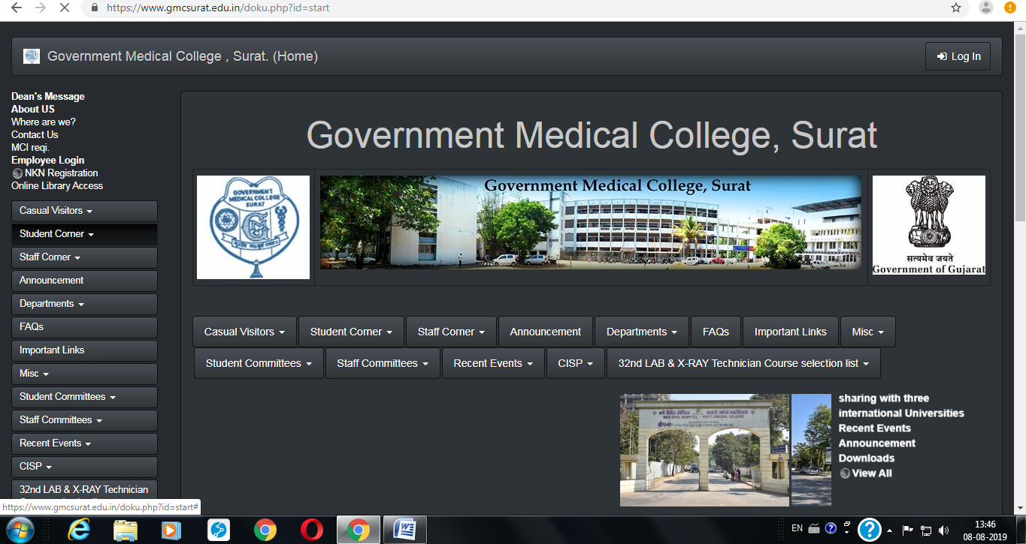

Step 2: Go to Online HREC

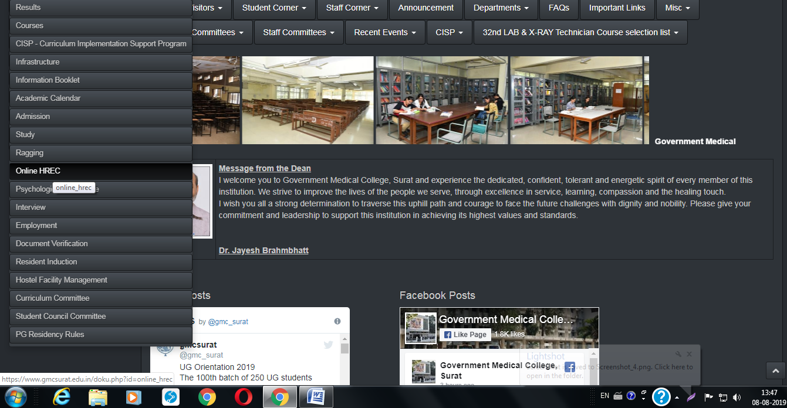

Step 3: Download Format for submission of protocol for thesis or dissertation.

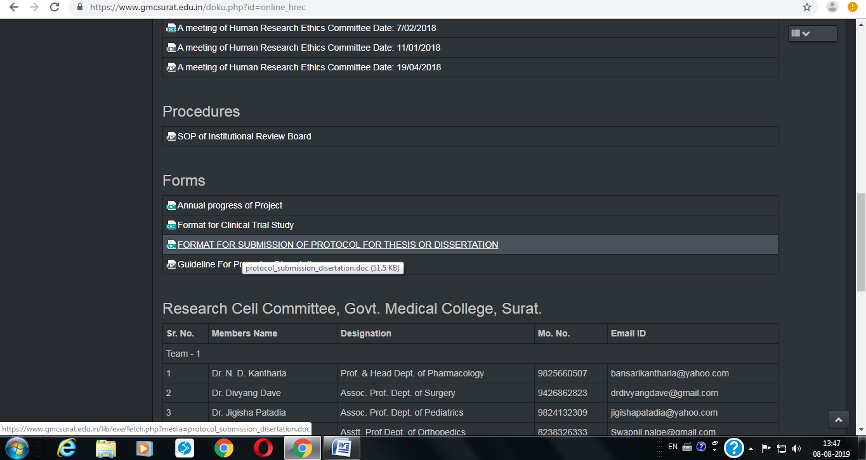

Prepare your thesis protocol by filling in all the required sections in the given format.

The protocol should be discussed in a Departmental meeting and finalized for submission to the SRC, along with the minutes of Departmental Meeting.

Requisite permission letter from Medical Superintendent / Dean of Medical College should be applied for.

All the documents given in the table below (as applicable to your specific dissertation) should be prepared beforehand and kept ready for upload.
Files to be uploaded:
Section | No. | Name | Components | File Type
A  (Administrative documents) | 1. | Covering Letter | Covering Letter | PDF
 | 2. | Letter of Permission (those relevant to your research project) | From Medical Superintendent | PDF
 |  |  | From Dean | PDF
 |  |  | From other Department | PDF
 |  |  | From other relevant authorities-Nursing College, School etc. | PDF
 | 3. | Undertaking | ICMR Guidelines will be followed | PDF
 |  |  | The project has not started yet | PDF
 | 4. | Departmental Meeting minutes | Approval as minutes of Departmental meeting discussion of the protocol with | PDF
B  (Main Research Document) | 1. | Research Protocol | Protocol | Word
C  (Participant Information & Consent Documents) | 2. | Participant Information Sheet (PIS) | In 3 languages- English, Hindi, Gujarati | Word
 | 5. | Participant Informed Consent Form (PICF) | In 3 languages- English, Hindi, Gujarati | Word
D  (Data Collection tools) | 6. | Questionnaires, tools, Performa to be used | In 3 languages- English, Hindi, Gujarati | Word
E  (Review Literature) | 7. | 2 Relevant References | Preferably one national and one international | PDF

Step 4: Your PG guide will login to their account via the GMCS website

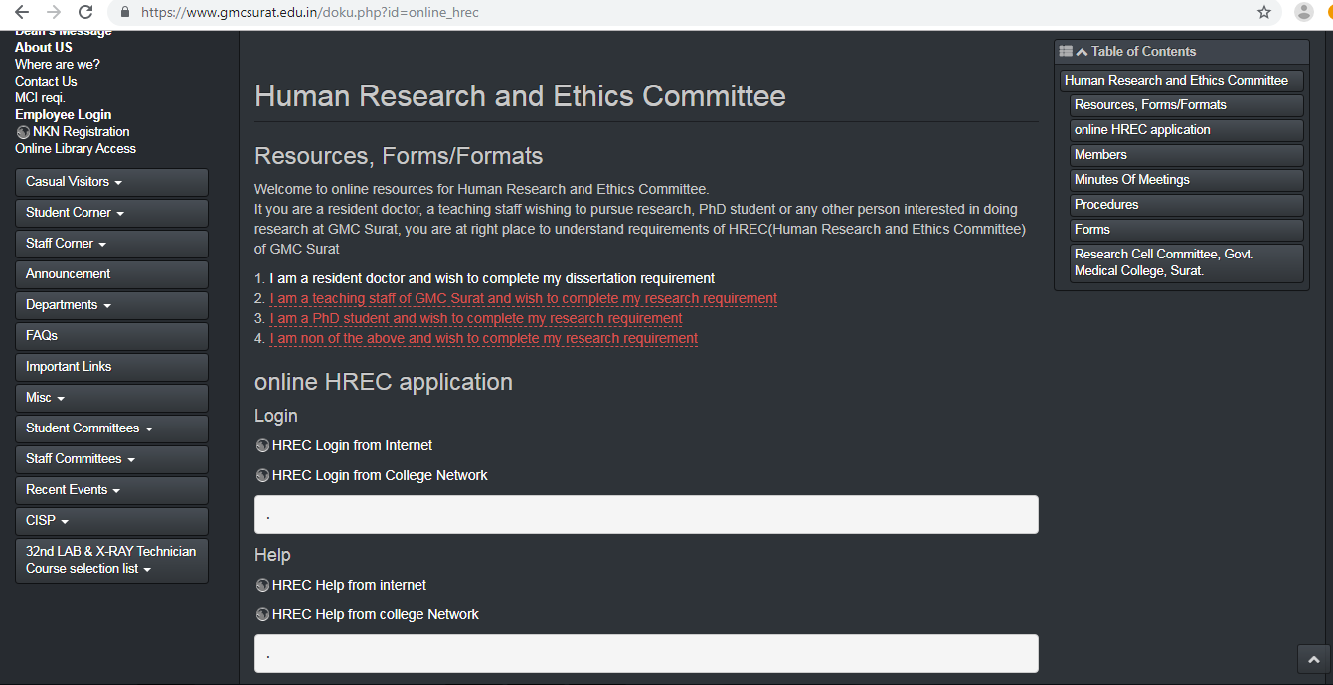

Step 5: Resident will enter the Username and Password given to them.

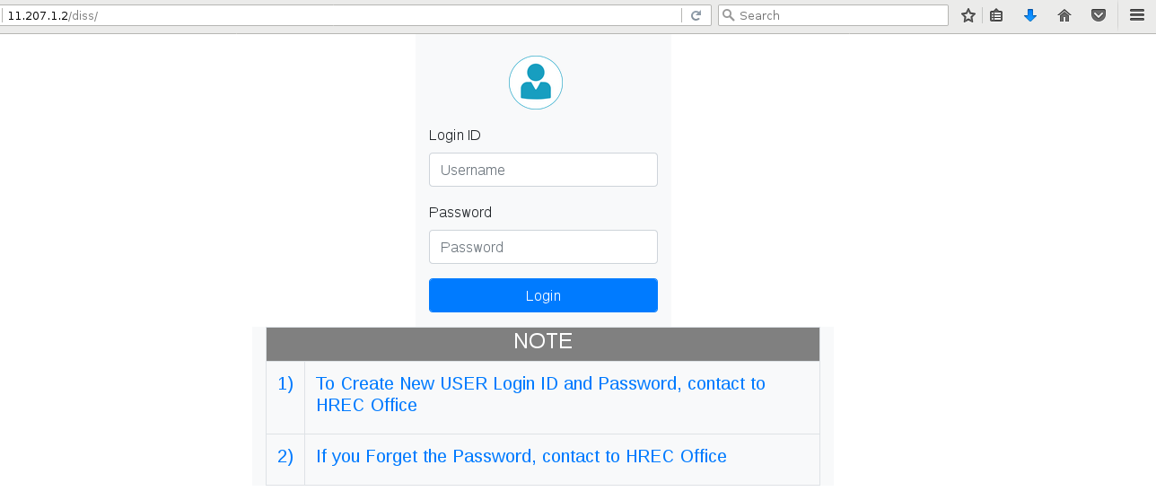

Step 6: After logging-in this page will appear.

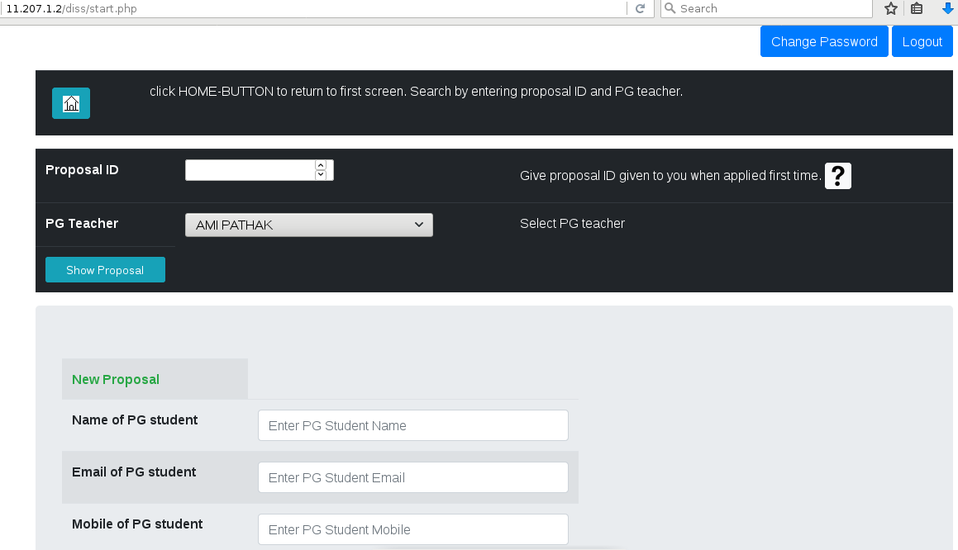

Step 7: In New Proposal fill all data as shown in below picture and then click on Save button.
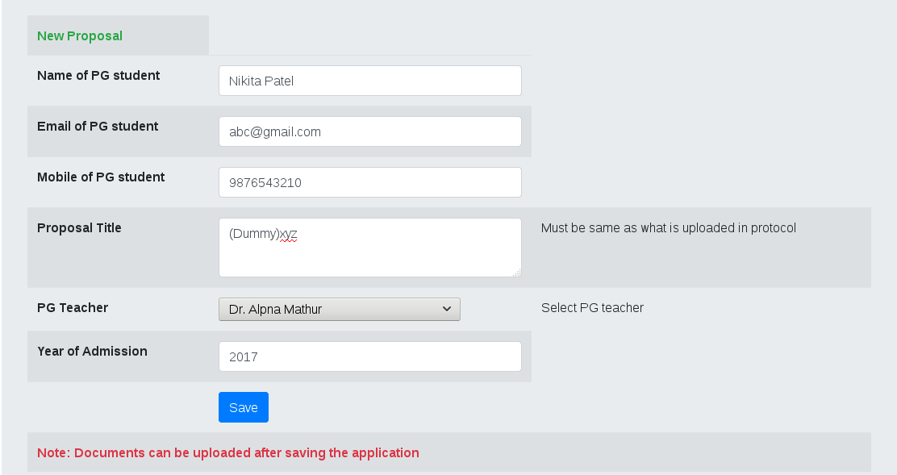

Step 8: This screen will be seen after you press save.

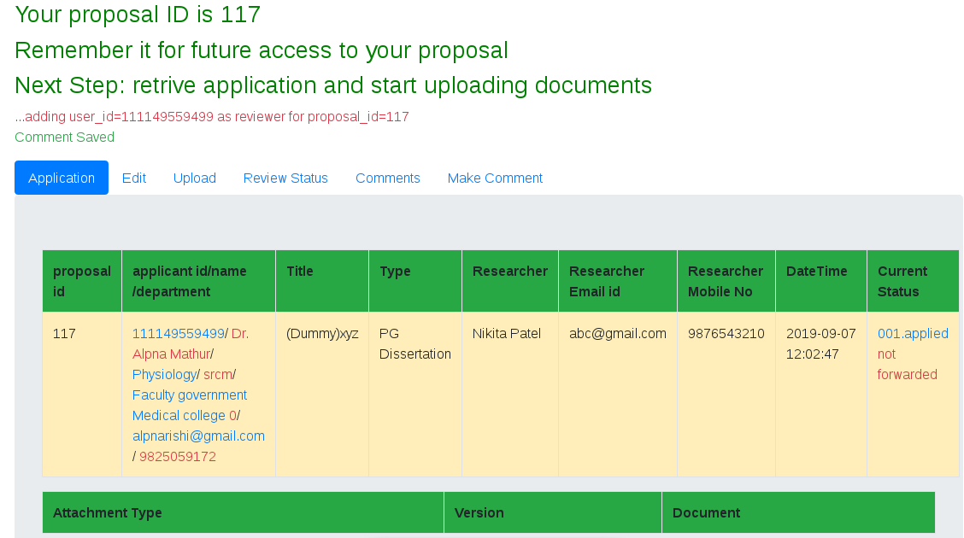

Step 9: If you want to Edit in application then click on Edit tab & press Update button.

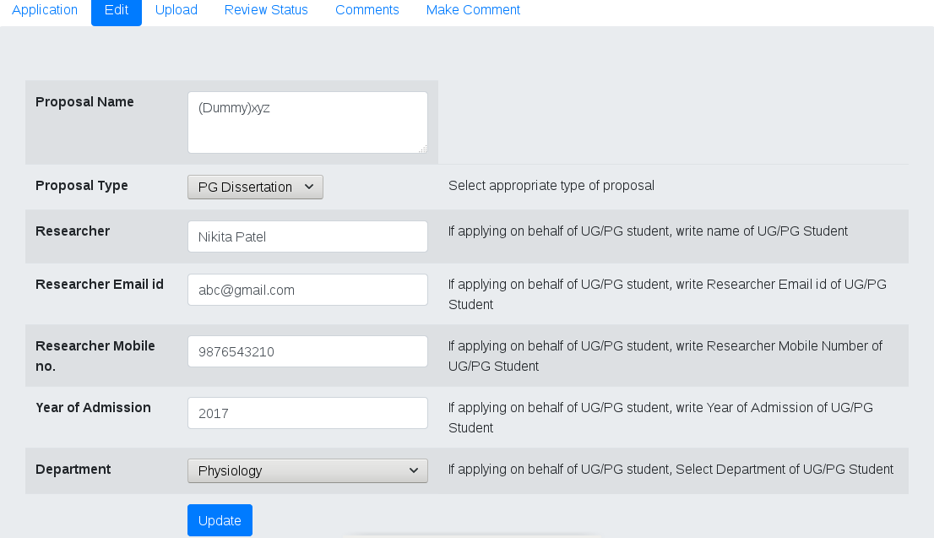

Step 10: Press on the Upload tab to upload the Documents.

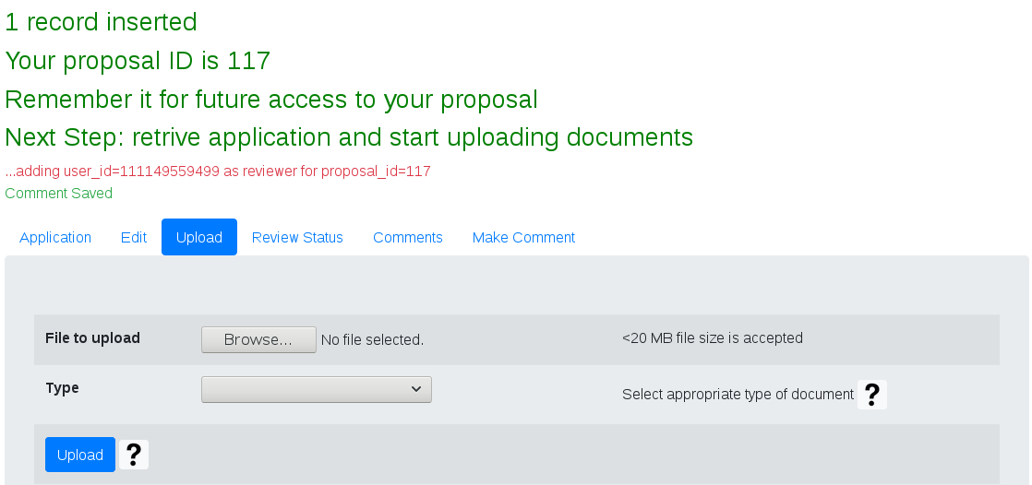

Step 11: Again ensure you have a folder ready with all the documents to be uploaded in the correct File Type - An example of such a folder is given below -

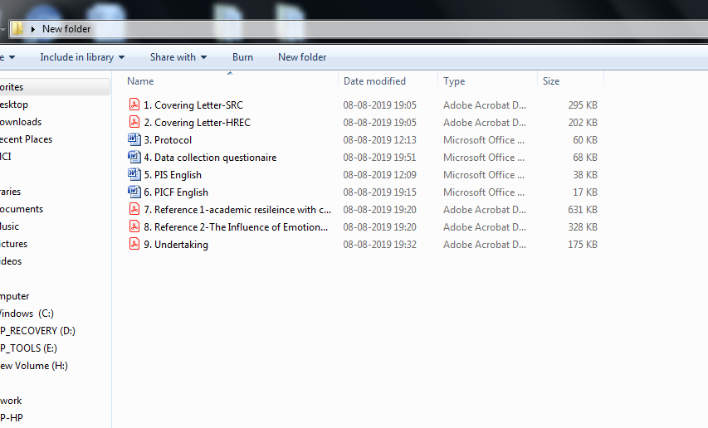

Step 12: Various types of documents to be uploaded, as seen in the drop-down menu

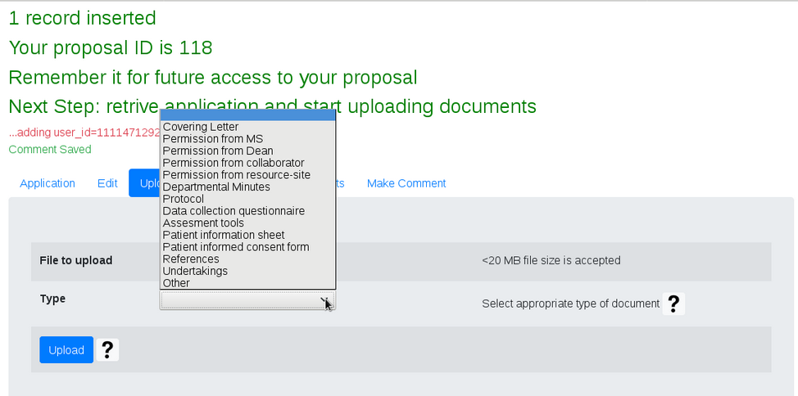

Step 13: Sequentially choose the file to be uploaded from your folder and the correct file type then press the upload button.

For e.g. to upload the covering letter -
Choose the PDF file that is your covering letter to SRC, then select the file type as ‘covering letter’, then press upload

Step 14: the uploaded file can be seen on the next screen like this -

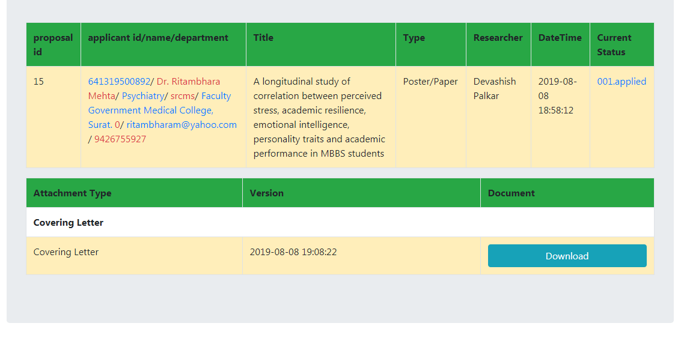

Step 15: In the similar way upload the rest of the files - Covering letter to HREC, Protocol, Data Collection Questionnaire, Assessment Tools, PIS, PICF, References and Undertakings

Step 16: Upload Covering letter to HREC

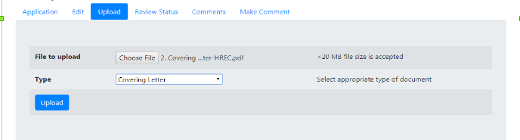

Step 17: Upload Protocol

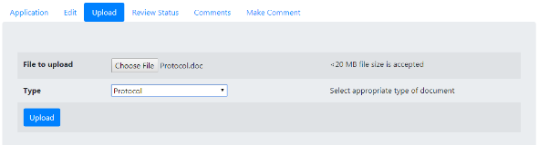

Step 18: Upload data collection questionnaire

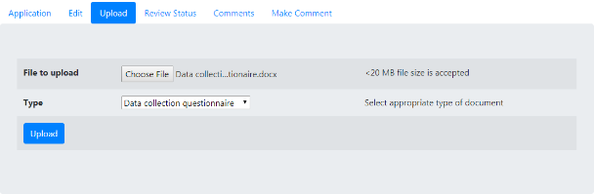

Step 19: Upload Patient Information Sheet

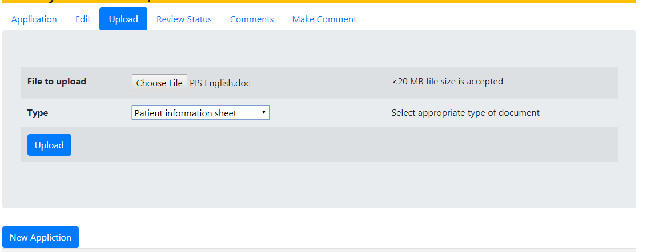

Step 20: Upload Patient Informed Consent Form

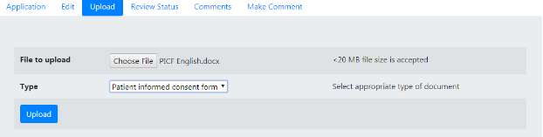

Step 21: Upload First Reference

Step 22: Upload Second Reference

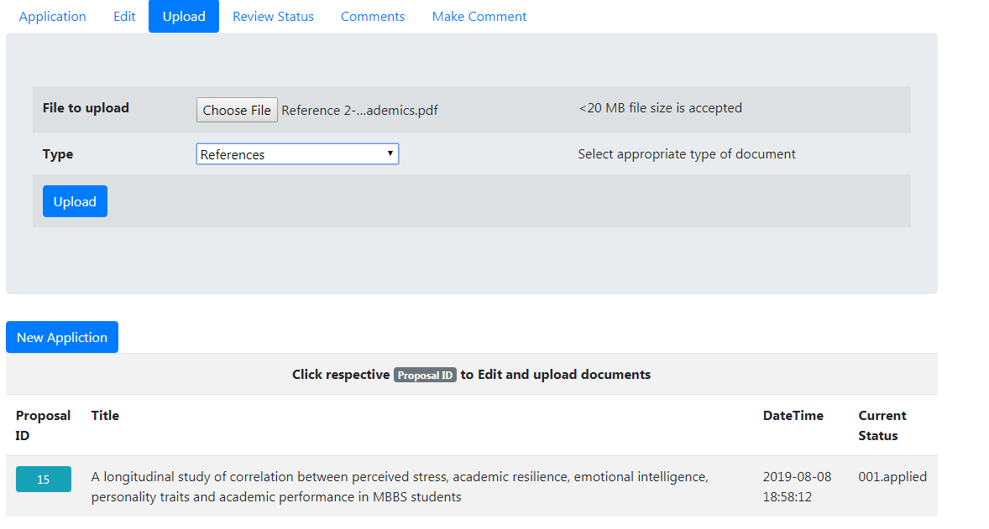

Step 23: Upload Undertaking
Please note: Now all undertakings are to be put in ONE document only.
Example is given on the website.

Step 24: The uploaded documents are visible like this

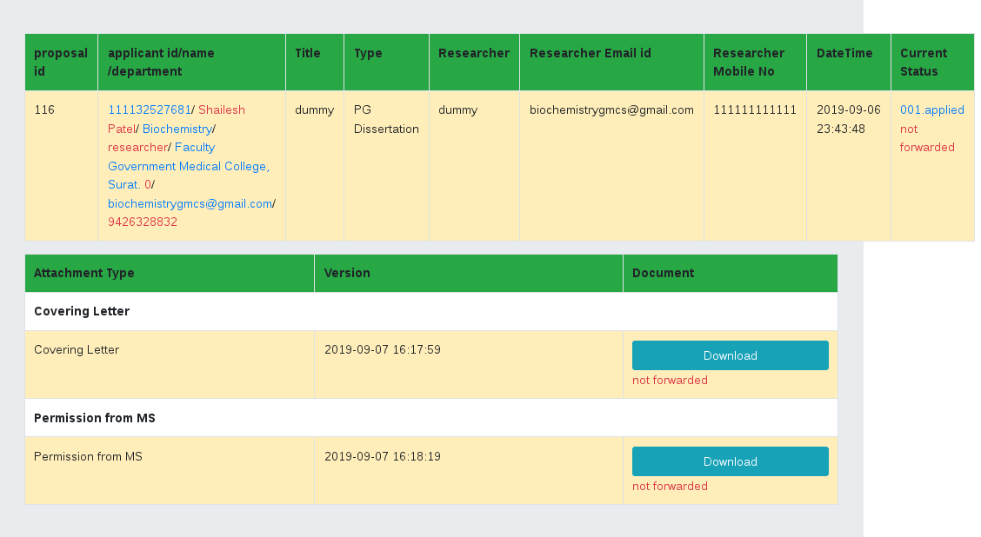

Step 25: Enter Proposal ID and select PG Teacher and click on show proposal to view your submitted proposal

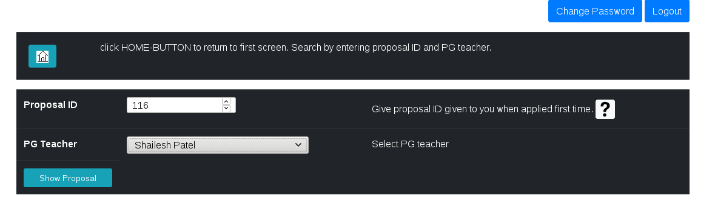

These steps will take you to summited proposal. Then further steps like edit, view, comments are shown. Then using this steps researcher can further edit their Proposal.
Thanks

Step 1:-
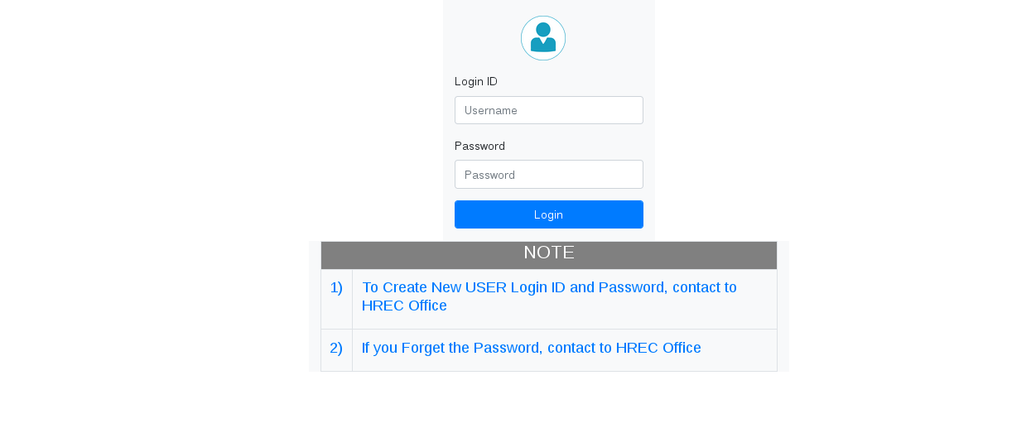
Step 2:-
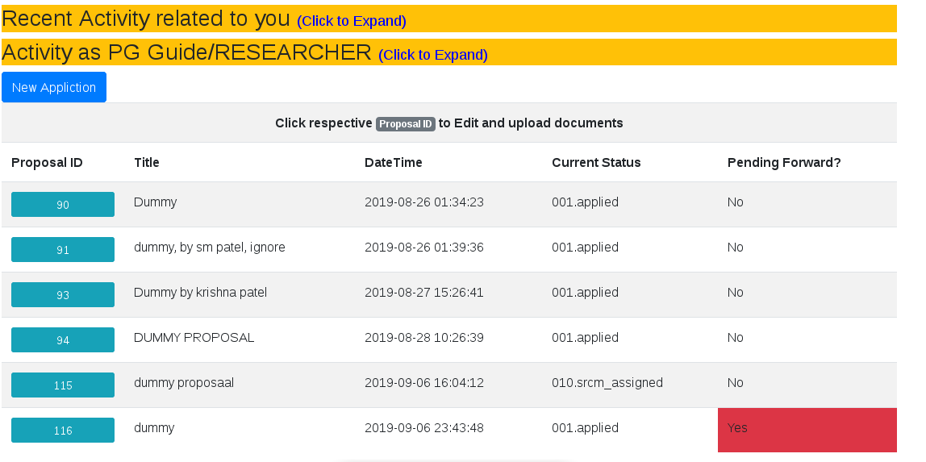

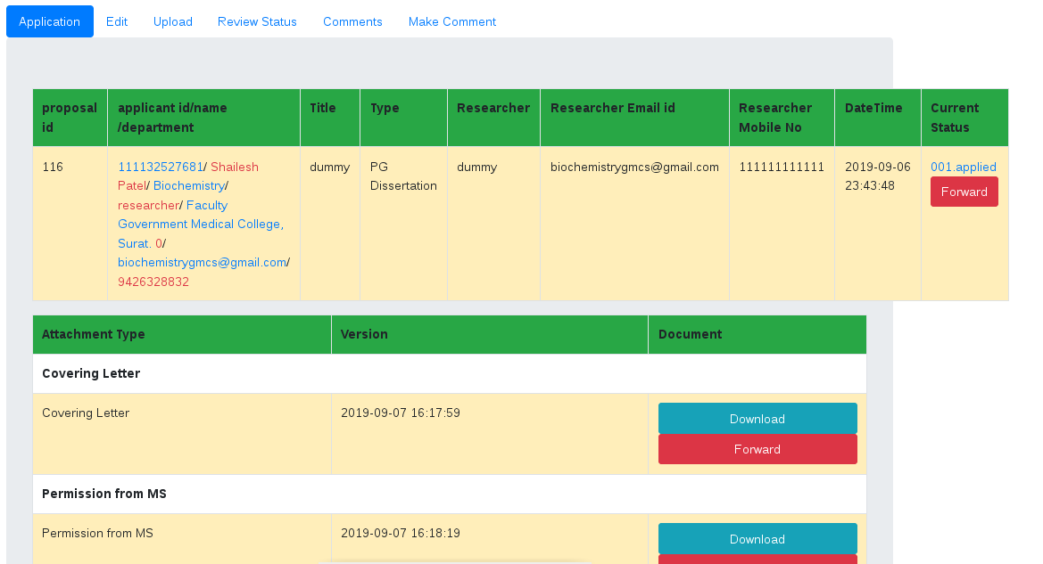
Step 3:-
Step 4:-

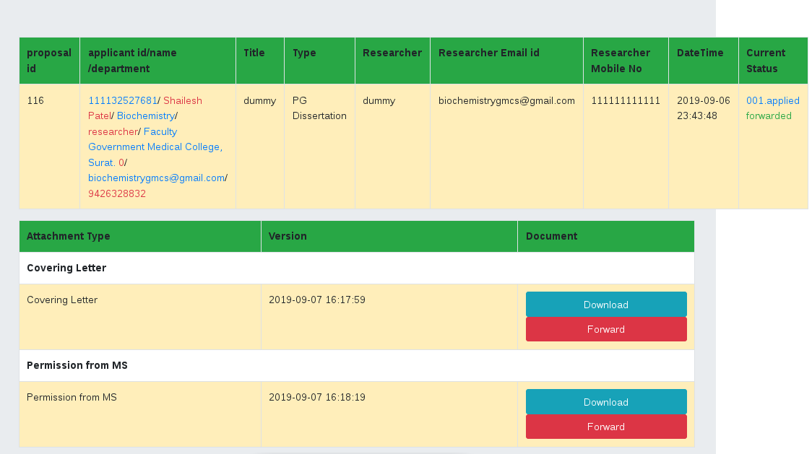

Step 5:
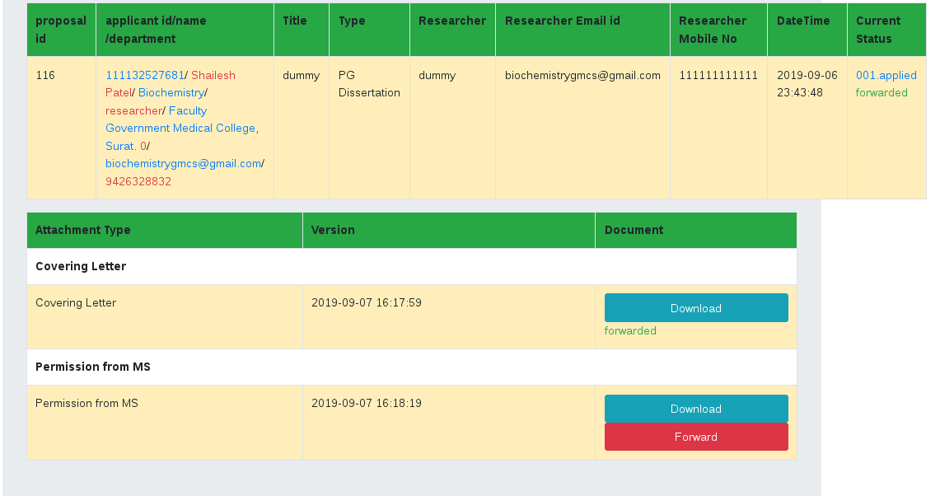

Step 6:

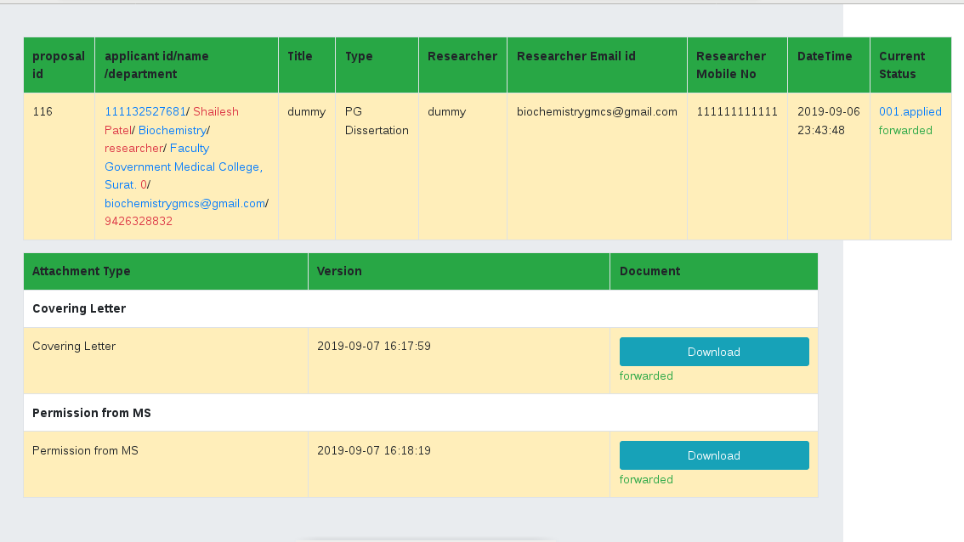

Step 7:-
