Department of Biochemistry

Government medical college Surat

Student Journal for Practical Biochemistry

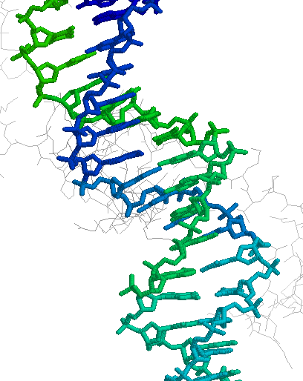

Certificate

of

Practical Journal Completion
Department of Biochemistry
Government Medical College Surat

Name of Student : ____________________________________

Roll Number : ____________________________________

Year of Admission : ____________________________________

Remarks : ____________________________________

Tutor  Department of Biochemistry  Government Medical College  Surat | Professor and Head  Department of Biochemistry  Government Medical College  Surat

I N D E X

No | Exercise | Date | Page No | Sign
1 | Introduction to Practical Biochemistry |  | 04
2 | Chemistry of Carbohydrates |  | 06
3 | Chemistry of Proteins and Amino acids |  | 17
4 | Chemistry of lipids |  | 27
5 | Physiological urine |  | 30
6 | Pathological urine |  | 37
7 | Estimation of acid output by stomach |  | 44
8 | Secretion and buffering of acids by kidney |  | 51
9 | Colorimetry |  | 56
10 | Estimation of Serum Creatinine |  | 61
11 | Estimation of Plasma Glucose |  | 64
12 | Estimation of Serum Cholesterol |  | 66
13 | Estimation of Serum Bilirubin |  | 68
14 | Estimation of Serum Total Protein |  | 71
15 | Estimation of Serum Albumin |  | 73
16 | Estimation of Cerebro Spinal fluid protein |  | 76
17 | Estimation of serum uric acid |  | 78
18 | Electrophoresis |  | 80
19 | Chromatography |  | 83
20 | Clinical Cases |  | 85
21 | Medical Biochemistry – Syllabus |  | 94
22 | Subject distribution and Paper Style |  | 96
23 | List of Model Questions.
24 | List of Model Justification.

1. Introduction to Practical Biochemistry

Purpose of Biochemistry Practical :

- Study of properties of basic biomolecules.
- e.g. Carbohydrate, Proteins ,lipid
- Study of biochemical investigative tools and it's principle
- e.g colorimetry, chromatography, electrophoresis , point-of-care-technologies (POCT)
- Study of patient case - history - laboratory investigations in context to understand clinical aspects of the biochemistry.
- Study of identification and use of variety of articles like conical flasks, ,volumetric flasks, tube, measuring cylinders, glass pipettes, micropipettes, reagent bottles.

Precaution require during biochemistry practical :
- Wear apron and Tie hair during practical.
- Never do mouth pipetting to take reagents.
- While heating, keep your test tube away from your body.
- Do not use any concentrated acids and alkaline solutions like concentrated HCL, NaOH, H2SO4, HNO3.
- Do not handle any chemical directly. Use pipette, Spatula etc.
- Turn off gas burner after completing practical.

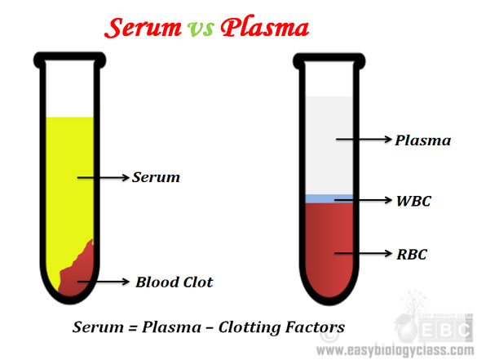
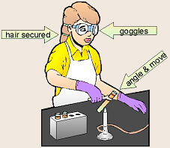

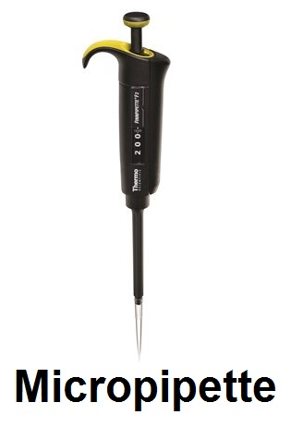
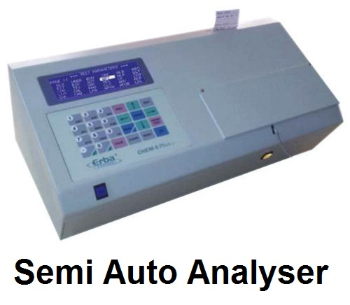
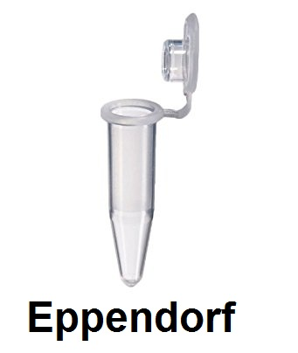

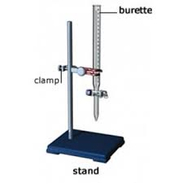

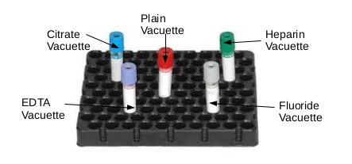
Disposal of laboratory Waste
There are guidelines to dispose waste. It is recommended that waste should be segregated at the point of generation & disposed in bags with correct colour coding.

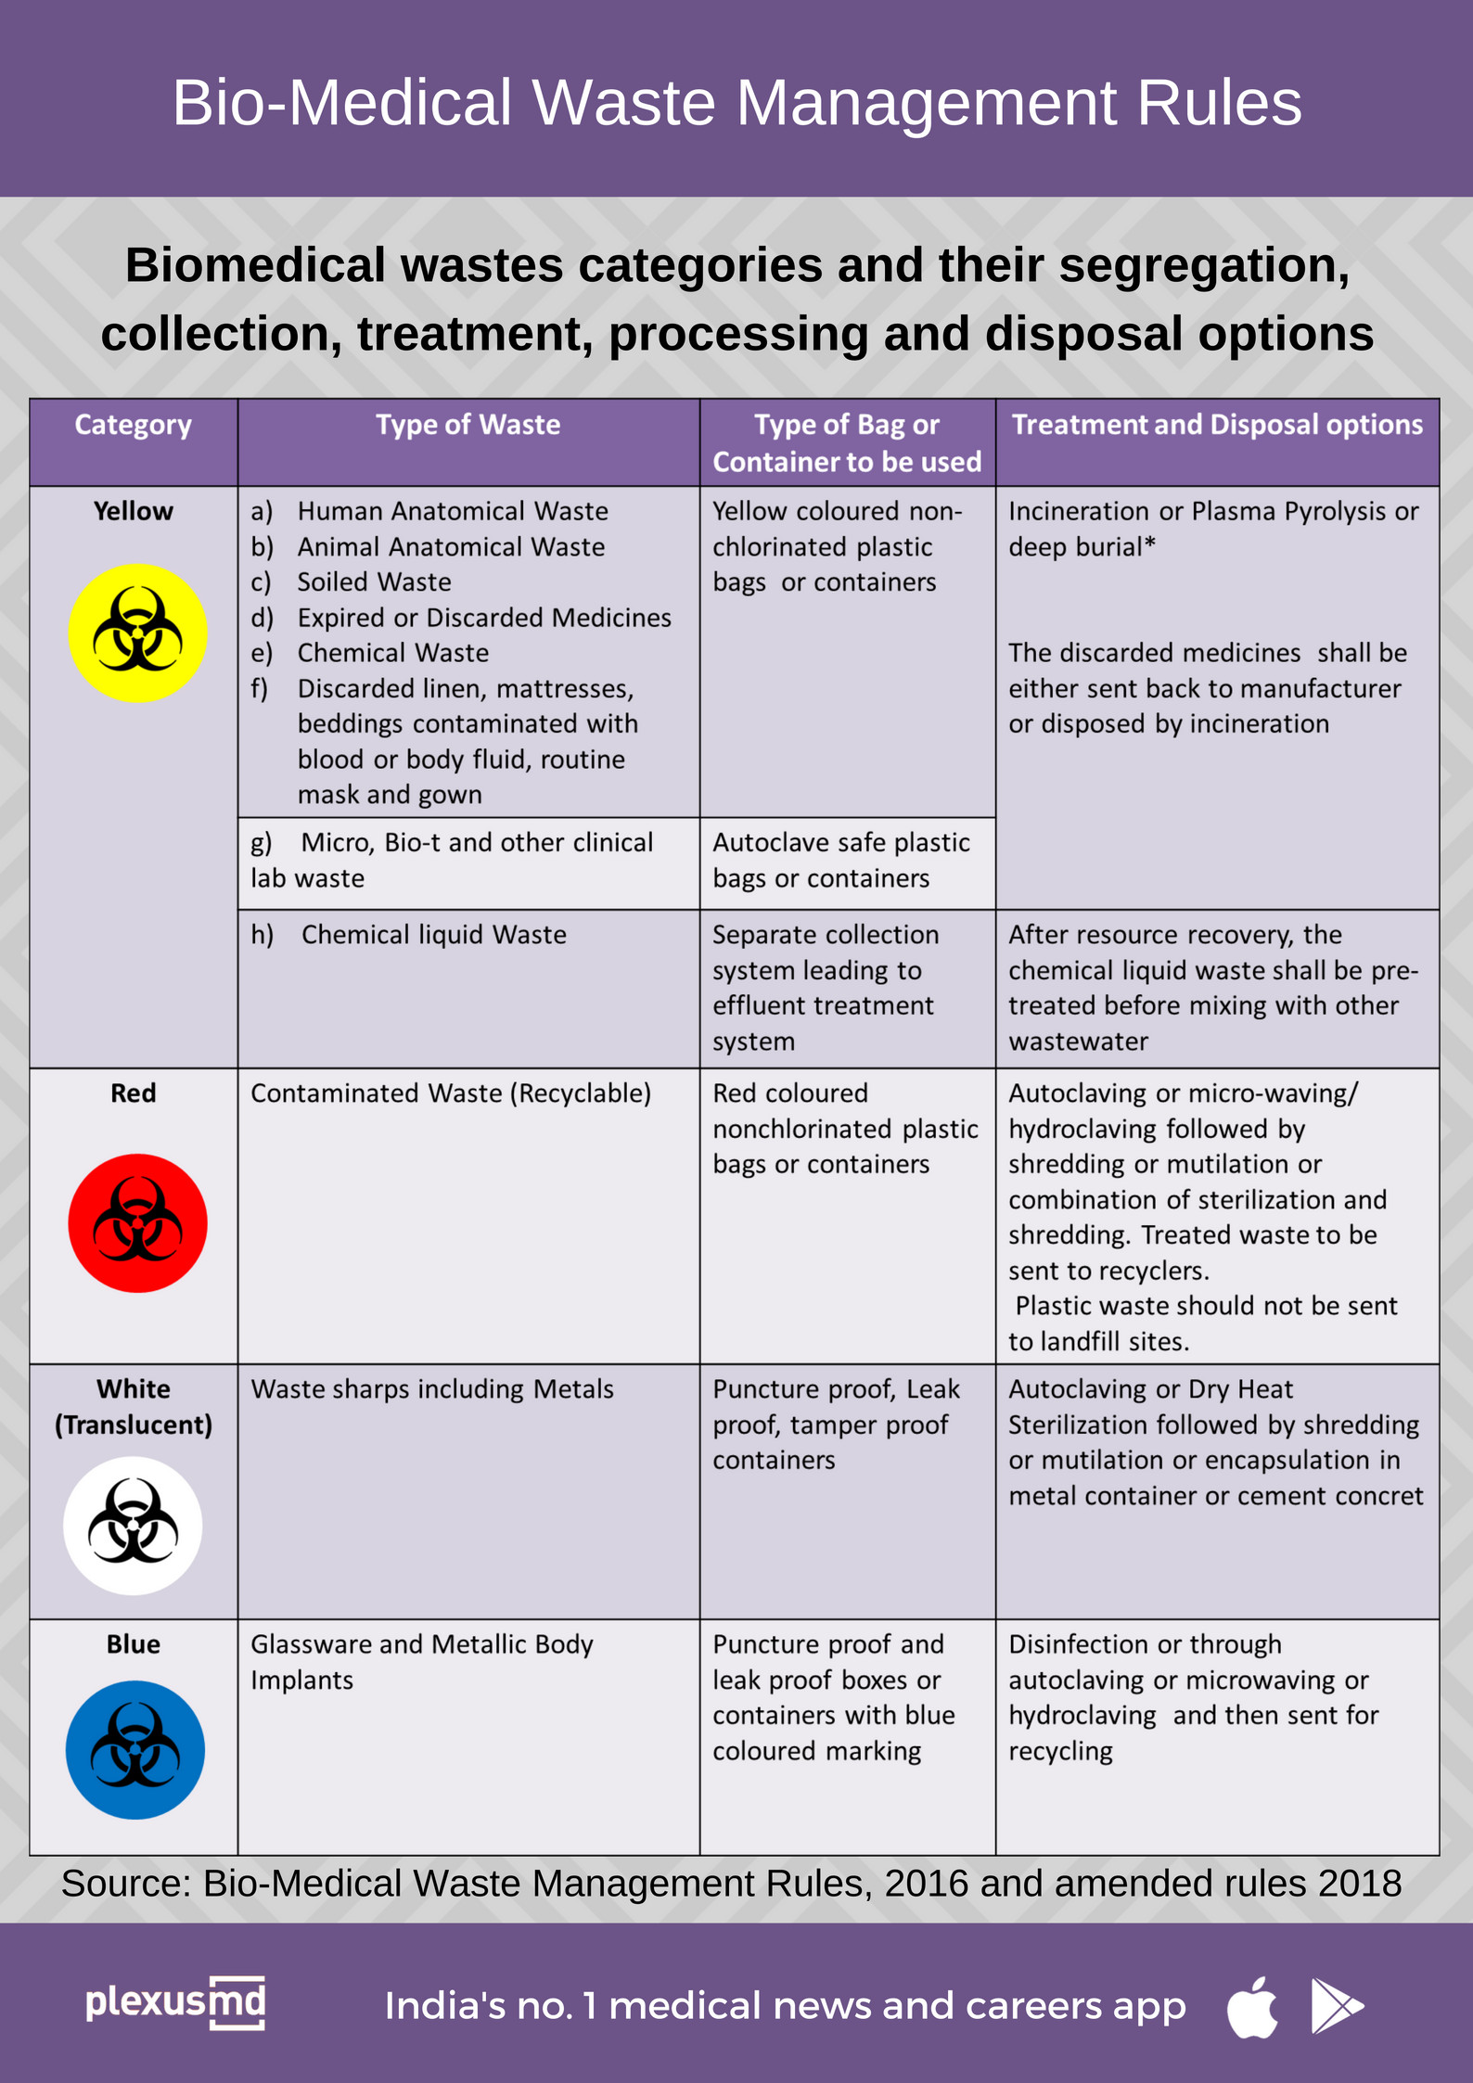

2.Chemistry of Carbohydrates
Test solution
- Glucose solution(400mg/dl) : Dissolve 4 gm of glucose powder in 1000 ml water
- Starch solution(1%): Add 10 gm of starch powder in 100 ml of water .Boil till solution become clear. Make up to 1 litre.
- Sucrose solution( (400mg/dl) : Dissolve 4 gm of Sucrose powder in 1000 ml water
- Fructose solution( (400mg/dl) : Dissolve 4 gm of Fructose in 1000 ml water
- Maltose solution( (400mg/dl) : Dissolve 4 gm of Maltose powder in 1000 ml water

Molisch’s test:
Reagent
- 1 % -Naphthol: Dissove 1 gm -Naphthol powder in 100 ml methanol
- Conc.H₂SO₄
Principle
All carbohydrates when treated with conc. sulphuric acid undergo dehydration to give fufural compounds. These compounds condense with Alpha-napthol to form colored compounds.
Molish test is given by sugars with at least five carbons because it involves furfurl derivatives,which are five carbon compounds.

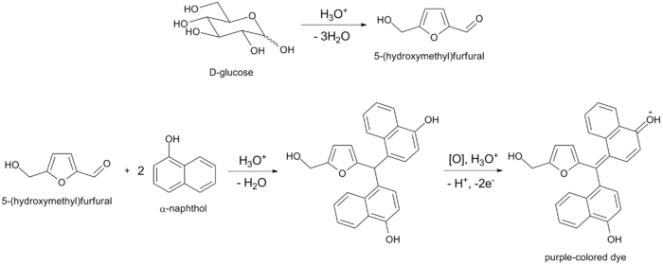

Benedict’s Test:
All Reducing sugars give positive benedict's test.Reducing sugars have a free aldehyde or keto group.
Reagent
Benedict’s Reagent:One liter of Benedict's solution contains ,
- 173 grams --------------------> sodium citrate,
- 100 grams ---------------------> sodium carbonate
- 17.3 grams -------------------->cupric sulphate pentahydrate.
With the help of heat,dissolve 173 gm of sodium citrate & 100 gm of sodium carbonate in 800 ml of water. Dissolve 17.3 gm cupric sulphate pentahydrate in 100 ml of water in different container.
Pour cupric sulfate solution in carbonate- citrate solution with constant stirring & make upto 1000ml.

Role of ingradient of benedict's solution:
1.Sodium citrate:Holding of cupric oxide in alkaline solution
2.Sodium carbonate:provide alkaline pH
3.cupric sulphate pentahydrate:Reducing Agent

Principle
Glucose (R-CHO) + 2Cu²⁺ + 2H₂O ^{(Boil)} Gluconic acid ( R-COOH) +
Cu₂O + 4H⁺

The principle of Benedict's test is that when reducing sugars are heated in the presence of an alkali(pH 10.6), they get converted to powerful reducing compounds known as enediols. Enediols reduce the cupric ions (Cu+2) present in the Benedict's reagent to cuprous ions (Cu+1) which get precipitated as insoluble red copper(I) oxide.
The color of the obtained precipitate gives an idea about the quantity of sugar present in the solution, hence the test is semi-quantitative.

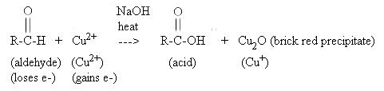

- Carbohydrates giving positive Benedict’s test:
Glucose, Fructose, Galactose,
Ribose, Glucuronic acid,
Lactose, Maltose
Note: Sucrose with no free reducing group give negative test.
- Non-Carbohydrates giving positive Benedict’s test:
High concentration of Uric acid , Creatinine and Ketones
Homogentisic acid (solution turns black due to black colored oxidized homogentisic acid)
Vitamin C (even without Boiling)
Certain drugs like aspirin, cephalosporins
- Starches
Starches do not react or react very poorly with Benedict's reagent, due to the relatively small number of reducing sugar moieties, which occur only at the ends of carbohydrate chains.
Different concentration of glucose gives different color of solution with Benedict’s test, depending on amount of precipitate and residual cupric sulphate.

Grade | Color of Reaction Mixture | Approximate Glucose concentration
+ | Green | 0.5-1 gm%
++ | Yellow | 1-1.5 gm%
+++ | Orange | 1.5-2 gm%
++++ | Red | >2 gm%

Benedict’s test is frequently used to detect glucose in urine. Although glucose is most frequent reducing substance present in urine, in some patient positive Benedict’s test may be due to non-glucose reducing substances listed above. This phenomenon may be called false positive result.

Glucose oxidase test:
Reagent:
Glucose strip or liquid reagent based on GOD-POD method
Principle:
Glucose + O₂ ^{Glucose Oxidase} Gluconolactone + H₂O₂

Gluconolactone + H2O ^{Spontaneous} Gluconate

H2O2 + (reduced colorless dye) ^{Peroxidase} Oxidized colored dye

Some of the dyes used are O-tolidine, tetramethylbenzidine, and potassium iodide, 4-aminophenazome + phenol .

Reagents for this test are present on a strip of paper in solid form. When the paper is wet with urine, the reagents dissolve in urine on paper and react with glucose in urine. The darkness of color can be correlated with amount of glucose present in urine.

Because Glucose oxidase enzyme can act only on beta-D-Glucose, other reducing substances do not give this test positive. (Exception: Galactose can react with glucose oxidase, but very slowly)

Following reaction occur when urine contain compounds reacting with H2O2.

Glucose + O₂ ^{Glucose Oxidase} Gluconolactone + H₂O₂

H₂O₂ + Vitamin C ^{Peroxidase} Oxidized Vitamin C + H₂O

Thus, compounds like Vitamin C, Aspirin utilize H₂O₂ produced in the reaction. Due to lack of H₂O₂, peroxidase can not oxidize dye. Thus, glucose may not be detected even if present, if urine contain Vitamin C or Aspirin in large amount. This phenomenon is called false negative result.
In neonate, positive Benedict’s test in urine, in presence of negative Glucose oxidase test, indicate possible presence of Fructose or Galactose in urine. (But note the exception mentioned above). Fructose and galactose are found in some inborn deficiency of enzymes of their metabolic pathways.

Performed Benedict’s test and Glucose oxidase strip test with following compounds and fill up the table given.
Compound | Benedict test | Glucose Oxidase Strip Test | Inference
Fructose
Vitamin C
Glucose with Vitamin C
Cephalosporin Drugs
Barfoed’s Test:
This test is based on the same principle as Benedict’s test. But, the test medium is acidic. In acidic medium(pH 4.6) monosaccharides react faster than disaccharide. Monosaccharides react fast within 1-2 minutes but disaccharides take longer i.e. 7-12 minutes.
Reagent:
- Barfoed's reagent: Dissolve 70 gm of cupric acetate monohydrate in 800 ml of water. Add 9 ml glacial acetic acid & make to 1000 ml with water.
Principle
Acidic pH(4.6),Heat
RCHO + 2Cu2+ + 2H2O RCOOH + Cu2O↓ + 4H+

Seliwanoff’s Test
Seliwanoff’s test is a chemical test which distinguishes between aldose and ketose sugars. This test is based on the fact that, when heated, ketoses are more rapidly dehydrated than aldoses.
Reagent

- Seliwanoff's reagent: Add 50mg of Resorcinol in 66 ml of water. Add 33 ml concentrated HCL. Wear goggles. The reagent is colorless if red color develop, discard it.
Principle
Ketohexoses like fructose on treatment with HCl form 5-hydroxymethylfurfural, which on condensation with resorcinol gives a cherry red complex.
Sucrose is hydrolyzed into glucose and fructose when boiled in acidic medium of Seliwanoff’s reagent. Fructose, present in hydrolysate gives positive Seliwanoff’s test.

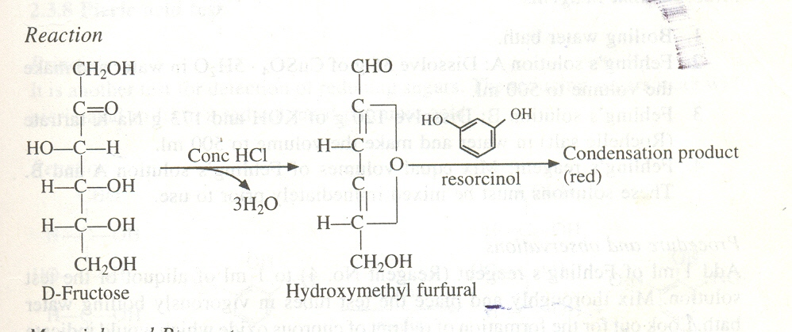

Inversion Test:
Reagent
- 10 % HCL
- 40% NaOH : dissolve 40 gm of NaOH pellet in 100ml Water
- Benedict's reagent
- Seliwanoff's reagent
Principle
When sucrose is boiled with conc. HCl, It is hydrolyzed into its constituent monosaccharides i.e. fructose and glucose. The hydrolyzed glucose and fructose give Benedict’s test. Fructose gives seliwanoff’s test.

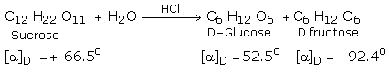

Sucrose is dextrorotatory. The optical rotation changes from dextrorotatory to leavorotatory on hydrolysis, since fructose causes a much greater leavorotation than the dextrorotation caused by glucose. This is known as inversion. The resultant hydrolysate is called invert sugar, which is sweeter than sucrose because fructose is sweeter than sucrose.

Iodine test for starch
Reagent:
- Iodine solution : Dissolve 1.27 gm Iodine and 3 gm potassium iodide crystals in 100 ml water.Dilute 1:10 in water before use.

Iodine by itself is very poorly soluble in water. One way to dissolve iodine in water is to add potassium or sodium iodine. Those salts dissolve into potassium or sodium ions and iodine ions. The iodine ion (I-) reacts with the free iodine (I2) to form a triiodide ion (I3-) which is soluble in water and can react with glucose chains.

Principle
Iodine binds starch to give blue colored complex.
When glucose chains are sufficiently long they coil up like springs. This coil is supported by weak links between the glucose molecules. These links break down at high temperatures and the glucose chains uncoil. When the chains are longer than about 9 glucose molecules a triiodide ion (I3-) fits inside the coil (Figure ).The longer the glucose chains are the more iodine molecules fit into the coils and the more intense the color reaction will be.
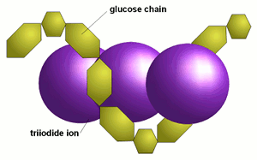
The resulting color depends on the length of the glucose chains. Shorter chains (starting at about 9 glucose molecules in unbranched chains and up to 60 glucose molecules in branches chains) give a red color .
Amylose, which consists of very long glucose chains between occasional branch points and very large dextrines give a dark blue color .
while amylopectin, which has much more branch points and shorter glucose chains between these branch points, gives a more reddish color in the presence of iodine.

Hydrolysis Test for starch
When starch/dextrin is boiled with HCl, It is hydrolyzed into monosaccharides i.e. glucose.So Benedict test give positive observation
TEST | METHOD | OBSERVATION | INFERENCE
Molisch’s Test | 1ml OS + 2 drops of α-napthol solution mix.  Than, Add 2 ml. of conc. Sulphuric acid carefully through the side of the test tube without shaking. | Purple ring is formed at the junction of acid and solution. | Carbohydrate present.
Benedict’s Test | 5ml of Benedict’s reagent + 8 drops of OS, mix  Boil and cool. | Green/Yellow/ Orange/Red/ Brick Red precipitates seen | Reducing Group present.
Barfoed’s Test | 1 ml OS + 1 ml Barfoed’s reagent Boil for 30 sec , Cool Excess boiling may give false positive results. | Red colored precipitates. At the bottom of the tube. | Disaccharides absent. Monosaccharide present
Seliwanoff’s Test | 1 ml O.S. + 1 ml Seliwanoff’s reagent.  Boil and cool for 5 min | Red colored formed. | Keto sugars present e.g. Fructose
Iodine Test | 1 ml OS + 2 drops of iodine solution, Mix | Blue color develops. | Starch present.
Iodine Test | 1 ml OS + 2 drops of iodine solution, Mix | Violet color develops | Dextrine present
Inversion Test | 1 ml OS+ 1 ml of 10% HCL. Boil for 2mins.Cool.  Make it alkaline with 5 drops of 40% NaOH.  From this solution perform Benedict & Saliwanoff test. | Benedict’s & Saliwanoff’s test are positive | Sucrose is present if OS give negative Benedict's test
Hydrolysis test for starch/  dextrin | Step-1: Perform Benedict’s Test with OS.  Step-2: 0.5 ml OS+ 0.5 ml of 10% HCl . Boil for 2 mins. Cool. Make alkaline with 5 drops of 40% NaOH. From this solution perform Benedict’s reagent & Boil. | Benedict’s test is negative/ weakly positive  Benedict’s test is positive | Starch present (weak Benedict’s test with OS is due to free reducing groups at end of starch)
Glucose oxidase test ( on strip or with liquid reagents) | Method for the test will be provided in the laboratory | Observation will be explained in the laboratory | Glucose present in the solution

Perform tests mentioned in above table with various carbohydrates given to you.
TEST |  | Glucose | Sucrose | Fructose
Molisch’s Test | Observation
Molisch’s Test | + / --
Benedict’s Test | Observation
Benedict’s Test | + / --
Barfoed’s Test | Observation
Barfoed’s Test | + / --
Seliwanoff’test | Observation
Seliwanoff’test | + / --
Iodine Test | Observation
Iodine Test | + / --
Inversion Test | Observation
Inversion Test | + / --
Hydrolysis test for  starch | Observation
Hydrolysis test for  starch | + / --
Glucose oxidase test
Glucose oxidase test | + / --

TEST |  | Maltose | Starch
Molisch’s Test | Observation
Molisch’s Test | + / --
Benedict’s Test | Observation
Benedict’s Test | + / --
Barfoed’s Test | Observation
Barfoed’s Test | + / --
Seliwanoff’test | Observation
Seliwanoff’test | + / --
Iodine Test | Observation
Iodine Test | + / --
Inversion Test | Observation
Inversion Test | + / --
Hydrolysis test for  starch | Observation
Hydrolysis test for  starch | + / --
Glucose oxidase test
Glucose oxidase test | + / --

Questions:
- Explain biochemical reason why Sucrose gives negative Benedict’s test.
- Why the hydrolysis of sucrose is called ‘Inversion test’ ?
- Does alpha-D-Glucose in the solution react with Glucose Oxidase. Explain.
- Why do starch give negative benedict test ?
- Why Benedict test give different colour precipitation with different glucose concentration ?

3. Chemistry of Proteins and Amino acid

Proteins are made up of amino acids. Amino acids differ from each other in their side chain (-R group). The differing –R groups in different amino acids are responsible for many reactions mentioned below.

Preparation of Protein solutions:
- Egg albumin solution (1:21): Mix 50 ml of egg (only white part) in 1 liter of tap water. Use only for 24 hours
- Gelatine solution(0.5%): Dissolve 5 gm of Gelatin powder in 50 ml of water by slight Heating & make upto 1 liter
- Peptone solution(0.5%) :Dissolve 5 gm of Peptone powder in 50 ml of water by slight Heating & make upto 1 liter
- Casein solution(0.5%) : Dissolve 5 gm of Casein powder in 20 ml of 40% NaOH & make upto 1 Liter with water
Biuret Test
This test is given by all peptides having at least two peptide bonds. So, it is given by all proteins.
Reagents:
- 10% NaOH: Take 10gm NaOH pellets and make it up to 100ml with DI water.
- 1% CuSO4: 1 gm of CuSO4 in 100 ml DI water.

Principle:
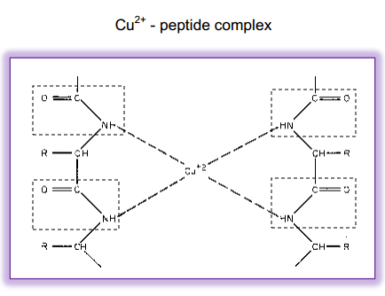

Cupric ions of copper sulphate solutions in alkaline medium form coordinate complex with at least two nitrogens of the peptide bonds to form purple colored complex. Thus color intensity is proportionate to the presence of number of peptide linkages.

Minimum of 2 peptide bonds (3 amino acids) are required for binding of Cu2 + with peptide. single amino acids and dipeptides do not give positive test.

The name of reaction is derived from organic compound biuret which is formed by condensation of 2 urea molecules at high temperature.

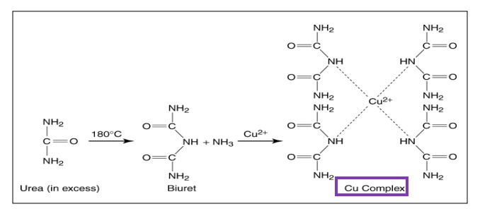
Figure of Biuret
Biurat is formed when solid urea powder is heated in a tube. The resultant Biurat is solid at room temperature and soluble in water.
The test produces color proportionate to number of peptide bonds which can be correlated with amount of protein. Similar reagent is used for estimation of serum proteins quantitatively.

Ninhydrin Test

This test is given by all compounds having free α-Amino groups. ex: peptides, proteins, free α- Amino acid. Different Proline and hydroxyproline give yellow color in this test.
Prepare reagent:
1 % Ninhydrine solution : 1 gm of Ninhydrine powder disolved in 100 ml DI water.
Principle:
Ninhydrine + α- Amino acid → hydrindantin + aldehyde + CO2 + NH3
Hydrindantin + NH3 + Ninhydrine → blue colored complex

Ninhydrin oxidises an α-amino acid to an aldehyde liberating NH3 and CO2 and is itself reduced to hydrindantin. Hydrindantin then react with NH3 and another molecule of ninhydrine to form a purple colored complex.

All amino acids that have a free amino group will give positive result (purple color) .While not free amino group-proline and hydroxy-proline (amino acids) will give a (yellow color).
Note: Many substances other than amino acids, such as amines will yield a blue color with ninhydrin, particularly if reaction is carried out on filter paper.
Xanthoproteic Test:
Note: Conce.HNO3 is Hazardous.This test is of Demonstration only.This test is answered by aromatic amino acids. ( Tyrosine, Tryptophane)
Reagent: Concentrated HNO3 :
Concentrated HNO3 is divided into 10 ml bottle. & keep it in refrigerator (2-8 'c). Such 7-8 bottle is kept in freeze. Every time open one bottle & Demonstate test. Use HNO3 Bottle directly for use as reagent. Old HNO3 give yellow colour to solution.
Principle
Concentrated nitric acid causes nitration of activated benzene ring of
tyrosine and tryptophan. (Benzene ring is considered activated when
additonal groups are attached to it) The nitrated activated benzene is
yellow in color. It turns to orange in alkaline medium.. Phenylalanine also
contains benzene ring, but ring is not activated, so it does not undergo
nitration. The reaction can be hastened by heating. The heat may be
produced by dilution of concentrated HNO3 with OS or may require
heating
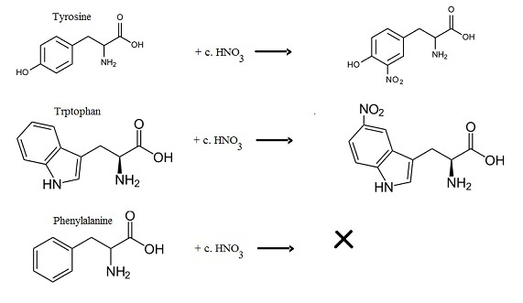
Aldehyde Test
Note: Conce.H2SO4 is Hazardous.This test is of Demonstration only.
Reagents
- 1:500 Formaldehyde Reagent:
Take 1 ml of Formaldehyde solution (37-41 % W/V) and make upto 500 ml with DI water.Use only for 1 week. Old Formaldehyde may not give test.
- 1 % Sodium Nitrite solution :
Take 1 gm sodium nitrite powder and make upto 100 ml with DI water. Use only for 1 week. Old Sodium nitrite may not give test.
- Sulphuric acid AR :
Concentrated Sulphuric acid is divided into 10 ml bottle. & keep it in refrigerator (2-8 'c).Such 7-8 bottle is kept in freeze.Every time open one bottle & Demonstate test.Use sulphuric acid Bottle directly for use as
reagent. Old Sulphuric acid give yellow colour to solution.
Principle
Indole ring is present in tryptophan. Formaldehyde react with indole ring to give violet colored complexes in presence of H2SO4. Addition of Sodium nitrite intensify and stabilize colour.
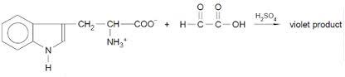
Millon’s reagent

Reagent:
- Millon's reagent:
Dissolve 10 gm of mercuric sulphate(HgSO4) +100ml DI water + 7 ml Conc.H2SO4
- 1% sodium nitrite:1 gm in 100 ml DI water

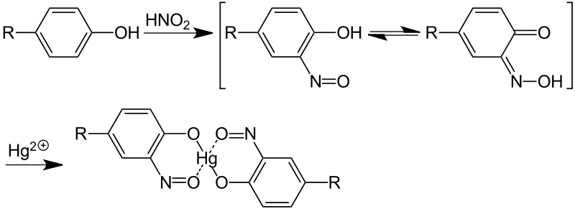
Principle

Tyrosine has hydroxyphenyl(Phenol) group. The hydrophobic group is in the core of protein. The protein is denatured by mercuric sulphate in boiling water exposing hydroxyphenyl group. Sodium nitrite reacts with sulfuric acid to form nitrous acid. The exposed hydroxyphenyl groups react with nitrous acid. The compound formed chelates Hg2+ & give red colour precipitates.
Sakaguchi’s Test
This test is for Guanido group Which is the R-group of arginine.
Reagent:
- 1%w/v α-Napthol: Dissolve 1 gm α-Napthol in 100 ml of methanol
- 10%w/v NaOH: Dissolve 10gm of NaOH & make it upto 100ml with DI water.
- Alkaline hypochloride : Make 100 ml 10 % NaOH & add 8 ml 5-6 % Analytical grade Sodium hypochloride.
Principle
In an alkaline medium, alpha-Napthol combines with guanidino group of arginine to form a complex, which is oxidized by bromine/chlorine.

Sulphur Test (Lead acetate test):
Reagent:
- 2% Lead acetate in 10% NaOH: Add 20 gm lead acetate, 100 gm NaOH in 1 liter of water. There is no need to make exactly up to 1 liter. Above solution will be more than 1 liter in volume.
Principle:
When protein containing cysteine & cystine is boiled with strong alkali, organic sulfur(R-SH) is converted to sulphide (Na₂S]. Addition of lead acetate to this solution causes precipitation of insoluble lead sulphide (PbS), which is black-gray in color. Methionine does not give this test due to the presence of thioether linkage (H3C-S-CH2-R) which does not allow the release of sulfur in this reaction.
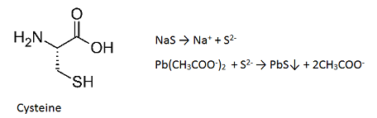

Heat coagulation test:
Reagent:
- 1% acetic acid: 1 ml acetic acid up to 100 ml with DI water.
Principle
Proteins have net zero charge at their iso-electric pH (pI). So, at pI, protein molecules have minimum repelling force. Thus proteins are easily precipitated at pI. When proteins are heated, weak bonds like hydrogen-bonds, salt bonds and van-der-wal forces are broken. Proteins are said to be denatured.
Core hydrophobic regions of denatured Albumin can form intermolecular associations and cause precipitation.Thus, in order to precipitate proteins like albumin, two conditions are required. 1) Bring albumin to its pI(5.4) by adding few drops of 1% acetic acid. 2)Heat the solution
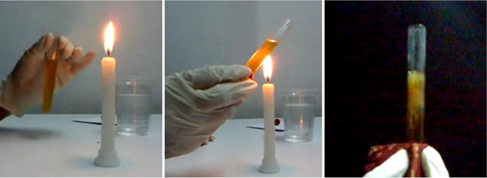
Half & Full Saturation Test:

Reagent:
- Saturated ammonium sulphate [(NH4)2SO4]: Add ammonium sulphate in 500 ml DI water till it stops dissolving.
- Ammonium sulphate [(NH4)2SO4] power

Principle
When ammonium sulphate is added to protein solution, water concentration decreases. This removes shell of water from outer surface of protein molecules, favoring formation of hydrogen bonds among protein molecules and causing their precipitation. While proteins like globulin, gelatin and casein are precipitated in half-saturated ammonium sulphate solutions, albumin is precipitated in full-saturated ammonium sulphate solution.

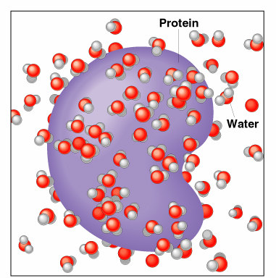

Protein molecules contain both hydrophilic & hydrophobic aminoacids.
In aqueous medium, hydrophobic amino acids form protected areas
while hydrophilic amino acids form hydrogen bonds with surrounding
water molecules (solvation layer).When proteins are present in salt solutions (e.g.ammonium sulfate), some of the water molecules in the solvation layer are attracted by salt ions. When salt concentration gradually increases, the number of water molecules in the solvation layer gradually decreases until protein molecules coagulate forming a precipitate; this is known as “salting out”.
For example,albumin requires higher salt concentration for
precipitation than casein or gelatin.Albumin particals are smaller in
size & so have larger surface area,so they hold more water molecules
around them.so a higher concentration of Ammonium sulphate is
required.The salt concentration used is described as 'half saturation'(for
casein,gelatin,globulin) or ' full saturation' (for albumin).
PROCEDURES
TEST | METHOD | OBSERVATION | INFERENCE
Biuret  test | - 10% NaOH (2 ml ) +  1% CuSO4 (2 ml)  - divide above mixture in two parts of 2 ml  - part 1: add 2 ml OS  part 2: add 2 ml H2O | Pink or Violet Colour develops in part 1. No such color develop in part 2 | Two or more peptide linkages present. Protein present
Xantho-proteic test | - OS (0.5 ml) + HNO3_{con} (1 ml) Mix it. (Solution turns yellow) + 40%NaOH (1 ml) in above mixture.  - Solution turns orange  Note: Use Fresh (tightly packed) conc.HNO otherwise test come negative. | Yellow-Orange colour develops. | Aromatic Amino Acids Tyrosine and Tryptophan present in protein.
Ninhydrin test | - OS (1 ml) +  1% Ninhydrine  (2 drops)  - Mix, Boil (1 min).  - Cool. | Blue or Purple colour develops. | Alpha Amino groups of proteins at N-terminal are responsible for positive test with proteins.
Aldehyde Test | - 1 ml Protein Solution ₊ 1 drop of 1:500 formalin. Mix.  - Slant the test tube and slowly add 1 ml of conc. H₂SO₄ . Mix.  - Add 1 drop of 1% sodium nitrite solution in Test tube. Mix.  - Use Fresh(tightly packed) conc.H2SO4 &1:500formaline otherwise test come negative. | Violet color is formed. | Indole group present in protein. Tryptophan present in the protein.
Million’s test | - 0.5 ml protein sol. +50 ul sodium nitrate sol.^{n}+100 ul Millon’s reagent. mix well & Heat | Red coloured precipitate 0bserved. | Hydroxyphenyl group present in protein. Tyrosine present in protein.
Sakaguchi test | 1 ml Protein sol.^{n} + 2 drops of alpha Napthol + 1 ml Alkaline sodium  Hypochloride | Carmine Red colour observed. | Guanidino group present in protein. Arginine present in protein.
Sulfur test (Lead acetate test) | - 0.5 ml OS + 0.5 ml Lead acetate reagent  - Boil for 1 minute | Black- Grey colour seen. | Sulfhydryl group (-SH) present in protein.  Cysteine & Cystine present in protein
Heat coagulation test | 5 ml Protein solution + add 2-3 drops of 1% acetic acid | White precipitates seen in upper part of solution, as compared to clear lower part of solution | Albumin is precipitated when denatured at its pI~5.4
Half saturation test | 2 ml of the protein sol.^{n} + 2 ml of saturated sol.^{n} of (NH₄)₂ SO₄ (Thus, saturated (NH₄)₂ SO₄ is half diluted) | White precipitate formed. | Casein, Gelatin and Globulin are precipitated at half saturation with (NH₄)₂ SO₄
Full saturation test | 5 ml. Of protein sol.^{n} + a pinch of Ammonium Sulphate powder, Shake  Repeat above steps till some undissolved (NH₄)₂ SO₄ remains at the bottom of the test tube. | White precipitate formed | Albumin precipitates at full saturation with (NH₄)₂ SO₄
Molisch’s test | - 1ml OS + 2 drops of α-napthol solution, mix  - Add 2 ml. of conc. Sulphuric acid carefully through the side of the test tube without shaking. | Purple ring is formed at the junction of acid and solution. | Proteins contain Carbohydrates

What you will do:
- Perform tests mentioned in table..
TEST |  | Albumin | Casein
Biuret Test | Observation
Biuret Test | + / --
Xantho-proteic test | Observation
Xantho-proteic test | + / --
Ninhydrine test | Observation
Ninhydrine test | + / --
Aldehyde test | Observation
Aldehyde test | + / --
Millon's Test | Observation
Millon's Test | + / --
Sakaguchi's Test | Observation
Sakaguchi's Test | + / --
Sulfur Test | Observation
Sulfur Test | + / --
Heat Coagulation Test | Observation
Heat Coagulation Test | + / --
Half saturation  test | Observation
Half saturation  test | + / --
Full saturation  test | Observation
Full saturation  test | + / --
Molisch’s test | Observation
Molisch’s test | + / --

TEST |  | Gelatin | Peptone
Biuret Test | Observation
Biuret Test | + / --
Xantho-proteic test | Observation
Xantho-proteic test | + / --
Ninhydrine test | Observation
Ninhydrine test | + / --
Aldehyde test | Observation
Aldehyde test | + / --
Millon's Test | Observation
Millon's Test | + / --
Sakaguchi's Test | Observation
Sakaguchi's Test | + / --
Sulfur Test | Observation
Sulfur Test | + / --
Heat Coagulation Test | Observation
Heat Coagulation Test | + / --
Half saturation  test | Observation
Half saturation  test | + / --
Full saturation  test | Observation
Full saturation  test | + / --
Molisch’s test | Observation
Molisch’s test | + / --

Questions
- Mention food sources of Albumin, Casein and Gelatin.
- Which of the Albumin, Casein and Gelatin is nutritionally best? Explain.
- If by mistake Ninhydrin touches your skin while doing the ninhydrin test, skin gets bluish stain. Explain.

4. Chemistry of lipids

Lipids are heterogeneous group of compounds soluble in non-polar solvents like chloroform but not soluble in polar solvents like water.
While body is water medium, lipids of body require specialized methods for digestion, absorption and transport.
Bile salts cause emulsification of oil due to their amphipathic nature and ability to reduce surface tension. Thus making bile salts essential for digestion and absorption of lipids of food.
Lipids of blood are transported as lipoproteins. Without lipoproteins, lipids would be insoluble is plasma (93% water).

Reagent
- Any oil : Ground nut oil, coconut oil
- Non polar Solvent : Acetone/ Methanol
- Bile salt solution : Dissolve 0.6 gm sodium deoxycholate in 100 ml DI water. Do not take tape water for making bile salt solution,Precipitation occur due to interference by calcium.

TEST | METHOD | OBSERVATION
Solubility of oil in water | - 0.1 ml of oil + 1 ml water, mix, for 15 sec. | Big oil drops are observed
Solubility of oil in non-polar solvent | - 0.1 ml of oil + 1 ml Acetone/Methanol, mix, for 15 sec. | oil droplets are not observed
Emulsification of oil in Bile salts. | - Take 2 test tubes T1 and T2  - Take 1 ml H2O in T1 test tube.  - Take 1 ml Bile salt solution(Sodium deoxycholate solution) in T2 test tube.  - Add 0.1 ml of oil in T1and T2.  - Mix T1 & T2,all together for 15 sec. against palm of your hand. | Compare size of oil drops and turbidity immediately  .  T1: Big oil drops, Clear water(Compared to T2)  T2: Small oil drops, Turbid solution (Compared to T1)

What will you do:
- Perform the test shown above with the oil provided. Draw table showing the tests and your observations.

TEST | OBSERVATION | INTERFERENCE
Solubility of oil in water
Solubility of oil in non-polar solvent
Emulsification of oil in Bile salts.

Structure of bile salt

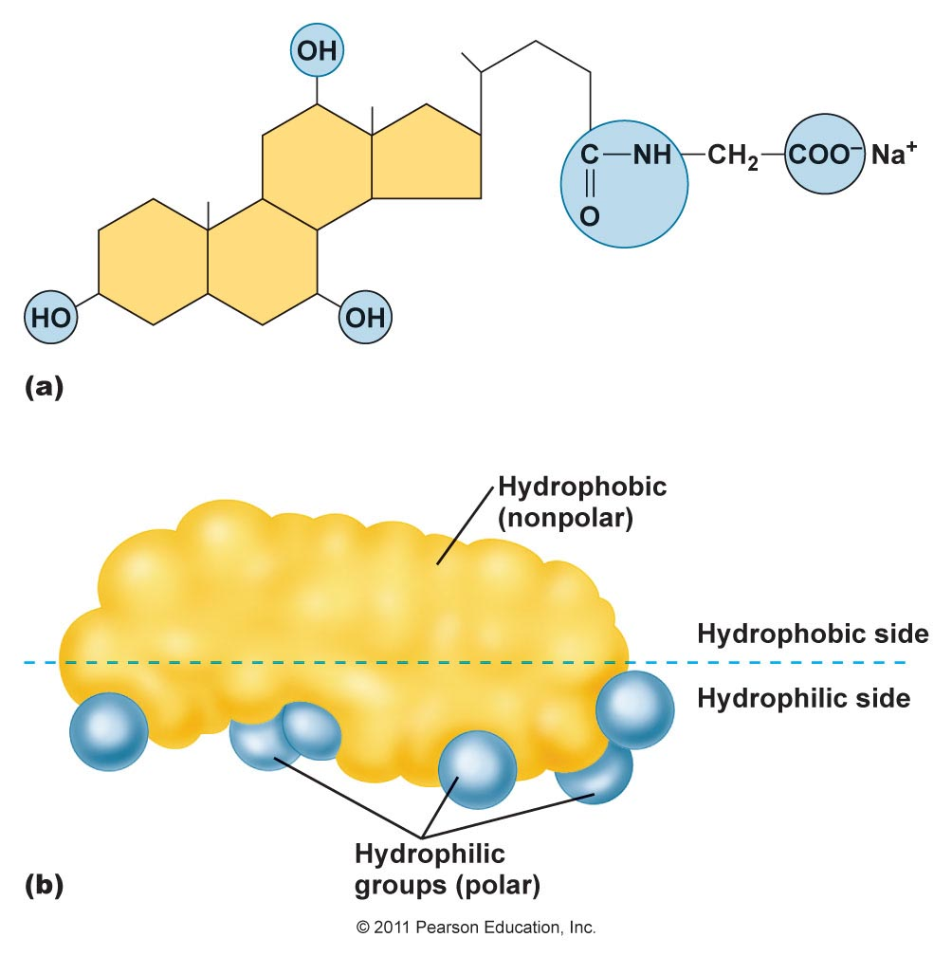

Structure of an oil droplet in a bile salt solution.
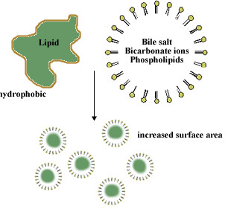
Structure of a micelle.

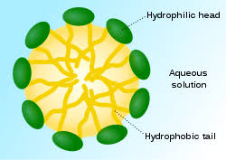
Structure of a lipoprotein particle.
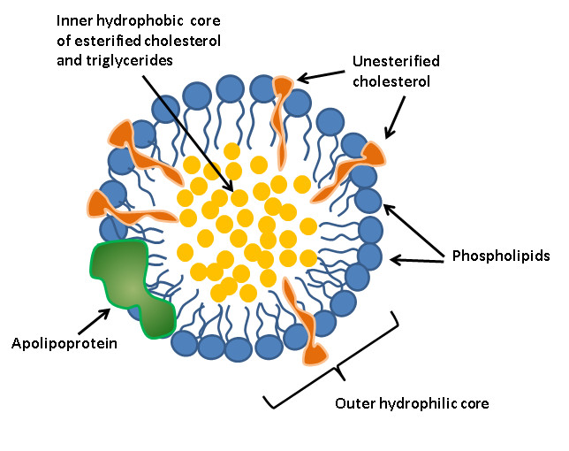
Questions
Questions
- Write the function of Micelle.
- Write the functions of Lipoprotein.
- Write the functions of bile salts in Lipid digestion.

5. Physiological Urine
Artificial Urine sample:
Ammonium sulfate 2 gm
Sodium phosphate dibasic(monobasic 2 gm
Pottasium dihydrogen phosphate 2 gm
Urea powder 2 gm
creatinine powder 2 gm
Uric acid powder 1 gm
Calcium carbonate/Calcium chloride : 1 gm.
NaCl 4 gm,
And make upto 2 liters

Physical characteristics of urine
Volume:
Normal adult excretes 800-2000 ml of urine daily
Factors affecting urine volume:
- According to quantity of fluid ingested
- Environment temperature
- Physical activity
- Loss of water in feces, via skin, in vomitus etc.
Collection of urine to measure volume:
Discard the first morning urine. Then collect urine during each micturition in a vessel up to, including the next morning urine.
Some conditions with increased urine volume:
  - Diabetes mellitus
  - Diabetes insipidus (low specific gravity of urine)
  - Diuretics drug therapy
Some conditions with decreased urine volume:
  - Dehydration
  - Renal failure
Appearance:
Normal urine is clear and transparent when freshly voided. On standing bacterial urease converts urea into CO2 and Ammonia. Ammonia makes urine alkaline. Phosphates precipitate in alkaline urine making it turbid.
Color:
Fresh urine is amber yellow. This colour is due to urobillin.
Odour:
Fresh urine has an aromatic odor due to presence of volatile organic acids produced by body and intestinal bacteria.
Reaction:
Fresh urine is normally acidic (pH<7.0). Post-prandial urine is alkaline due to secretion of HCl in stomach, the condition known as “Alkaline Tide”.
Specific gravity:
Normal range-1.003 to 1.035 gm/ml of urine. The greater the amount of solutes per unit volume of urine, the greater the specific gravity. It is high in diabetes mellitus, while low in diabetes insipidus.
Determination of specific gravity: Wipe the urinometer by a filter paper and allow it to float in the urine contained in the cylinder. See carefully that the apparatus do not touch the sides or bottom of the cylinder, when it is at rest take the reading from lower meniscus (true surface) of urine. Note the temperature of urine. If it differs from the standard temperature written on the urinometer, add one unit (0.001) for every 3 degree rise from the standard temperature.

Chemical analysis of urine
A. Inorganic Chemical constituents
Ammonia:
Reagent:
- 1% phenolphthalein : Dissolve 0.5 gm of phenolphthalein in 50 ml of methanol. Phenolphthalein is insoluble in water
- 2% sodium carbonate : Dissolve 10 gm of sodium carbonate in 500 ml of water
Principle:
Urinary ammonia is derived from glutamine in kidney. It is secreted as a buffer against H+ secreted by tubules.

NH4⁺ + OH⁻ → NH3 + H2O

On heating NH3 evaporate, dissolve in water around a glass road and make it alkaline. At alkaline pH phenolphthalein ions are formed which is pink coloured.
Phenolphthalein is a weak acid, which can lose H+ ions in solution. The phenolphthalein molecule(HIn) is colorless, and the phenolphthalein ion( In⁻) is pink. When a base is added to the phenolphthalein, the molecule ⇌ ions equilibrium shifts to the right, leading to more ionization as H+ ions are removed.

HIn --------------------------------------> H⁺ + In⁻
colourless PH >8.2 Red colour

For phenolphthalein: pH 8.2 = colorless; pH 10 = red
Procedure:
- Take 2 ml urine in a test tube and add a drop of phenolphthalein. Add drop wise 2% sodium carbonate solution till the solution turns faint pink. Boil and hold a glass rod dipped in phenolphthalein at the mouth of the test tube. Phenolphthalein turns pink due to gaseous ammonia.

Chloride:
Note:Conc.HNO3 is Hazardous. This test is of Demonstrated only.
Reagent:
- Concentrated HNO3
- 3% AgNO3 : Dissolve 0.3 gm of AgNO3 in 10 ml of water.
Principle:
AgNO3(aq) + NaCl(aq) → AgCl(s) + NaNO3(aq)
White precipitation
When acidified urine reacts with silver nitrate,a white precipitate of silver chloride is formed.
Procedure:
- [2 ml of urine] + [0.5 ml concentrated HNO3] + [0.5 ml 3% AgNO3]
- Curdy white precipitate of AgCl is formed.
- (Concentrated HNO3 is added to prevent precipitation of urate and acid phosphates by AgNO3)

Calcium:
Reagent:
Saturated ammonium oxalate solution: Dissolve ammonium oxalate powder in 100 ml of water till it become undissolved.
Principle:
Calcium precipitated as insoluble calcium oxalate with ammonium oxalate.
CaCl2(aq) + (NH4)2C2O4(aq) → CaC2O4(s) + 2 NH4Cl(aq)

Procedure:
- Sulkowitch Test: To 0.5 ml urine and add 1 drop of saturated ammonium oxalate solution.Calcium precipitated as insoluble calcium oxalate is observed as turbidity.

Phosphorus:
Note:Conc.HNO3 is Hazardous. This test is of Demonstrated only.
Reagent:
- Concentrated HNO3
- 5% Ammonium Molybdate : Dissolve 2.5 gm of Ammonium Molybdate in 50 ml of water.

Principle:Inorganic phosphorus reacts with ammonium molybdate in an acidic medium to form a phosphomolybdate complex.

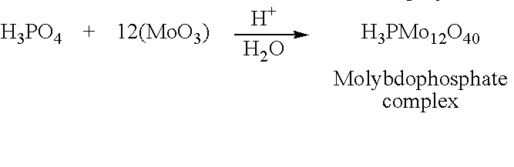
Procedure:
- [1 ml of urine] + [0.5 ml concentrated HNO3] + [1 ml of 5% Ammonium Molybdate], Heat
Canary yellow precipitate of Ammonium phosphomolybdate are formed

Sulphate:
Reagent:
- 1 % HCL : Take 1 ml of concentrated HCL & make upto 100 ml
- 10% Barium chloride :Dissolve 50 gm of Barium chloride in 500 ml of water

Principle:
HCL
SO₄⁻² + BaCl2 ------------------→BaSO4 + KCL

Procedure:
[1 ml urine] + [3 drops 1 % diluted HCL] + [ 6drops of 10% Barium chloride].
White precipitate of BaSO4 are formed.

B.Organic Chemical constituents

Urea:
(Specific Urease Test)
Reagent:
1% phenolphthalein :Dissolve 1 gm of phenolphthalein in 100 ml methanol
Principle:
Urea NH3 + CO2
Urease
CO2 evaporates.

NH3 + H2O NH4⁺ + OH⁻

In this reaction the liberation of NH3 changes the pH to alkaline side, turning phenolphthalein to pink colour.

Procedure:
[2 ml Urine] + [2 drops phenolphthalein]
Add 2% Na2CO3 till faint pink color is seen.
Add acetic acid, one drop at a time, with mixing, till faint pink color just disappears.
Add a spatula of Urease powder( Jack Bean Meal Powder), mix.
Pink color develops after few minutes.

Uric acid:
Phosphotungstic acid reduction test:
Reagent:
- 20% Sodium carbonate: Dissolve 20gm of sodium carbonate in 100ml of water
- Phosphotungstic acid Reagent :
Stock : Dissolve 50 gm of sodium tungstate in 400 ml of water & add 40ml of 85% phosphoric acid .Heat this solution for 5 minute in microwave oven. Dilute it 5 times with water.
Principle:
Uric acid is reducing agent in alkaline medium.It reduced phosphotungstic acid into tungsten blue.
Procedure
To 2.5 ml of urine add 0.5 ml of sodium carbonate and 0.5 ml of Phosphotungstic acid reagent working reagent.

Creatinine
Reagent:
Alkaline picrate reagent:
Mix R1 and R2 1:1 to make working alkaline picrate reagent.
Principle: Creatinine forms creatinine picrate in alkaline medium which is orange in colour.
Procedure: 1 ml alkaline picrate solution + 1 drop of urine & mix.

Physical Characteristics of Urine.

Physical characteristics of urine | Observation | Interference
Volume
Appearance
Colour
Odour
Reaction
Specific gravity

Inorganic constituents of urine.

Inorganic constituents of Urine | Observation | Interference
Ammonia
Chloride
Calcium
Phosphorus
Sulphate

Organic constituents of urine

Organic constituents of Urine | Observation | Interference
Urea
Uric acid
Creatinine

6. Pathological Urine

Appearance:
Turbid: infection (cells make urine turbid)
Color:
Yellow: Hepatic jaundice & obstructive jaundice (Conjugated bilirubin)
Red: Hematuria, rifampicin therapy
Red on exposure to air: porphyria
Black on exposure to air: alkaptonuria
Odour:
Fruity: diabetic ketoacidosis (acetone)
Mousy smell: Phenylketonuria. (Phenylacetyl glutamine)
Foul smell: Urinary tract infections. (H2S etc.)
Specific Gravity :

High Specific Gravity
- Diabetes mellitus
- Diarrohea
- Dehydration

Low Specific Gravity
- Diabetes insipidus.
- Renal failure
- Excessive fluid intake
- Acute tubular necrosis

Abnormal Constituents of Urine
I.Protein:
Reagent :
A. Sample preparation :
- 10 mg% albumin :Take 1 ml serum in 500 ml DI water.
- 50 mg% albumin: Take 5 ml serum in 495 ml DI water.
- 100 mg% albumin: Take 10 ml serum in 490 ml DI water.
B.1% acetic acid
- 5 ml of acetic acid in 500 ml of water
C. 30% Sulphosalisylic acid:
- Dissolve 150 gm of Sulphosalisylic acid in 500 ml of water.

Proteinuria and albuminuria
Proteinuria
Normal Adult | <150 mg /day
Proteinuria | >=150 mg /day
Proteinuria | >3500 mg / day
Albuminuria
Normal Adult | <30 mg /day
Microalbuminuria | 30-300 mg /day
Macroalbuminuria | >300 mg /day

Albumin (Filtered but not reabsorbed) and Tamm-Horsfall protein (secreted by renal tubules) are normally present.

Causes of Proteinuria:
- Pre-renal: (overload proteinuria)
  - (Many non-Albumin proteins)
  - Multiple myeloma (light chains of immunoglobulins)
  - Severe hemolysis (Hemoglobin)
  - Severe muscle injury (Myoglobinuria)
- Renal:Glomerular diseases (Mainly albumin, being small)
  - After streptococcal infection
  - Diabetes mellitus
  - Hypertension
  - Lipoid Nephrosis (Nephrotic range proteinuria)
  - Tubular diseases (decreased reabsorption of proteins)
  - (Small, normally reabsorbed, proteins like Beta2 microglobulin, Retinol Binding protein)
  - Tubular necrosis due to Drugs and toxins
- Post Renal: (various blood and cellular proteins)
  - Bleeding in urinary tract
  - Infection in urinary tract
  - Tumor in urinary tract

Other causes:
  - Postural: on standing posture.
  - Exposure to cold, physical activity, fever.
  - Last weeks of pregnancy

Heat coagulation Test:
Principle :
Proteins have net zero charge at their iso-electric pH (pI). So, at pI, protein molecules have minimum repelling force. Thus proteins are easily precipitated at pI.
When proteins are heated, weak bonds like hydrogen-bonds, salt bonds and van-der-wal forces are broken. Proteins are said to be denatured.Core hydrophobic regions of denatured Albumin can form intermolecular associations and cause precipitation.Thus, in order to precipitate proteins like albumin, two conditions are required.
- Bring albumin to its pI(5.4) by adding few drops of 1% acetic acid
- Heat the solution
Procedure :
Fill 3/4 th of the test tube with urine sample,Heat the upper part on the flame till either turbidity appears or urine starts boiling.Then add few drops of 1% acetic acid if turbidity develops & note change.

In case of multiple myeloma, light chains of immunoglobulin precipitate between 40-60 degrees centigrade. With further heating turbidity disappears. Turbidity appears again on cooling to 40-60 degree centigrade.

Sulphosalisylic Test:

Principle
Test is based on the precipitation of urine protein by a strong acid, sulfosalicylic acid. Precipitation of protein in the sample seen as increasing turbidity.Unlike the routine urine protein chemistry dipstick pad, the SSA reaction will detect globulin and Bence-Jones proteins, in addition to albumin.
Method:
3 ml of urine + 0.3 ml of 30% Sulphosalisylic acid, mix.
Turbidity indicates presence of urinary proteins.
Iodinated contrast agents used for evaluation of renal disorders can give the test positive.
False positives:
- X-ray contrast media
- High concentration of antibiotics, such as penicillin and cephalosporin derivatives.
False negatives:
- Highly buffered alkaline urine. (The urine may require acidification to a pH of 7.0 before performing the SSA test.)
- Dilute urine
- Turbid urine - may mask a positive reaction. Again, best practice is to always used supernatant from a properly spun urine sample.

Dip-Stick Test:
Principle
Testing for protein is based on the phenomenon called the "Protein Error of Indicators" (ability of protein to alter the color of some acid-base indicators without altering the pH).
This principle is based on the fact that proteins alter the colour of some pH indicators even though the pH of the media remains constant. This occurs because proteins (and particularly albumin) acquire hydrogen ions at the expense of the indicator as the protein’s amino groups are highly efficient acceptors of H+ ions.
Indicator-H+(Yellow) + Protein → Indicator(Blue-green) + Protein-H+
At pH 3 and in the absence of proteins both indicators are yellow, as protein concentration increases the colour changes through various shades of green until it becomes a dark blue.
According to the manufacturer, the strip’s protein pad contains tetrabromophenol blue or 3',3,5',5-tetrachlorophenol-3,4,5,5-tetrabromosulphonphthalein, as well as an acid buffer substance to maintain pH at a constant level.
The main problem with the protein tests found on urine test strips is that very alkali urine can neutralise the acid buffer and produce a false positive reading that is unrelated to the presence of proteins. Another similar error occurs if the strip is left submerged in the urine sample for too long.

This method is more sensitive to albumin than to globulin, Bence Jones protein and mucoprotein are examples of globulin components that are sometimes present in urine, but are not distinguishable by the dipstick method for protein

Method: Dip the strip for Albumin in urine. Drain excess urine from strip. Read the color chart. (Read instruction manual provided with the strips for time of reading after dip).
Because the dipstick test detect albumin, it can not identify many pre-renal proteinuria caused by Hb, Mb and light chains of Igs.
All the three tests mentioned above are qualitative and used for screening proteinuria and albuminuria. Once proteinuria is found quantitative estimation of proteinuria and albuminuria is required for clinical decision making.

What Will You Do:
Perform all three tests with urine. Draw table of your observations.

Sr. no | Concentration | Heat coagulation test | Dipstick test | Sulphosalisylic acid | Interference
1 | 10 mg %
2 | 50 mg %
3 | 100 mg %
4 | Urine sample

Question
Q-1.Which of the three tests is most sensitive?
Q-2.Write biochemical explanation of proteinuria in diabetes mellitus and hypertension.

II.Acetone & acetoacetic acid (Ketone Bodies):
Reagent
- Ammonium sulphate powder
- Small crystals of sodium nitroprusside
- liquor Ammonia
- Rothera’s powdered reagent :
Sodium Nitroprusside 1 gm
Sodium carbonate 20 gm
Ammonium sulphate 20 gm

Mix & grind all in fine particales & stored in air-tight container.

Sample Preparation
- 0.1 ml/L Acetone : Take 0.1 ml Acetone in 1000 ml DI water.
- 1 ml/L Acetone : Take 1 ml of Acetone in 1000 ml DI water.
- 10 ml/L Acetone : Take 10 ml of Acetone in 1000 ml DI water.

Principle
Acetoacetic acid and acetone form a violet coloured complex with sodium nitroprusside in alkaline medium. Acetoacetic acid reacts more sensitively than acetone. Values of 10 mg/dl of acetoacetic acid or 50 mg/dl acetone are indicated. Phenylketones in higher concentrations interfere with the test, and will produce deviating colours. ß-hydroxybutyric acid (not a ketone) is not detected.

Sodium Nitroprusside : acetone form a violet coloured complex with sodium nitroprusside in alkaline medium
Sodium carbonate: Provide Alkaline medium
Ammonium sulphate : Precipitate other protein which give purple colour with sodium nitroprusside & make solution Heavier than liquire Ammonia, so Ammonia may be remain on top of solution ,so purple ring is formed.

Rothera’s test, liquid reagent

Saturate 2ml urine with ammonium sulphate powder.
Add a small crystal of sodium nitroprusside. Mix.
Add 0.5 ml liquor ammonia by side of the tube to form a ring.
Permanganate/Purple color ring is formed
Rothera’s test, powdered reagent

Take a pinch of Rothera’s powdered reagent
Add 1-2 drops of urine on powder.
Permanganate/purple color is formed
What Will You Do:
Perform both tests with given sample of urine.
Perform both tests with 0.1ml/L , 1/ml/L , 10 ml/L acetone

Sr. no | Concentration | Rothera’s test,powder reagent | Rothera’s test, Liquid reagent | Interference
1 | 0.1 ml/L
2 | 1 ml/L
3 | 10 ml/L
4 | Urine sample

Perform both tests with given sample of urine.
Perform both tests with 0.1ml/L , 1/ml/L , 10 ml/L Acetoacetate

Sr. no | Concentration | Rothera’s test,powder reagent | Rothera’s test, Liquid reagent | Interference
1 | 0.1 ml/L
2 | 1 ml/L
3 | 10 ml/L
4 | Urine sample

Question
Q-1.Which other tests in blood and urine are usually done when tests for ketone bodies are positive?
III.Bile Salts:
Reagent
Bile salt sample : Dissolve 2 gm of Bile salt powder into 1000 ml of water.
Sulfur powder
Principle
Sulphur powder is non-polar. It floats on water surface due to surface tension of water. Bile salt reduces surface tension of water and thereby sulphur powder sinks.
Procedure
Hay’s sulfur flower Test:
Sprinkle a pinch of sulfur powder over 2 ml urine in a test tube & Sprinkle a pinch of sulfur powder over 2 ml Water in a test tube. Observed & compare immediately without shaking of test tubes.
sulfur powder sink to the bottom of the test tube if bile salts are present.

What Will You Do:

Perform the Hay’s sulfur flower test with given sample

Sample | Observation | Interference
Bile salt solution
Water
Urine sample

IV : Glucose

Perform both tests with 100 mg%, 500 mg%, 1 gm% glucose.
Glucose % | Benedict’s Test color | GOD Strip test color | Interference
100mg%
500 mg%
1000mg%
Urine Sample

7. Estimation of acid output by stomach.

Parietal cells of gastric mucosa secrete H+ using H⁺-K⁺-ATPase.
Gastrin, acetylcholine (from vagus) and histamine stimulate H+ secretion.

Thus, abnormality of parietal cells, G cells and Vegas are important in disturbances of gastric acid secretion.

Collection of Gastric juice for Analysis
Preparation of the Patient:
1. Patient should be fasting 10 to 12 hours (preferably since bed time night before).
2. Patient should have not received any medications specially anticholinergic agent, H2 blocker, Antacids since night before as they are liable to alter the results.
3. Procedure should be explained to the patient in simple words.

Procedure:
- Remove dentures if there are any from patient’s mouth.Take the Nasogastric tube and lubricate it.
- Check patient’s nostrils and choose the one (while patient still sitting up right with neck flexed) through which breathing is easier and nostril is wider.
- Begin intubation by gently pushing the tube, some times tube gets-curled up in the pharynx and there is excessive coughing or gaging which may prevent further passage, at this time tube is drawn back a few inches, patient, is reassured and intubation is resumed.
- During this insertion patient is instructed to swallow and continue to swallow throughout the intubation period.
- After the tube has progressed to approximately 40 cm (the first mark on the tube), the head may be allowed to resume its comfortable position.
- Continue intubation by gently pushing the tube with the patient still swallowing until the fourth mark or 65 cm is reached.
- Tape the tube to the patient’s nose with adhesive tape. At this point patient is sent to the X-ray for fluoroscopy to check position.
- The tube should lie along the lesser curvature with the tip in the antrum of the stomach.
- In patient with partial gastrectomy tip of tube should be in the most dependent portion of the stomach.

Collection of Gastric Juice For Analysis
- Empty the stomach of its contents with a 50 cc. Syringe.
- After recording the pH volume and colour, this residual volume may be discarded.
- After emptying stomach of the residual volume, collection of gastric juice is begun under Basal conditions.
- At least four samples are collected each 15 minutes apart in separate containers.
- Collection may be carried out either manually with the syringe or by using a suction pump.
- During this procedure patency of nasogastric tube is maintained by injecting about 50 cc of air down the tube.
- Gastric fluid specimen should be spot checked as a guide to whether the patient is making-acid or is achiorohydric.
- After having collected gastric juice under basal conditions augmented or stimulated gastric analysis may be carried out as follows:
- Pentagastrin administered by sub-cutaneous injection in the dose 6 mg per kg body weight. It is a synthetic peptide having the biologically active sequence of gastrin. The Gastric secreation is collected every 15 minutes for next 1 hour.
1. Basal acid output (B.A.0):
It is the acid output in milimol per hour in the basal secretion.
2. Maximal acid output (M.A.0)
It is the acid output in milimol per hour, given by the sum of acid output of the four 15 minute sample after the stimulation.

Hypochlorhydria: (decreased acid output, pH>4)

Pernicious anemia

Autoimmunity to parietal cells destroys them.
- Antibodies to Na+-K+-ATPase are found
- Chronic Helicobacter Pylori infection of gastric mucosa.
- Treatment with Proton pump inhibitors, H2-Blocker
- Vagotomy
Hyperchlorhydria: (increased acid output)
- Zollinger-Ellision Syndrome

G cells tumors in GIT
Reagent
- 0.1 mol/L NaOH : Dissolve 20 gm of NaOH in 5000 ml of water
- 1 % phenolphthalein : Dissolve 1 gm of phenolphthalein in 100 ml methanol

Sample preparation
Gastric juice Sample : 0.1mol/L HCL solution
How 0.1 mol/L HcL will be prepared?
1000ml of HCL solution contain=11.5 mol H⁺
??????? =0.08 mol H⁺
=1000x0.1/11.5
=8.6 ml
So add 17 ml of concentrated HCL & make upto 2 liter with water.

Examples

Example-1:
If you want your result will be Gastric Acid Output (mmol/hr) = 5 mmol/hr and You give Fasting Gastric juice output in 1 hour =100 ml/hr then prepare gastric juice sample as follow,

Fasting Gastric juice output =100 ml/hr
BAO = 5 mmol/L

100 ml of fasting gastric juice contain = 5 mmol/L HCL
1000 ml of fasting gastric juice contain = ???
= 1000 x 5
-----------
100
= 50 mmol/L HCL
= 0.05 mol/L HCL
Now We use fixed 10 ml of Gastric juice sample & titrate with fixed 0.1 mol/L NaOH
10 ml of 0.05 mol/L HCL =-------ml of 0.1 mol/L NaOH
V1=10 ml of Gastric juice V2=???? ml of NaOH
NI=0.05 mol/L HCL N2=0.1 mol/L NaOH

V2=10 x 0.05/0.1
=5 ml of 0.1 mol/L NaoH
Thus 5 ml of 0.1 mol/L NaOH is required to titrate 10 ml of 0.05 mol/L HCL.

Now ,Check your sample of gastric juice is made proper or not by following formula,

Gastric Acid Output =
[Average Reading R] *[Gastric Juice Output in one hour] ---------------------------------------------------------------------
100
We require 5 ml of NaOH & give 100 ml/hr Gastric output,so our result is
Gastric Acid Output = 5 x 100/100
=5 mmol/hr ,that is our BAO.

Example-2:
If you want your result will be Gastric Acid Output (mmol/hr) = 8 mmol/hr and You give Fasting Gastric juice output in 1 hour =80 ml/hr then prepare gastric juice sample as follow,

Fasting Gastric juice output =80 ml/hr
BAO = 8 mmol/L

80 ml of fasting gastric juice contain = 8 mmol/L HCL
1000 ml of fasting gastric juice contain = ???
= 1000 x 8/80
= 100mmol/L HCL
= 0.1 mol/L HCL
Thus Take 8.6 ml of Concentrated HCL solution and make upto 1000ml with water is made to 8.6 mol/L HCL solution.
Now We use fixed 10 ml of Gastric juice sample & titrate with fixed 0.1 mol/L NaOH

10 ml of 0.1 mol/L HCL = __________ ml of 0.1 mol/L NaOH
V1=10 ml of Gastric juice V2=???? ml of NaOH
NI=0.08 mol/L HCL N2=0.1 mol/L NaOH

V2 =10 x 0.1/0.1
=10 ml of 0.1 mol/L NaoH
Thus 10 ml of 0.1 mol/L NaOH is required to titrate 10 ml of 0.1 mol/L HCL.

Now , Check your sample of gastric juice is made proper or not by following formula,

Gastric Acid Output = [Average Reading R]* [Gastric Juice Output in one hour] ---------------------------------------------------------------------
100

We require 10 ml of NaOH & give 80 ml/hr Gastric output, so our result is Gastric Acid Output = 10 x 80/100
= 8 mmol/hr ,that is our BAO.

Principle:

Acid output in stomach is measured as mmol/hour. For its measurement, amount of gastric juice output as well as amount of acid in gastric juice needs to be measured.

Amount of Gastric juice output is measured by suction of gastric juice using Ryle’s tube inserted in to stomach.

Amount of acid in gastric juice is measured as follows.
Free Acidity:
Due to H+ ions.
Combined Acidity:
Some of the H+ in gastric juice are bound to other anions like proteins and lactic acids at low pH of Gastric Juice. These represent combined acidity.
(Proteins-).(H+) , (Lactate-).(H+)
Free Acidity + Combined Acidity = Total acidity
On addition of alkali, initially free H+ and later on combined H+ are neutralized.
When not much H+ remain in solution (at pH 8.6), Phenolphthalein indicator becomes pink. The requirement of alkali is used to calculate acid output.

Procedure:
First Reading:
- Step 1
Take10 ml gastric juice in a flask/beaker.
Add 1 drop of phenolphthalein.(Do not mouth pipette anything)
- Step 2
Fill burette with 0.1 mol/L NaOH up to zero mark.
Perform as follows.
- Step 3
Add 1 ml of NaOH from burette, mix, and watch for pink color.
Repeat above step till pink color develops.
Suppose reading is X₁ ml of NaOH
Second Reading:
- Repeat-step 1 and step-2 of first reading.
- Add [X₁ - 1] ml of NaOH from burette mix.
- Add NaOH drop wise till pink color develops.
- Take Reading will be X_{2.}
Third Reading:
- Repeat-step 1 and step-2 of first reading.
- Add [X₂ - 1] ml of NaOH from burette mix.
- Add NaOH drop wise till pink color develops.
- Take Reading will be X_{3.}
Find Average(R) of X₂ & X₃ .

Calculation:Explanation of calculation:

1 mol NaOH ≡ 1 mol HCl
R ml of 0.1 mol/L NaOH ≡ R ml of 0.1 mol/L HCl
≡ R /10 ml of 1 mol/L HCl
≡ R /(10*1000) mol/ ml of HCl
≡ (R /10)mmol/ml of HCl

Thus, 10 ml of Gastric Juice will have (R/10) mmol HCl equivalents.
Thus, 1 ml of Gastric Juice will have (R/100) mmol HCl equivalents.

Gastric acid output = (R/100) * G mmol/hr
G = Gastric Juice Output (ml/hr)
Normal Gastric Juice Output (ml/hr) = 80 ml/hr

Result:
Gastric Acid Output = [Average Reading R]* [Gastric Juice Output in one hour] (mmol/hr) -------------------------------------------------------------
100

Reference Ranges:
- Fasting Gastric Juice Output: 20-100 ml /hr
- Basal Acid Output (BAO): Measured in fasting state
- Normal 1-6 mmol/hr
- ZE Syndrome >15 mmol/hr (M)
>10 mmol/hr (F)
- Maximum Acid Output (MAO): Measured after pentagastrin stimulation
          - Normal 5-40 mmol/hr

In pernicious anemia, both MAO and BAO are almost zero.
Above reference ranges are not universally accepted. Serum gastrin level, pH of gastric juice and other clinical finding e.g megaloblastic anemia are important to establish diagnosis.

What will you do:

Estimate gastric acid output in given sample or gastric juice.
Consider Gastric juice output 80 ml/hr.

Initial reading (X) | Next reading (Y) | Volume of NaOH used (X-Y) ml
Average of (X-Y)

Gastric Acid Output = [Average Reading R] * [Gastric Juice Output in one hour]
------------------------------------------------------------------ 100

Result : Your Gastric acid output is --------------------------

Comment on your result:

Questions
Q-1 What is Zollinger-Ellision syndrome?
Q-2 What happens to Gastric acid output in the ZE syndrome? Why?
Q-3 Write complications of the ZE syndrome.
Q-4 Write cause of destruction of parietal cells in pernicious anemia.
Q-5 What happens to Gastric acid output in the pernicious anemia? Why?
Q-6 Which other important products are formed and secreted by parietal cells?
Q-7 Why should destruction of parietal cell lead to anemia?
Q-8 What is difference between gastrin and pentagastrin.
Q-9 Both pernicious anemia and ZE syndrome result in high serum gastrin level. Explain.
Q-10 Explain mechanism of action and use of ranitidine and omeprazole as drugs.

8.Secretion and buffering of acids by kidney.

Reagent
- 1 % phenolphthalein :Dissolve 0.5 gm of phenolphthalein in 50 ml of Methanol.
- Neutral formalin (formaldehyde):Take 500ml of formaldehyde & add 0.1ml of phenolphthalein in solution. Then add 0.1 mol/L NaOH till colorless formaldehyde solution become slight pink coloured.
- 0.1mol/L NaOH : Dissolve 20 gm of NaOH & make upto 5000 ml with Water.

Urine Sample Preparation:

Urine output ml/day = U
Titrable acidity mmol/day = A

A
Take ---- x 68 gm of KH₂PO₄ MW of KH₂PO₄ = 68 gm/L
U

Ammonia bound acidity mmol/day = B

B
Take ---- x 66 gm of (NH₄)₂SO₄ MW of (NH₄)₂SO₄ = 132 gm/L
U

Here two NH4+ is released when 1 molecule of (NH₄)₂SO₄ will be dissociated.

Example
You want to give Titrable acidity = 30 mmol HCL /day &
Ammonia bound acidity = 40 mmol HCl /day ,then prepare Urine sample as follow,

Urine output U = 1500 ml/day
Titrable acidity mmol/day A = 30 mmol HCL/day
= A/U x 68
=30/1500 x 68
=1.36 gm of KH₂PO₄

Ammonia Bound acidity mmol/day B = 40 mmol HCL/day
= B/U x 66
=40/1500 x 66
=1.76 gm of (NH₄)₂SO₄

Finally dissolve 1.36 gm of KH₂PO₄ and 1.76 gm of (NH₄)₂SO₄ & make upto 1000 ml with water.
Principle:

Catabolism of food substances produces H+ and OH-. In the process, there is excess of H+ over OH-. Excess H+ is excreted by kidney. NH3 and Phosphate buffer the H+ secreted by renal tubules.
NH3 + H+ -------------→ NH4+ ----(1)

HPO42- + H+ -------------→ H2PO4- ----(2)

You will estimate total Acids in urine and proportions buffered by ammonia and phosphate.
Correlate the experiment with theoretical concepts of renal regulation of pH learnt in the classroom.

pK of reaction (1) is 9.25.
pK of reaction (2) is 6.8.
For phenolphthalein: pH 8.2 = colorless; pH 10 = red

HIn --------------------------------------> H⁺ + In⁻
colourless PH >8.2 Red colour

Phenolphthalein is a weak acid, which can lose H+ ions in solution. The phenolphthalein molecule(HIn) is colorless, and the phenolphthalein ion( In⁻) is pink. When a base is added to the phenolphthalein, the molecule ⇌ ions equilibrium shifts to the right, leading to more ionization as H+ ions are removed.

When urine, acidic in nature, is titrated with NaOH, initially reaction (2) goes towards left. When all H2PO₄⁻ is converted into HPO₄²⁻, pH rises to 8.6, causing ionization of phenolphthalein .Phenolphathalein ion produced pink colour,so solution turn into pink coloured. NaOH required to reach this stage represent H+ bound to phosphate, called “Titrable Acidity”.

Neutral formalin is added to urine. We will convert formalin (Acid) to Neutral formalin, otherwise formalin(acid) itself react with NaOH when we measure H⁺ of NH₄^{+.}
Now, Formaldehyde is added to urine. Following reaction occur.

4NH₄Cl + 6HCHO → N₄(CH₂)6 + 6H₂O + HCl ---- (3)

Released H+ decrease pH of urine, making phenolphthalein colorless again.Further titration with NaOH, till phenolphthalein become pink, will actually represent H+ bound with ammonia released during reaction (3). It is called “Ammonia bound acidity”.
H+ bound to NH3 can not be titrated without adding formaldehyde. Hence, H+ bound to phosphate is called titrable acidity.
Procedure:
First Reading:
- Step -1
  - Take 25 ml urine in a flask/beaker.
  - Add 1 drop of phenolphthalein.(Do not mouth pipette anything)
- Step - 2
  - Fill burette with 0.1 mol/L NaOH up to zero mark.
- Step - 3
  - Perform as follows.
  - Add 1 ml of NaOH from burette, mix, and watch for pink color.
  - Repeat above step (adding 1 ml NaOH) till pink color develops.
  - Suppose reading is X₁ ml of NaOH
- Step - 4
  - Add 10 ml of neutral formalin & Mix.
  - The pink color disappears.
  - Repeat step-3.
  - Suppose the reading is Y₁
Second Reading:
- Repeat-step 1 and step-2 of above.
- Add [X₁ - 1] ml of NaOH from burette & mix.
- Add NaOH drop wise till pink color develops.
- Take reading X₂.
- Add 10 ml of neutral formalin & Mix.
- Add [Y₁-1] ml of NaOH from burette & Mix.
- Add NaOH one drop wise till pink color develops. Take reading Y₂.
Third Reading:
- Repeat-step 1 and step-2 of above.
- Add [X₂ - 1] ml of NaOH from burette & mix.
- Add NaOH drop wise till pink color develops.
- Take reading X₃.
- Add 10 ml of neutral formalin & Mix.
- Add [Y₂-1] ml of NaOH from burette & Mix.
- Add NaOH one drop wise till pink color develops. Take reading Y₃.
Find X (Average of X₂ & X₃ ) and Y (Average of Y₂ & Y₃ ) .

Explanation of calculation:

Titrable acidity: reading X ml

1 mol NaOH ≡ 1 mol HCl
X ml of 0.1 mol/L NaOH ≡ X ml of 0.1 mol/L HCl
≡ X /10 ml of 1 mol/L HCl
≡ X /(10*1000) mol/ml of HCl
≡ (X /10)mmol/ml of HCl
As titration is done with 25 ml of urine,

Titrable acidity in 25 ml of urine = (X /10) mmol HCl
Titrable acidity in 1 ml of urine = X /(10*25) mmol HCl

If urine output per day is U ml
Excreted Titrable acidity /day = (U * X) / 250 mmol HCl

Ammonia bound acidity: reading Y ml

It is expressed either as mmol of HCl or mg of ammonia

Ammonia bound acidity / day = (U * Y) / 250 mmol HCl

H+ + NH3 → NH4+

1 mmol of NH3 binds 1 mmol of H+ to form 1 mmol of NH4+ ---(b)

MW of Ammonia (NH3) = 17 gm
1 mmol NH3 = 17 mg of NH3 ---(a)

From (a) and (b)

Excreted Ammonia / day = (U * Y) /250 mmol NH3
= ((U * Y) /250)*(17) mg NH3

Excreted Ammonia / day = U * Y * (0.068) mg NH3

Reference Range:
Titrable acidity = 20-50 mmol HCl / day
Ammonia bound acidity =[30-50 mmol HCl/day] or [510-850 mg NH3/day]
Total acid excretion =70-100 mmol/day

What will you do:
Estimate Titrable and ammonia bound acidity in given sample of urine.
Titrable acidity
No | Initial reading(ml) | Final reading(ml) | Difference(ml)
X1
X2
X3
Average X

Ammonia bound acidity
No. | Initial reading(ml) | Final reading(ml) | Difference(ml)
Y₂
Y₃
Average Y

Result & conclusion

Titrable acidity =

Ammonia bound acidity =

Questions
- What is the source of phosphate in urine?
- What is the source of ammonia in urine?
- Explain Diabetic ketoacidosis elevate urinary ammonia.

9. Colorimetry

Colored molecule absorbs various wavelength of light passing through their solution.
Colored solution

Imparted light →         → immerging light

                

For a given wavelength of light, ratio of immerging light intensity to imparted light intensity is called Transmittance T.

T = e^{-kct}
c = concentration of colored molecule
t = length of light path
k = constant

-kct = log _{e} T

$\frac{{\text{log}}_{\text{10}}T}{\text{log}e}$
-kct =

-k’ct = log T (common logarithm) k’ =constant

-k’ct = log (T*100/100)

-k’ct = log (T*100) – 2

k’ct = 2 - log (T%) (T% is called percentage Transmittance)

k’ct = A (2 – logT%) is called Absorbance, denoted as A.

Following graph describe relationship between T% and A.

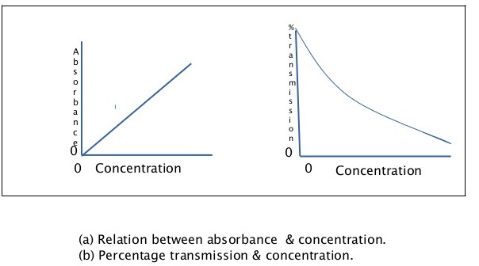

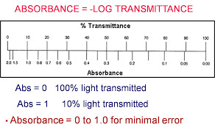

A = k’ct. (Beer’s and Lambert’s law)
Hence,
A ∞ t Absorbance is proportional to length of light path

A ∞ c Absorbance is proportional to concentration of substance

Therefore, If light path is constant, for concentration (C1 and C2) and respective absorbance (A1 and A2)

C1/C2 = A1/A2

If A1 and A2 is measured and C2 is known
C1= (A1/A2)*C2 can be calculated. --------(1)

This principle is utilized by biochemistry laboratory to measure various substances in biological materials.

Various instruments based on the principle are colorimeter and spectrophotometer.

Instrument:

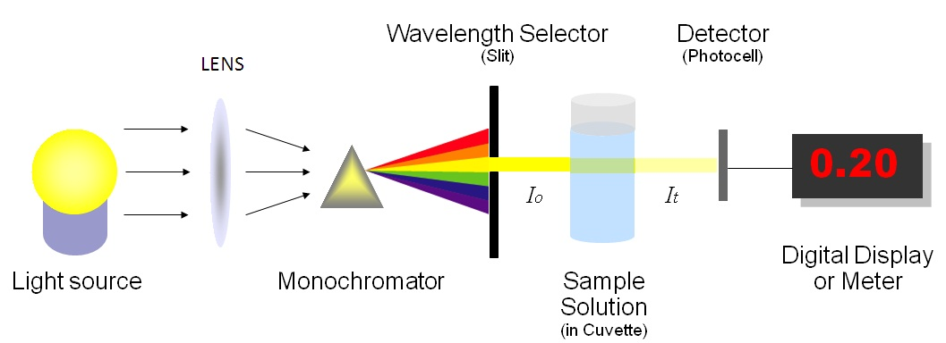

Filter  (nm) | Filter color | Absorbed color | Color of solution to be analyzed
340 | UV(colorless) | UV(colorless) | Nucleic acid,Reducing Equivalent
405 | Violet | Violet | Yellow green
450 | blue | Blue | Yellow
505 | Bluish-green | Blue-green | Red
546 | Green | Green | Red-violet
578 | Yellow | Yellow | Violet
630 | Orange | Orange | Greenish blue
670 | Red | Red | Blue green

Light source emit light of all wavelengths
Monochromator allow only certain wavelength of light to pass. (Mono + color)
Cuvette is a transparent vessel holding colored solution
I₀ ₌ Imparted light
I_{t} = Immerging light
Photocell converts light in to current. Current is proportional to light intensity.
Galvanometer measures current.
General procedure to use colorimeter:
Suppose concentration of Glucose in plasma is to be estimated.

Glucose is colorless, hence can not be measured directly.
Add fixed amount of Y in fixed amount of plasma. P and Q are produced
Glucose + Y → P + Q
Suppose Q is colored compound and absorbs light of a particular wavelength. Its concentration will be proportional to concentration of glucose.
Take a solution of glucose with known concentration C (it is called calibrator) and process as above in 2.
Take a water (it is called blank) and process as above in 2.
Measure absorbance of color produced by Sample and Standard and blank.
Blank Absorbance, amount of color produced with no glucose, needs to be deducted from absorbance of Sample and Standard.
Using equation (1)

[ O.D. of Test ] - [ O.D. of Blank ]
Sample Glucose conc. = ------------------------------------------- X Std Conc
[ O.D. of Standard ] - [ O.D. of Blank ]

What will you do:
Reagent:
Buffer:

pH | Chemical drug | Mol/L | MW | Gm/L
6.853 | Na2HPO4 | 0.025 | 141.96 | 3.549
6.853 | KH2PO4 | 0.025 | 136.09 | 3.402
9.139 | Na2 tetraborate | 0.01 | 381.37 | 3.814

Red Dye
Preparation of Red Dye Stock
Dissolve 20 mg of Phenol red
+
50 ml of 9.1 pH buffer

Diluted Red Dye (Dilute ration = 1:30 )
Red coloured solution (stock-1) = 20 ml
+
Buffer of pH=9.1 = 580 ml

Blue Dye
Preparation of Blue Dye Stock
Dissolve 20 mg of BCG (Bromocresol green)
+
50 ml of 6.8 pH buffer

Diluted Blue Dye (Dilute ration = 1:20 )

Red coloured solution (stock-1) = 10 ml
+
Buffer of pH-6.8 = 290 ml

Note: Dilution of stock coloured solution will be always done with respective Buffer.

Exercise:1
You will be given a concentrated colored solution.
Dilute it in a series of test tubes as follows. Measure absorbance.
Test tube | Diluted  Red Dye  (micro-liter) | Buffer of pH=9.1 (micro-liter) | Dilution Ratio  (X- Axis) | Absorbance (A)  on 505 nm Filter  (Y-Axis)
0 | 0 | 1000 | 0 %
1 | 200 | 800 | 20 %
2 | 400 | 600 | 40 %
3 | 600 | 400 | 60 %
4 | 800 | 200 | 80 %
5 | 1000 | 0 | 100 %
Draw Graph of various Dilution of dye versus its absorbance
Result & Conclusion:

Exerscise-2
Diluted Red Dye and Diluted Blue dye
Measure Absorbance of given coloured solutions on different filters.
Filters(nm)  (X-Axis) | Absorbance (Y-Axis)
Filters(nm)  (X-Axis) | Red coloured solution | Blue coloured solution
340
405
505
546
630
Note : Different colored solutions absorb light at different wavelengths in different proportions.
Draw Graph of various filter versus absorption on that filter for red colored solution & Blue coloured solution.
Result & Conclusion:

10. Estimation of serum creatinine

Creatinine is produced from creatine present mainly in muscles. It is filtered by glomerulus of kidney.

Principle:
Picrate + OH- ----------→ activated [ Picrate-OH-]* complex
[ Picrate-OH-]* + creatinine ------→ Creatinine-Picrate complex + OH-

Red colored Creatinine-Picrate complex, also called Janovaski complex, is measured at 505 nm.
The rate of reaction is proportional to concentration of creatinine.
The rate of reaction is also indicated by rate of rise in Absorbance (ΔA)
Thus, [creatinine] ∞ ΔA
ΔA is difference of absorbances in 60 seconds of reaction
ΔA for standard is ΔA _{standard} and ΔA for sample is ΔA_{sample}

ΔA_{sample}
Conc. of Creatinine in sample = ------------- X Standard
ΔA_{standard}

Reagents
The timed measurements of Absorbance require sophisticated colorimeters with flow-through cuvette. The reaction mixture is aspirated in the cuvette and Absorbance is measured at different time.
The Laboratory technologist will help to carry out following steps:
- NaOH solution :Refer to SOP for creatinine reagent
- Picric acid solution : Refer to SOP for creatinine reagent

Creatinine Standard
2 mg/dl Creratinine :
Dissolve 0.010 gm of creatinine powder in 500 ml of 0.1 mol/L HCl solution
Creatinine Test sample.
4 mg/dl Creratinine :
Dissolve 0.020 gm of creatinine powder in 500 ml of 0.1 mol/L HCl solution
6 mg/dl creatinine :
Dissolve 0.030 gm of creatinine powder in 500 ml of 0.1 mol/L HCl solution
0.1mol/l HCL solution
Add 17.4 ml of Conc. HCL solution (11.5 molar Conc.HCL solu.) & make
upto 2000 ml with DI water.

Creatinine Reagent
Creatinine R 1 |  |  | Creatinine R 2
NaOH | 12 gm |  | Picric acid | 4.582 gm
Brij(30%) | 10 ml |  | Brij(30%) | 10 ml
D.I. Water | Upto 1000 ml |  | D.I. Water | Upto 1000 ml
Working alkaline -picrate reagent:
Creatinine R 1 |  | 50 ml
Creatinine R 2 |  | 50 ml

Procedure
For sample and standard perform following.
1 ml of Alkaline Picrate Reagent
+
0.1 ml Sample / Standard.
Mix it and Analyzed sample immediately at 505 nm wave length.
Note the absorption (Optical Density=O.D.) at starting of reaction and at end of reaction (after 60 second)
Calculate : Change in O.D. in 60 second = ΔA = A₆₀ - A₀

Calculation and Result:
ΔA of Standard = ( )A₆₀ - ( ) A₀ _{= _________________}
ΔA of Sample = ( )A₆₀ - ( ) A₀ _{= _________________}

Concentration of Creatinine standard : ____________

ΔA of Sample
Conc. of Creatinine in sample = ------------------- X Conc. Standard
ΔA of Standard

Your result will be ---------------------------------

Comment on your result :

Reference Range:
Male 0.7 - 1.3 mg%
Female 0.6 - 1.2 mg%
1 mmol = 1000 micromole
Creatinine Molecular weight = 113.12 gm/mol

Question:
- Express adult plasma creatinine reference range in micromole/L.
- Write clinical conditions in which plasma creatinine increases.

11. Estimation of plasma glucose
Reagent:
Glucose reagent : Dissolve 100mg of 4- Aminoantipyrine dye in 1000ml of DI water and add 1 ml of phenol saturated water .

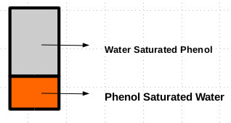

Note :
Wear goggles & Glove while taking phenol.
Senior person must be present.
Glucose test sample :
Add 3 ml of analytical grade Sodium Hypochlorite solution
& make upto 10 ml with DI water
Glucose standard sample :
Add 1 ml of analytical grade Sodium Hypochlorite solution
& make upto 10 ml with DI water.

Principle:
_{Glucose Oxidase}
Glucose + O₂ Gluconolactone + H₂O₂

_{Spontaneous}
Gluconolactone + H₂O Gluconate

_{Peroxidase}
H₂O₂ + 4-aminophenazone + phenol Quinonamine -red color

Procedure
Reagents | Blank | Standard | Test
H2O | 0.1 ml
Glucose Standard |  | 0.1 ml
Plasma |  |  | 0.1 ml
Glucose oxidase + Peroxidase Reagent (GOD POD reagent) | 1 ml | 1 ml | 1 ml
Mix & Incubate at RT for 30 min. Then take absorbance at 505 nm

Calculation:
O.D. of Blank = _____________
O.D. of Standard = _____________
O.D. of Test = _____________
Glucose Standard Concentration = _____________

[ O.D. of Test ] - [ O.D. of Blank ]
Sample Glucose conc. = ------------------------------------------- X Std Conc
[ O.D. of Standard ] - [ O.D. of Blank ]

Test Glucose concentration. = ___________________

Comment on your result:

Reference Ranges:
Fasting Plasma Glucose | Interpretation | Oral Glucose Tolerance | Interpretation
<=110 mg% | Normal | <139 mg% | Normal
111-125 mg% | Impaired Fasting Glucose | 140-199 mg% | Impaired Glucose Tolerance
>=126 mg% | Diabetes mellitus | >=200 mg% | Diabetes mellitus

Fasting = No food intake for at least 8 hours
Oral Glucose Tolerance = 75 gm glucose orally after 8 hrs of fasting.
Above results are valid if found on two or more occasions.
Question:
- Write clinical condition for increase and decrease glucose level in plasma
- Draw reference range table again with mmol/L format. (Glucose MW=180 gm).
- Write advice to be given to person for fasting blood sugar (FBS) and post prandial blood sugar (PP2BS) estimation.
- What is RBS?

12. Estimation of serum cholesterol
Reagent
Cholesterol reagent :
Dissolve 100mg of 4- Aminophenabenzene & 1 ml of phenol saturated water and make upto 1000ml with DI water.
Cholesterol test sample :
Add 3 ml of HOCL(analytical grade) & make upto 10 ml with DI water
Cholesterol standard sample :
Add 1 ml of HOCL(analytical grade) & make upto 10 ml with DI water

Principle:
Cholesterol ester Cholesterol esterase Cholesterol + Fatty acid

Cholesterol + O₂ Cholesterol Oxidase Cholest-4-en-3-one + H₂O₂

H₂O₂ + 4-aminophenazone + phenol Peroxidase Quinonamine

Procedure:

Reagents | Blank | Standard | Test
Water | 0.1 ml
Cholesterol Standard |  | 0.1 ml
Serum |  |  | 0.1 ml
Cholesterol oxidase Peroxidase Reagent (CHOD POD reagent) | 1 ml | 1 ml | 1 ml
Mix, incubate at RT for 30 min.Read absorbance at 505 nm

Calculation:
O.D. of Blank = _____________
O.D. of Standard = _____________
O.D. of Test = _____________
Cholesterol Standard Concentration = _____________

[ O.D. of Test ] - [ O.D. of Blank ]
Sample Cholesterol conc. = ----------------------------------------- X Std.Conc.
[O.D. of Std. ] - [ O.D. of Blank ]

Test Cholesterol concentration. = ___________________
Comment on your result:

Reference Ranges:
Desirable: <200 mg/dL
Borderline: 200-239 mg/dL
High: >=240 mg/dL

Question
- Rewrite reference ranges in mmol/L format. Cholesterol MW = 386.64 gm
- Write significant of cholesterol.
- Write conditions of increase cholesterol.

13. Estimation of Serum Total bilirubin

Reagent:
R1 (Caffeine)
- Dissolved 75 gm caffeine in 900 ml deionised water with constant mixing
- Add 112 gm Na Benzoate in above mixer with constant mixing
- Add 112 gm anhydrous Na Acetate in above mixer with constant mixing
- Add 2 gm disodium EDTA in above mixer with constant mixing
- Make upto 2 liter with deionised water
- Filter if turbid
- Store in glass container in freeze
- If crystalline precipitation are seen at 2-8'C, bring solution to room temperature to redisolve it before use
Diazo A
- Dissolve 10 gm sulfanilic acid in 900 ml deionised water
- Add 30 ml concentrated HCL in above mixer
- Make upto 2 liter with deionised water
- Store in glass container
Diazo B
- Dissolve 1.25 gm Na nitrite(NaNo2) and make upto 250 ml with deionised water.
- Store in brown glass container
R2 (Diazo Mix)
Mix Diazo A 10 ml & Diazo B 0.3 ml
Billirubin test solution
Dissolve 2 mg of billirubin powder & make upto 100 ml with DI water
Billirubin test solution :
Dissolve 4 mg of billirubin powder & make upto 100 ml with DI water.

Principle
One molecule of bilirubin reacts with two molecules of diazotized sulfanilic acid (diazo mix) in an acid solution to form two purple azobilirubin molecules (560 nm). Direct bilirubin reacts in water as well as with acceletor (e.g. caffeine, methanol) , while indirect bilirubin react only in presence of acceletor.

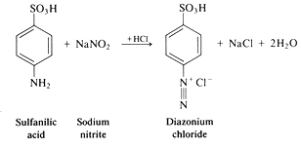
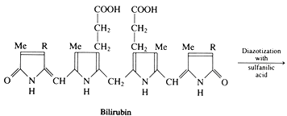
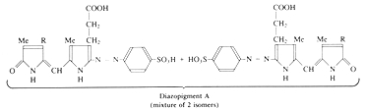

Reagents

Reagents | Test Blank | Test | Standard Blank | Standard
Sample | 0.1 ml | 0.1 ml
Standard |  |  | 0.1 ml | 0.1 ml
R1 (Caffeine Reagent) | 1 ml | 1 ml | 1 ml | 1 ml
Incubate for 10 minute
R2 (Diazo Mix) |  | 0.2 ml |  | 0.2 ml
Diazo Blank Reagent (Diazo A) | 0.2 ml |  | 0.2 ml
Incubate for 10 minute.Take absorbance at 560 nm

Blanks are taken to subtract absorbance caused by hemolysis (resulting in presence of red color of hemoglobin in serum).
Diazo blank reagent does not have sodium nitrite, hence do not produce azobilirubin.

Calculation:
O.D. of Blank = _____________
O.D. of Standard = _____________
O.D. of Test = _____________
Cholesterol Standard Concentration = _____________

[ O.D. of Test ] - [ O.D. of test.Blank ]
Total Bilirubin (mg/dL). = ----------------------------------------- X Std.Conc [O.D. of Std. ] - [ O.D. of std.Blank ]

Result
Total Bilirubin (mg/dL) = _______________________
Comment

Reference ranges: (For Adults)
Total Bilirubin < 1.3 mg/dl
Direct Bilirubin < 0.4 mg/dl
Indirect Bilirubin < 1.3 mg/dl
Bilirubin = MW 584.67 gm
1 mmol=1000 micromole

Questions:
- Enumerate causes of unconjugated hyperbilirubinemia and mixed hyperbilirubinemia.
- Express Reference ranges in micromole/Liter.
- Sample for bilirubin should not be exposed to light. Phototherapy is used in treatment of neonatal jaundice. Explain and correlate.

14. Estimation of serum total protein

Except immunoglobulins, majorities of plasma proteins are synthesized by liver. Various tissues catabolize plasma proteins. Plasma protein concentration reflects balance between their synthesis and catabolism. Under certain conditions intact proteins from plasma are also lost through GIT, urine and skin. Proteins from intravascular compartment may reach other body compartments. Protein concentration may also be affected by change in plasma water.
Reagent:
Refer to SOP for total protein.
- Weight 3 gm Cuso4.5H2O.
- Dissolve in approx. 500 ml water.
- Weight 9 gm (Na K Tartrate).(4H2O) and 5 gm KI.
- Add sequentially 9 gm (Na K Tartrate).(4H2O) and 5 gm KI in copper sulphate solution.
- Weight 24 gm NaOH.
- Add slowly with mixing 24 gm NaOH in 100ml of water.
- Add slowly with mixing NaOH solution in copper sulphate solution.
- Make upto 1 liter with water
Total Protein Standard:
Dilute Serum pool with DI water(1:20 ratio)
Prepare 10 ml of standard (0.5 ml pool serum+ 9.5 ml DI water)
Total Protein Test:
Dilute Serum pool with Nine part of DI water(1:10 ratio)
Prepare 10 ml of Test (1 ml pool serum+ 9 ml DI water)
Principle :
Two or more peptide bonds of proteins form coordination complex with one cu²⁺ in alkaline solutions to form a colored product. The absorbance of the product is determined spectrophotometrically at 540 nm.

Procedure:
Reagents | Blank | Standard | Test
H₂O | 0.1 ml | - | -
Protein standard | - | 0.1 ml | -
Sample | - | - | 0.1 ml
Biuret reagent | 1 ml | 1 ml | 1 ml
Mix and incubate at 37⁰ C temperature for 30 min.
Read Absorbance at 540 nm

Calculation and result:
O.D. of Blank = _____________
O.D. of Standard = _____________
O.D. of Test = _____________
Total Protein Standard Concentration = _____________

[ O.D. of Test ] - [ O.D. of Blank ]
Total Protein (gm/dL). = ----------------------------------------- X Std.Conc.
[O.D. of Std. ] - [ O.D. of Blank ]

Total Protein (gm/dL). = _______________________
Comment :

Reference ranges: Serum proteins 6.0-8.0 g/dL
Albumin 3.5-5.5 g/dL
Globulins 2.0-3.6 g/dL
Fibrinogen 0.2-0.6 g/dL

Questions:
- Explain why Serum protein reference ranges are lower than that of plasma.
- Why reference ranges for plasma proteins can not be expressed in mmol?
- Enumerate conditions affecting plasma protein level.

15. Estimation of serum albumin

Different disorders affect different plasma proteins differently. Thus, it is useful to know albumin and globulin concentration in serum, in addition to total protein. Once total protein and albumin (as shown below) are estimated, serum globulin can be calculated.

Reagent :
Albumin Standard:Dilute Serum pool with DI water(1:20 ratio).Prepare 10 ml of standard (0.5 ml pool serum+ 9.5 ml DI water).
Total Protein Test:Dilute Serum pool with Nine part of DI water(1:10 ratio).Prepare 10 ml of Test (1 ml pool serum+ 9 ml DI water).
BCG reagent : Refer SOP for Albumin reagent preparation.
Add 42mg BCG(MW=698) in approx. 250 ml DI water.
Add 5.9 gm succinic acid (MW=118.09 ,pKA1=4.2 ,pKA2 = 5.6) in above mixer while constantly mixing.
Add 1.8 ml of 30% Brij-35 In above mixer while constantly miximg.
Add 1 gm NAOH in above mixter while constatly mixing
Add 200 mg Na azide in above mixer while constatly mixing.
If required adjust pH to 4.2
Make upto 1000 ml with volumetric flask with deionised water.

Principle:
BCG = BromoCresol Green

At pH 4.2: [Albumin⁺] + [BCG⁻] → [Albumin⁺ BCG⁻ complex]

At pH 4.2 BCG is yellowish, while Albumin⁺ BCG⁻ complex is greenish. The green color is measured at 630 nm.
Procedure:

Reagents | Blank | Standard | Sample
H₂O | 0.1 ml | - | -
Standard | - | 0.1 ml | -
Sample | - | - | 0.1 ml
BCG reagent | 1 ml | 1 ml | 1 ml
Mix, and Take absorbance at 630 nm after 10 minutes.
Absorbance | A_{blank} | A_{standard} | A_{sample}

Calculation and result:

O.D. of Blank = _____________
O.D. of Standard = _____________
O.D. of Test = _____________
Albumin Standard Concentration = _____________

[ O.D. of Test ] - [ O.D. of Blank ]
Albumin (gm/dL). = ----------------------------------------- X Std.Conc.
[O.D. of Std. ] - [ O.D. of Blank ]

Your Result will be --------------------------
Comment on your result

Reference ranges:
Serum Total proteins 6.0-8.0 g/dL
Serum Albumin 3.5-5.5 g/dL
Serum Globulins 2.0-3.6 g/dL
Plasma Fibrinogen 0.2-0.6 g/dL
Questions:
- Calculate S.Globulin from Sample’s Albumin concentration & If Total Protein = 7 gm/dl.
- Enumerate conditions of alter A:G Ratio.
16.Estimation of Cerebrospinal fluid protein.

Cerebrospinal fluid is not freely permeable to plasma proteins. Hence, its concentration is almost 1/100 times the plasma. Some proteins are synthesized by the pia matter itself. Under various CNS inflammatory conditions, CSF protein is increased due to increased permeability of pia matter as well as due to increased synthesis by it.

Reagent:
Pyrogallol Red reagent:Refer to SOP for Pyrogallol red reagent

PR(Pyrogallol red)
Making Reagent
- Dissolve pyrogallol red 60 mg in 100 ml of methanol.
- Store in plastic container.
MB(molybabdate)
Making Reagent
- Dissolve disodium molybdate 0.24 gm in 100 ml of deionized water.
- Store in plastic container.
Final microprotein Reagent
Making Reagent
- Dissolve succinic acid 5.9 gm in 900 ml of deionized water.
- Add sodium oxolate 0.14 gm in above mixture with constantly mixing.
- Add sodium banzoate 0.5 gm in above mixture with constantly mixing.
- Add PR(Pyrogallol red) 40 ml in above mixture with constantly mixing.Discard other 60 ml PR(Pyrogallol red).
- Add (molybabdate) 4 ml in above mixture with constantly mixing.Discard other 96 ml (molybabdate).
- Calibrate PH meter and if required adjust PH to 2.5.
- Make up to above mixture 1 L with deionized water.
CSF Protein Calibrator: Take 0.02 ml of serum protein & make upto 10 ml with DI water
CSF protein Sample :Take 0.04 ml of serum Protein & make upto 10 ml with DI Water

Principle:
pyrogallol red-molybldate complex combine with protein and give colour which is mesure at 630 nm.

Procedure:
Reagents | Blank | Standard | Test
H₂O | 0.1 ml | - | -
CSF Protein Standard | - | 0.1 ml | -
CSF Test | - | - | 0.1 ml
Pyrogallol Red reagent | 1 ml | 1 ml | 1 ml
Mix, wait for10 min, mix before reading at 630 nm.

Calculation and result:

O.D. of Blank = _____________
O.D. of Standard = _____________
O.D. of Test = _____________
CSF Protein Standard Concentration = _____________

[ O.D. of Test ] - [ O.D. of Blank ]
Protein conc. in CSF(mg/dL). = ----------------------------------------- X Std.Conc.
[O.D. of Std. ] - [ O.D. of Blank ]

Your result & comment

Reference ranges: 15-45 mg/dl

Questions
Enumerate conditions affecting CSF protein level.

17. Estimation of plasma uric acid

Uric acid is formed by catabolism of purines. Uric acid is excreted by kidney.

Reagent:
Uric acid test sample :
Add 1.5 ml of analytical grade Sodium Hypochlorite solution& make upto 10 ml with DI water.
Uric acid standard sample :
Add 0.5 ml of analytical grade Sodium Hypochlorite solution& make upto 10 ml with DI water.

Principle:
Uric acid yields allantoin and H2O2 on action by uricase. Peroxidase use hydrogen peroxide to oxidize various colorless dyes to red colored quinonimine like dyes measured at 505 nm by absorption photometry .
Uricase
Uric acid + 2H2O + O2 ------------→ Allantoine + CO2 + 2H2O2

H₂O₂ + 4-aminophenazone + phenol Peroxidase Quinonamine (red color)

Procedure:
 | Test | Standard | Blank
Serum | 0.1 ml
Standard |  | 0.1 ml
Water |  |  | 0.1 ml
Reagent | 1 ml | 1 ml | 1 ml
Incubate at 37'c for 30mins.Measure absorbance at 505 nm.

Calculation
O.D. of Blank = _____________
O.D. of Standard = _____________
O.D. of Test = _____________
Uric acid Standard Concentration = _____________

[ O.D. of Test ] - [ O.D. of Blank ]
Uric acid (mg/dL). = ----------------------------------------- X Std.Conc.
[O.D. of Std. ] - [ O.D. of Blank ]

Result & Comment:

Reference ranges:
Male : 3.6 - 7.7 mg/dL (214 to 458 micromole/L)
Female : 2.5 – 6.8 mg/dL (149 to 405 micromole/L)

Questions:
- Enumerate conditions affecting plasma uric acid level.
- Calculate molecular weight of uric acid from reference ranges given.

18.Electrophoresis
Reagent: Refer to Sop for Serum & Hb electrophoresis

Principle:
Electrophoresis is a refers to the migration of charged molecules under electrical field.

Procedure:
Prepare thin 1 % Agarose gel in appropriate buffer.
Apply appropriate sample in thin line over agarose gel.
Keep gel with sample applied in electrophoretic chamber & connect the gel with buffer through strips of filter paper and apply appropriate voltage.
After sample run is completed, switch off the power supply and remove slide from chamber.
Denature proteins in methanol and dry the gel with heating.
Stain slide with appropriate stain.

Buffer :
Barbiturate Buffer (for protein electrophoresis)
Tris Buffer (for protein electrophoresis)
TEB Buffer (for Haemoglobin electrophoresis)

Supporting Media:
Whatman Filter Paper
Cellulose Acetate Paper
Agarose Gel
Polyacrylamide Gel

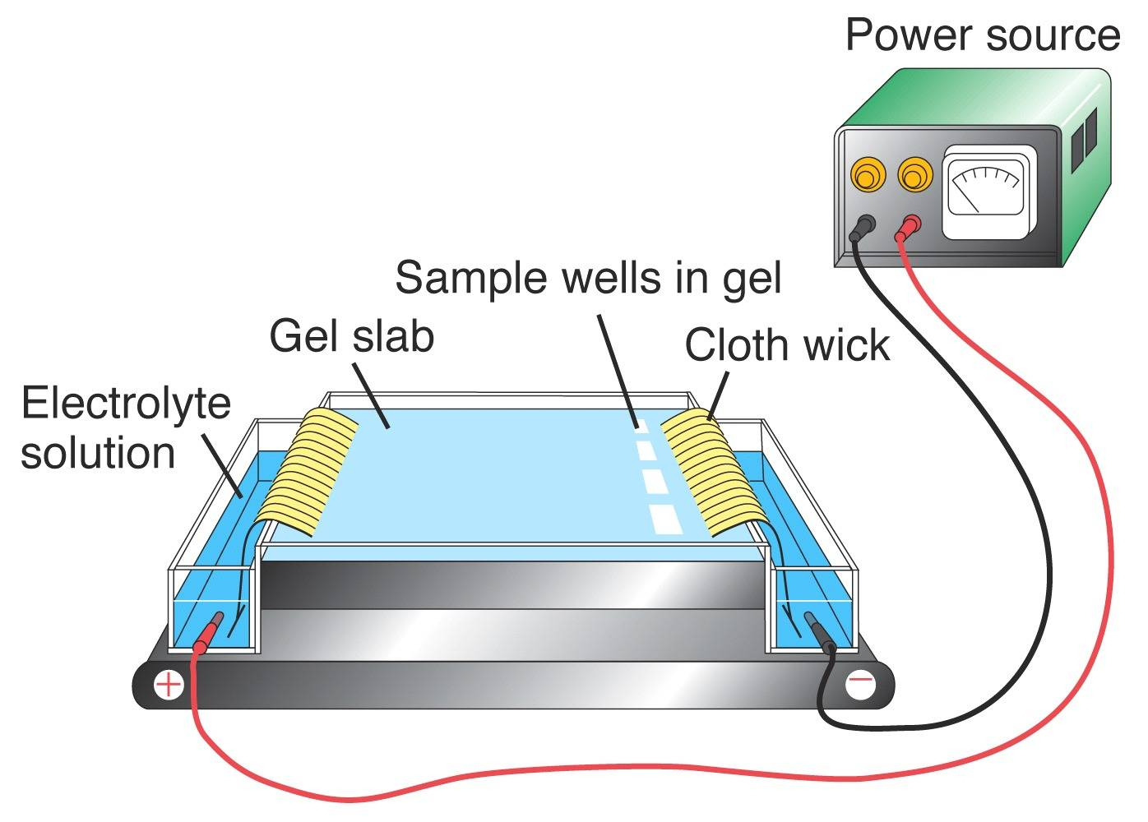

Clinical Applications:
Diagnosis of sickle trait and sickle disease.
Diagnosis of multiple myeloma

Questions:

- What is agarose? Why it is used to prepare gel.
- Name other electrophoresis support media.
- How much agarose is required to prepare 15 ml of 1% agarose?
- Which sample is used for hemoglobin electrophoresis?
- What was voltage, current and duration of electrophoresis demonstrated to you?
- What are major hazard of electrophoresis procedure?
- What precautions must be taken to avoid them?
- What is difference between electrophorogram of serum protein and plasma protein?
- Name stain used during demonstration.
- Draw hemoglobin electrophoretic patten in normal, sickle trait and sickle cell disease patients. Explain its biochemical basis.
- Draw hemoglobin electrophoretic patten in HbC and HbD carrier patients. Explain its biochemical basis.
- Draw serum protein electrophoretic patten in multiple myeloma. Explain its biochemical basis.
- What is monoclonal antibody?

19. Chromatography

Principle : Chromatography is a process in which components of a mixture are separated by differential distribution between a mobile phase and a stationary phase. Components with greater distribution into the stationary phase are retained and move through the system more slowly.

Requirements :

Amino acid standard : 1% amino acid standard
Mobile phase : 12(Butanol):3(Glacial acetic acid):5 (Di water)
Sample Type : Serum,Urine .
Equipments & consumables :Chromatography chamber(air tight), Glass road, clips, Whatman fiter paper, Gloves, pencil, scale, centrifuge, pipettes
Stain : Ninhydrin solution (0.25 %)(250 mg of Ninhydrin powder in 100 ml of methanol/acetone)

Procedure :
Clean hands throughly with soap.
Wear gloves before handling filter paper.
Take a Whatman filter paper ,make a horizontal line at one end of filter paper,around 1.5-2 cm above from the edge of the paper.
Put marking at 3.5 cm apart for each sample for sample application.
Repeat sample & standard application for twice once previous sample gets dried .
Take 500 ml of mobile phase reagent in reagent chamber.
Clip the dried filter paper on glass rod,Make sure that distance between each sample & road is equal.
Put glass rod in chromatography chamber, make sure that sample application sites do not get dipped in the solvent.
Close the chamber air tight .Note the time & allow the separation for 4 hours.
Remove the paper from chamber after 4 hours, allow the paper to dry at room temperature.
Take 0.25% Ninhydrin solution in shallow plastic container big enough to accommodate the entire filter paper. Dip paper in it for few seconds.
Put the paper in incubator at 100ºc for 20-25 minute/ till purple bands are seen Preserve the paper in dark room for latter use.

Calculate Rf value
Distance from application point to solute center
Rf= ---------------------------------------------------------
Distance from application point to solvent front

Questions :
- Name stationary phase in the experiment. Is it mainly hydrophobic or mainly hydrophilic? Explain.
- Name mobile phase in the experiment. Is it mainly hydrophobic or mainly hydrophilic? Explain.
- List hydrophobic amino acids used in the experiment.
- List hydrophobic amino acids used in the experiment.
- Comment why some amino acids move faster and other slower during the chromatography.
- Why wearing gloves is essential in the experiment?
- Why wearing protective eye glass is essential in the experiment?
- Name few conditions where abnormal amount of some amino acids are lost in urine. Explain their biochemical basis.

Clinical Case - 1
Early in the morning, 40 years old male patient came in emergency with complain of chest pain, perspiration and altered consciousness for 4 hours. Patient also had diabetes mellitus for 10 years. He was taking medicine for diabetes mellitus irregularly. In history, it was found that he was chronic alcoholic and a day before chest pain , he also had heavy alcohol ingestion., with no feed intake.Doctor asked for few blood investigations. From ECG finding and abnormal cardiac function test. Diagnosis of myocardial infarction was confirmed.

Following treatment was given
- loading dose of anti-platelet drug (Aspirin)
- loading dose of hypocholesterolemic (Statin group) drug
- Fibrinolytic drug (streptokinase)
- 50% dextrose saline with Thiamine (Vitamin B1)
After complete management and recovery after 7 days of admission in hospital, at time discharge from hospital, physician advised to take medicines regularly and to take more amount of fruit and fiber food.
- Random Blood Sugar = 30 mg %
- HbA1C = 9 %
- S. Cholesterol = 350 mg %
- S. Triglyceride = 250 mg %
- S. HDL Cholesterol = 25 mg %
Question
- What are chronic complication of DM?
- Why uncontroled diabetic mellitus increase chances of atherosclerosis?
- What is cardiac function test?
- Which test will you prefer to do for diagnosis of myocardial infarction, if patient come after 4 day of onset of chest pain?
- How statin reduce cholesterol level?
- What is biochemical explanation of hypoglycemia?
- Why physician asked to give injectable 50% Dextrose saline with Thiamine (Vitamin B1)?
- What is role of fruits and fiber in chronic diabetes mellitus and atherosclerosis?
- Why blood sample for blood sugar estimation is collected in fluoride containing vial?
- What is re-perfusion injury ? And what is role of allopurinol to prevent it?
- How will you calculate patient’s LDL cholecterol?
- What is role of fibrinolytic drugs (streptokinase) in myocardial infarction?

Clinical Case – 2
56 year male patient came in emergency with alter-conciuosness & haemetemesis . He was suffering from chronic cirrhotic liver disease due to chronic alcoholism. On examination , it was found that he has edema on both lower limb, fluid collection in peritoneal cavity (Ascites), yellowish discolouration of skin & sclera (icterus), with hypotension (decrease Blood Pressure).
On blood investigation following was found.
- Blood Glucose : 50 mg%
- Serum Protein : 5.5 gm %
- Serm Albumin : 2.0 gm%
- Serum Ammonia : Very High
- Serum Total Billirubin : 20 mg%
- APTT – Test : 60 second
- APTT – Control : 30 second
- APTT – INR : 2
- Haemogloin : 6 gm%
Ultra Sono-Graphy detected
- Cirrhosis of Liver
- Fatty Liver
Physician advise to give Following treatment
- Injection 10% Dextrose
- Injection Thiamine (B1)
- Injection Vitamin K
- Injection 10% Albumin
- Oral Neomycin (Anti-microbial, Antibiotic)
- Liq Lactulose (Laxative)
- Oral Phenylbutarate
Question
- Biochemical explaination about following symptoms in chronic alcoholic
  - Alter conciousness
  - Haemetemesis
- Biochemical explaination about following signs in chronic alcoholic
  - Edeme
  - Ascites
  - Hypotension
- What is hepato-renal syndrome?
- Biochemical reason for giving following in patient of chronic alcoholic
  - Dextrose plus thiamine
  - Vitamin K
  - 10% Albumin
  - Oral Neomycin (Anti-microbial, Antibiotic)
  - Liq Lactulose (Laxative)
  - Oral Phenylbutarate

Clinical Case – 3

A 54 year old obese person come in emergency with altered consciousness level and increase respiratory rate (tachypnia) for last 4 hours.
He is having history of uncontrolled diabetes mellitus since 15 years, as he was not following any medical advice from physician. He was on insulin therapy for 3 years, but he was not taking regular dose of insulin. Patient's relative is telling that he is also having complain of weakness and decrease urine output for last 2 days.
On General examination, physician noted
- Dryness of mouth
- Pale & dry conjunctive
- Shrunken eye ball.
- Feeble (low volume) pulse
- Tachypnea (increase respiratory rate)
- Tachycardia (increase heart rate)
- Very low blood pressure (70/40 mm Hg).
Doctor makes admission in ICU and asked immediately for blood investigation.
Parameter | Value | Reference range
RBS | 500 mg/dl | 140 mg/dl
Serum Acetone | 10 mg/dl | <1 mg/dl
Serum Creatinine | 2.5 mg/dl | 0.4 - 1.4 mg/dl
Blood Urea | 150 mg/dl | 15 - 45 mg/dl
Serum Na+ | 120 mmol/l | 135 - 145 mmol/l
Serum K+ | 6.0 mmol/l | 3.5 - 5.0 mmol/l
pH | 7.1 | 7.35 - 7.45
pO2 | 95 mmHg | 90 - 100 mmHg
pCO2 | 24 mmHg | 32 - 40 mmHg
HCO3- (Bicarbonate) | 12 mmol/l | 24 - 32 mmol/l
Diagnosed = “Diabetic ketoacidosis with acute renal failure”
Advised to following treatment.
- Inj normal saline fast I.V. (4-5 litre in 1st 24 hrs) Until systolic blood pressure reaches to normal
- Inj Human Insulin injection slow infusion I.V.As per blood sugar level
- Inj Bicarbonate 200 ml I.V.
- K+ Binding resin Sachets Orally.
Urinary catheterization done.
But urine output is nil
To follow below protocol for treatment of this patient.
- If RBS > 200 mg/dl ---> Give Normal Saline + Human Insulin
- If RBS < 200 mg/dl ---> Give Dextrose Saline + Human Insulin
Doctor asked to repeat following investigation during management
- RBS every 2 hourly.
- Serum K+ level after 4 hours.
- Arterial Blood Gas analysis after 6 hours (if require)

24 hours after admission and intensive care
- He get consciousness, normal respiration ,
- normal blood pressure & 1200 ml of urine output.
- RBS = 150 mg% with Human insulin infusion
- Serum acetone = 2 mg/dl
- Electrolyte and ABG = Normal.
He shifted to ward & remained admitted for 5 days in hospital.

On discharge, physician advises to take prescribe insulin dose regularly as well as regular follow up with FBS & PP2BS.
Question
- Give explanation for altered consciousness and increase respiratory rate in this case.
- What metabolic and functional abnormality can occur due to increase acetone level?
- Why after 24 hours serum acetone came down nearer to normal level?
- What is patho-physiology behind decrease urine output in this patient?
- Give comment on patient ABG report.
- Give biochemical reason for increase K+ level in this case.
- What is biochemical reason for giving dextrose saline plus human insulin infusion if RBS is below 200 mg%?
- How bicarbonate, insulin and K+ binding resin reduce serum potassium level?

Clinical Case-4

64 year old Female has complained of Tremor in hands, weakness, fever and loss of appetite since 3 monthes. Following investigations are done on admission in hospital.
Reference Range
Hemoglobin – 7.0 gm/dL (12 – 16 gm/dL)
Serum Iron- 90 microgram/dL (41 – 141 microgram/dl)
Serum TIBC- 450 microgram/dL (251 – 406 microgram/dL)
Serum Ferritin- 3 nanogram/ml (12-300 nanogram/ml)
Physician diagnosed her as iron defeciency anemia and prescribed Antibiotics and oral iron tablets, Folic acid and vitamin B12 tablets for 3 months.

Question
1) What is reason behind weakness and fever in this patient?
2) What is TIBC and Ferritin? Give its Clinical significance.
3) What can be the reason of low iron and high TIBC ?
4) What can be the reason of low level of Ferritin?
5) Why physician prescribed antibiotic to this patient?
6)What is the reason of giving folic acid and Vitamin B12 to this patient?
7) Write the causes of Iron defeciency anemia.

Clinical Case 5

15 year old male patient was admitted in Hospital with following chief complain since 1 week.
Breathlessness
Pain in knee joints and Abdomen
Yellowish discoloration of skin
Fever.
Physician advised him following investigation.
Reference range
Serum Total Bilirubin- 6 mg/dL (<1.3 mg/dl)
Serum Direct Bilirubin- 0.8 mg/dL (<0.4 mg/dl)
Serum Indirect Bilirubin- 5.2 mg/dL (<1.3 mg/dl)
Serum ALT- 30 U/L (<45 U/L)
Serum Creatinine- 0.8 mg/dL (0.8 – 1.3 mg/dl)
Hemoglobin- 6 gm/dL (12 – 16 gm/dL)
Dithionite test- Positive
Peripheral smear Sickle cell shape RBSs are seen with Malarial parasites are present.

Patient is diagnosed as sickel cell crisis. Physician prescribed antibiotics, Hydroxyurea, correct hydration and anemia.
Question
1) Write genetic defect present in this patient.
2) What is the reason of having breathlessness and pain in knee joints?
3) What is the reason of precipitation of sickel cell crisis?
4) What is the reason of yellowish discoloration of skin?
5) What is the role of Hydroxyurea in sickel cell disease patient?
6) Write biochemical explanation of sickling.

Clinical Case 6

A 25 year old male patient admitted in hospital with history of Snake bite He has complain of swelling and pain (cellulitis) at the site of snake bite . After Few hours of admission he got difficulty in breathing , weakness in all the limbs and hematuria (blood in urine).Physician advised following investigation.
Reference range
Hemoglobin- 6 gm/dL (12 – 16 gm/dL)
Serum Total Bilirubin- 3.5 mg/dL (<1.3 mg/dl)
Serum Direct Bilirubin- 0.5mg/dL (<0.4 mg/dl)
Serum Indirect Bilirubin- 3.0 mg/dL (<1.3 mg/dl)
Prothrombin time 28 second (12-14 Sec)

Physician advised the following treatment
- Anti snake venom Antibody ,
- Antibiotics,
- Neostigmine injection.
- Atropine injection.
Question
- Why does indirect billirubin raised in this patient?
- What is mechanism of action of neostigmine ?
- What is the reason of high prothrombin time?
- Why snake bites cause weakness and muscle paralysis?
- What is the reason of swelling and pain (cellulitis) at site of snake bite?

Medical Biochemistry – Syllabus
Medical Biochemistry encompasses any topic of biochemistry relevant to human health and diseases. As medicine is an ever expanding body of knowledge, Medical Biochemistry syllabus is continuously expanding.
At bare minimum, you are expected to get integrated knowledge of theoretical and practical aspects of following in context of the field of Medicine. In addition, newer advances in the field of medical biochemistry needs to be studied.
Carbohydrates:
Chemistry, Nutrition, Digestion, Absorption, Transport, metabolism & biochemical basis of related diseases, their treatment & prevention. Alcohol metabolism
Amino acids and Proteins:
Chemistry, Nutrition, Digestion, Absorption, Transport, metabolism and biochemical basis of various diseases, their treatment and prevention.
Enzymes
Hemoglobin and Heme metabolism
Plasma proteins ,Collagen, elastin and extracellular matrix proteins
Lipids:
Chemistry, Nutrition, Digestion, Absorption, Transport, metabolism and biochemical basis of various diseases, their treatment and prevention.
Prostaglandins
Nucleic Acids:
Chemistry, Nutrition, Digestion, Absorption, Transport, metabolism and biochemical basis of various diseases, their treatment and prevention.
Genetics
DNA and RNA structure and functions, Genome and Chromatin
Replication, Transcription, Genetic code and Translation
DNA Damage and repair, Mutations , Recombinant DNA Technology ,Cell cycle and its regulation , Biochemistry of cancer
Biochemical basis of genetic diseases, their treatment and prevention.
Integration of metabolism:
Bioenergetics,Cellular Respiration,Interrelationship among metabolic pathways,Biochemical basis of related diseases, their treatment & prevention.
Vitamins:
Chemistry, Nutrition, Digestion, Absorption, Transport, metabolism and biochemical basis of various diseases, their treatment and prevention.
Minerals:
Chemistry, Nutrition, Digestion, Absorption, Transport, metabolism and biochemical basis of various diseases, their treatment and prevention.

Water and pH:
Water biochemistry and biochemical basis of related disorders.
Blood buffers, regulation of blood pH and biochemical basis of related disorders.
Xenobiotics:
Chemistry, Metabolism and excretion of xenobiotics.
biochemical basis of related disorders
Tools for study of Biochemistry:
Colorimetry
Chromatography
Electrophoresis
ELISA
RIA
PCR and blotting techniques

Biochemistry of supramolecular structures (overlapping above topics):
Biochemical characteristics of various organelles, cells, tissues and organs e.g. Mitochondria, perioxisomes, general cell structure, RBC, Liver, Brain, Heart, Skeletal muscles etc.

Subject distribution and paper style
Paper distribution:
Paper 1:
Chemistry, digestion, absorption and metabolism of Carbohydrate, Lipid, Water, pH, Minerals
Paper 2:
Chemistry, digestion, absorption and metabolism of Protein( including hemoglobin, plasma proteins and enzymes), Nucleic acids including genetics, Vitamins, Xenobiotics
Note: Overlapping common topics are acceptable in any paper e.g integration of metabolism, nutrition, tissue and organ biochemistry, biochemistry laboratory techniques, biochemistry of microorganisms (e.g HIV), environmental biochemistry and Cancer.

Paper style( paper 1 and 2)
Section 1
Q-1 Short notes (2 out of 3) 08 marks
Q-2 Describe in brief (4 out of 6) 12 marks
Q-3 Write answer in few line(5 out of 6) 05 marks

Section 2
Q-4 Case with 5 questions 10 marks
Q-5 Answer in few lines(5 out of 7) 10 marks
Q-6 Write answer in few line(5 out of 6) 05 marks

List of Model Questions
General
- Blood buffer mechanism
- Renal Buffer mechanism for acid base balance.
- Arterial Blood Gas Analysis & interpretation.
- H2O2 – Myeloperoxidase (MPO) – Halide system of ROS (reactive Oxygen species)
- Fluidic Model of Cell membrane
- Type and Example of Transport mechanism.
- Primary & Secondary cause of Hyperuricemia (Gout)
- Chemi-osmotic hypothesis.
- Energy production in TCA cycle.
- Uncouplers of Oxidative phosphorylation
- Principle, Type and utility of Electrophoresis.
- Principle, Type and utility of ELISA.
- Principle and utility of Colorimeter
- Biochemical changes in Liver,Adipose tissue and muscle in well fed state
- Biochemical changes in Liver,Adipose tissue and muscle in well fasting.
Carbohydrate
- Mucopolysaccharide
- Proteoglycans
- Digestion & absorption of carbohydrate
- Lactose intolerance
- Energy production of Glycolysis
- Regulation of Glycolysis
- Amphibolic role of TCA cycle
- Significant of NADPH
- Significant of HMP Shunt pathway
- Substrate & Regulation of Gluconeogenesis
- Sorbitol Pathway
- Polyol pathway and it’s significant
- Effect of alcoholism on gluconeogenesis, oxidation of fatty acid & TCA cycle.
- Diagnostic criteria for Diabetes Mellitus
- Define and significant of Glycate haemoglobin
- Metabolic alteration in Diabetes Mellitus
- Acute and Chronic complication of Diabetes Mellitus
- Biochemical explaination of Diabetic Ketoacidosis
- Define C-peptide & it's significant.
- Define and significant of Glycated (HbA1c) haemoglobin
- Advance glycated end product.
- Type of Diabetes Mellitus . Explain LADA, MODY,Gestational diabetes & Secondary diabetes
- Von Gierke’s Disease
- G6PD deficiency
- Fate of Acetyl CoA.
- Ketone body synthesis & utilization
- Alcohol metabolism
- Epimer & Isomer
Lipid
- Name and Significant of Essential Fatty acid
- Type ,Difference & clinical significant of saturated & unsaturated fatty acid.
- Fate of cholesterol
- Ketogenesis and ketolysis
- Metabolism of LDL
- Regulation of LDL receptor
- Formation of Eicosanoid & explain its inhibitor with significance.
- Pathogenesis of atheroscerosis in contex of 'oxidised LDL'.
- Type and differenciation of oxidation of fatty acid
- Rancidity of Fatty acid
- Liposome & Micelle
- Function of Phospholipids
- Lung surfactant
- Role of Phospholipase A2 of Snake venum in RBC lysis.
- Role of phospholipid in signal transmission
- Lipid digestion –absorption.
- Significance and Regulation of Cholesterol.
- Risk factor for Atherosclerosis
- Prevention of Atherosclerosis
- Type and Function Lipoproteins
- Type and function of Apo-lipoproteins
- Metabolism of HDL
- Reverse cholesterol transport.
- Role of' Lipoprotein-a in Atherosclerosis
- Energy production of long (16 carbon ) saturated fatty acid through Beta oxidation
- Carnitine shuttle
- Assessment,Metabolic changes and influencing factors of obesity.
- Cause of Fatty liver
- Name the Lipotrophic Factor. Explain it’s effect
Protein and Amino acid
- Zwitter ion
- Functional classification of protein
- Protein structural –functional relationship
- Primary , Secondary , Tertiary and Quarternary structure of Protein.
- Define Chaperon & Prion protein
- Protein folding & unfolding.
- Define Protein Denaturation. Give It’s significant & causative factor
- Digestion & Absorption of Protein
- Urea cycle & Ammonia detoxification.
- Define & give significant of transamination, transdeamination & deamination.
- Overview of tyrosine & phenylalanine
- Fates of Tyrosine & Phenylalanine & it’s related disorder
- Biochemical explanation of Phenylketonuria
- Biochemical explanation of Albinism & Alkaptonuria
- Fates of Tryptophan & it’s related disorder.
- Maple Syrup Urine Disease
- Folate trap
- Collagen-Homocystineuria-Ectopia lentis
- Nitrogen disposal-GDH and Alpha ketoglutarate
- Role of Glutathione & NADPH for maintain RBC membrane
- Fates of Glycin
- Fates of Glutamic acid
- Transport and Detoxification of Ammonia
- Role of 2-3 BPG on oxygen diffusion-dissociation and effect during hypoxia
- Mechanism of the Halden & Bohr effect
- Developmental changes in Hemoglobin gene expression from intrauterine life to adult.
- Regulation of Hemoglobin synthesis.
- Haemoglobin degradation pathway & it's related disorder.
- Types , Causes and differentiation of Jaundice by serum and urine examination.
- Haemoglobin synthesis pathway & it's related disorder.
- Define Porphyria. Explain Causes, Clinical Feature and diagnosis of Acute intermittent porphyria and Congenital erythropoietic porphyria.
- Molecular and Biochemical explanation for pathogenesis of Sickle cell disease
- Molecular and Biochemical bases of Thalassemia.
- Define and explain cause & effect of Met-haemoglobinemia
- Transport Plasma proteins
- Storage proteins
Enzyme
- Write and Explain Factor affecting enzyme activity with example.
- Explain First order & zero order enzyme kinetics.
- Explain Difference in Function of Glucokinase and Hexokinase on bases of it’s Vmax and Km.
- Difference between Competitive inhibition and Noncompetitive inhibition.
- Diagnostic importance of isoenzyme
- Type of Enzyme Inhibition. Explain with example.
- Regulation of Enzyme activity
- Define Co-Enzyme, Cofactor , Apo-Enzyme , Prosthetic group & Holoenzyme
- Enumerate Liver Function Test & Write it’s significant.
- Enumerate Cardiac Function Test & Write it’s significant.
Nutrition & Vitamin
- Protein Energy Malnutrition (PEM)
- Difference between Kwashiorkor & Murasmus
- Factor affecting Basal metabolic rate
- Assessment of obesity.
- People having Mediterranean diet show low incidence of CHD
- Clinical significance of Dietary fibre
- Vitamin B12 & folic acid deficiency can cause hyperhomocysteinemia
- Folate trap
- Effect of Warfarin & Dicoumarol on Vitamin K metabolism
- Function of Vitamin K
- Function of vitamin C
- Role of Active form of Vitamin B1 (Thiamine) in metabolism and give it's significance.
- Visual cycle of Vitamin A
- Name and write clinical manifestation occur in Vitamin A deficiency.
- Metabolism, Function and Clinical significance of Vitamin D
- Homoestasis changes in calcium , vitamin D & parathyroid hormone in case of renal failure.
- Regulation of calcium.
- Hypocalcaemia
- Mucosal block theory of iron absorption.
- Iron deficiency Anemia
- Type and clinical features of Beriberi.
- Pernicious anaemia.
- Metabolic changes during starvation
- Metabolic role of Vitamin B12.
- Name Riboflavin (FAD) & Niacin (NAD+ & NADP+) dependant enzymatic reaction.
Molecular
- Type and Watson & Crick Model Of DNA
- Organisation of eukaryotic DNA.
- t-RNA.
- Degeneracy & wobbling phenomena
- Genetic codon
- Molecular basis of Sickle cell anaemia.
- Type of DNA polymerase & specify it's fuction.
- Name & role of the component of the DNA replication fork
- DNA repair mechanism.
- Define Telomer & Telomerase. It’s significant
- Effect and Type of Mutation with examples.
- Initiation of Transcription
- Post-transcription modification.
- Post translation modification.
- Protein synthesis inhibition by drugs.
- Salvage pathway of Purine synthesis and related disease.
- Lysch Nyhan Syndrome
- Adenosine deaminase deficiency.
- Lac operon
- Procedure & Significant of PCR
- Significant of RFLP in diagnosis of Sickle cell disease
- Microarray
- Recombinant DNA Technology
- DNA Library
- Uric acid synthesis and its inhibitors.
- Causes and management ( biochemical aspect ) of Gout
- Type and function of Topoisomerase
- DNA dependent RNA polymerase.
- Ribozymes
- Define Autosomal dominant & Autosomal recessive & Draw pedgree chart.

List of Model Justification

General
- Oral rehydration solution is made up of glucose and sodium both.
- Hyperkalemia can occur in Metabolic acidosis.
- Proteolytic enzymes are released in zymogen form.
- “TCA cycle is amphibolic in nature”
- Cigarette smokes is injuries to health of lungs
- Blood Buffers act quickly but not permanently.
- 2,4 – dinitrophenol (uncoupler ) leads to thermogenesis.
- Brown adipose tissue promotes thermogenesis.
- Diarrhea cause normal anion gap acidosis.
- Carbohydrate are essential for the metabolism of fat.
Carbohydrate
- Flouride is used as preservative for blood sample for glucose estimation.
- In absence of O2, glycolysis can not continue if there is no formation lactic acid.
- Uncontrolled diabetes mellitus leads to neuropathy and retinopathy.
- To maintain blood glucose after meal,Glucokinase play important role than hexokinase.
- Glycerol is used in enema.
- Acarbose is used in treatment of diabetes mellitus.
- Structure of proteoglycan is well suited for its function.
- During sprint there is extra yeild of ATP from anaerobic acid glycolysis.
- In acute myocardial infarction,there is elevation of lactic acid in cardiac myocyte.
- Lactase enzyme deficiency cause diarrhea after milk ingestion.
- Human can not digest cellulose.
- Pancreatitis leads to steatorhhea.
- Sucrose is non- reducing.
- Diabetic patients are more prone to Atherosclerotic disease.
- Fasting blood sample is require for complete lipid profile evaluation.
- Sucrose is called “invert sugar”.
- Erythrocytes transketolase enzyme activity is an indicator of thiamine status.
- Although no ATPs are formed in HMP shunt pathway, it is important for RBCs.
- “Alcohol inhibit gluconeogenesis,so it causes hypoglycemia,if person is on starvation.” explain it.
- Acute alcoholism can trigger gouty arthritis.
- Muscle glycogen cannot be utilized directlly for energy purpose
- Dextran is used as plasma volume expander.
- Muscle glycogen cannot contribute to blood glucose.
- G6PD deficiency causes hemolysis
- G6PD deficient patient are resistant to falciparum malaria.
- Primaquine administration in G6PD deficient patient can precipitate Hemolytic anaemia.
- Insulin is use to correct hyperkalemia.
- Patient of IDDM have more risk of diabetic ketocidosis than NIDDM.
- Cataract is more common in diabetes mellitus.
- Estimation of C-Peptide is better parameter to differentiate IDDM & NIDDM.
- Although no ATPs are formed in HMP shunt pathway, it is important for RBCs.
- For esimation of blood sugar, blood is collected in flouride bulb.
- Hyaluronidase is called as spreading factor.
- Protein & Amino acid
- HbS move slower than HbA in alkaline gel electrophoresis.
- 2,3 BPG decrease affinity of oxygen for hemoglobin.
- Phenobarbitone precipitate acute intermittent porphyria.
- Lead inhibit heme synthesis.
- Photosensitivity does not occur in acute intermittent porphyria.
- Glucose is given in treatment of acute intermittent porphyria.
- Blue fluoroscent light is useful in treatment of neonatal jaundice.
- Histidine & Arginine is semi-essential amino acid.
- Zwitter ions has no mobility in electrical field.
- Zwitter ions has minimum buffering & solubility capacity
- Ammonia is toxic to brain.
- Albumin/Globulin ratio is reversed in liver disease.
- Tyrosine becomes an essential amino acid for patients of phenylketoneuria.
- Fibrinogen estimation cannot be done in serum.
- Hepatic failure leads to coma.
- Peptide bond is called semi double bond.
- Glycine is optically inactive.
- Creatine is use to improve athletic performance.
- Increase level of Homocysteine increases risk of atherosclerosis
- MAO inhibitor are use in patient of depression
- In Carcinoid syndrome, patient may suffer from pellegra.
- Glutamate is use in management hepatic- uremic coma (hepatic encephalopathy).
- Vitamine B12 deficiency cause methy-melonic aciduria.
- Alpha 1 anti-trypsin deficiency cause emphysema.
- “Haemoglobin is good blood buffer”.
- 2-3 BPG concentration is higher in patient of COPD and cyanotic heart disease.
- Excess use of barbiturate cause anemia.
- Lead poisoning leads to anaemia.
- Tyrosine becomes an essential amino acid for patients of phenylketoneuria.
- Proline does not allow to form alpha helix.
Lipid
- Oxidized LDL is improtant in pathogenesis of atherosclerosis.
- In cystic fibrosis, Malabsorption of long chain fatty acid occurs, but not short chain and medium chain fatty acids.
- Eicosanoids are not true hormone.
- The inhibition of COX-1 can be overcome in endothelial cells but not in pletelets while patient is taking low dose Aspirin.
- Anti-inflamatory action of aspirin is reversible,but anti-platelet action is irreversible.
- LDL is metabolised via the LDL receptor.
- Liver plays a central role in lipid transport & metabolism.
- Triacylglycerol is a substrate for gluconeogenesis.
- HDL is involved in “Reverse Cholesterol Transport”
- Deficiancy of Lipoprotein lipase results in hypertriglyceridemia
- Cystic fibrosis causes deficiency of lipid soluble vitamin.
- Lingual lipase is important in lipid digestion in neonate.
- Orlistat (pancreatic and hepatic lipase inhibitor)treatment is supplemented with lipid soluble vitamins.
- Unsaturated cis-fatty acids decrease fluidity of membrane.
- In a patient with lipoprotein lipase deficiency, creamy layer is seen on the top of serum.
- High HDL level is decrease risk of coronary heart disease.
- Linoic acid and linolenic acid are essential fatty acid.
- Sunflower oil (Omega-3 & Omega-6 fatty acid) decrease risk of atherosclerosis.
- LDL increase risk of atherosclerosis.
- Rancidity of fatty acid increase risk of atherosclerosis.
- Snake bite causes severe haemolysis of RBCs.
- Carnitine deficient are adviced to take diet, containing medium chain fatty acid.
- Carnitine deficient can suffer from severe hypoglycemia.
- Pre-mature baby can suffer from Acute Respiratory Distress Syndrome.
- Orlistat is use as Anti-Obesity agent.
- Heparin is known as clearing factor
- Bile salts are detected in the urine of obstructed jaundice
- Explain “Statin is use in treatment of hypercholesterolemia"
- Eicosapentaenic acid and docosahexaenoic acids in food are good for health.
Enzyme
- CK-MB is more significant marker than LDH & S.GOT for diagnosis of Myocardial infarction.
- Sudden withdrawal of statin drugs can cause hypercholesterolemia.
- Aspirin cause suicide inhibition.
- Ethanol is use as antidote in methanol poisoning.
- Explain “Allopurinol use in gouty arthitis”
Nutrition & Vitamins
- Folic acid supplementation is essential in pregnancy.
- Vitamin- D deficiency does not cause Tetany.
- Oral iron tablets are advised to take along with glass of lemon water.
- Iron is conserved in our body.
- Copper is necessary for iron absorption.
- Vitamin B12 deficiency cause pernicious anemia
- A single intramuscular dose of Vitamin K is given to All newborns.
- Folic acid and Vitamin b12 are given together in treatment of megaloblastic anemia
- Pellagra can occur in carcinoid syndrome..
- Oedema occurs in Kwashiorkor.
- Vitamin C deficiency cause Scurvey.
- Pyridoxal phosphate deficiency can cause pellagra.
- Vitamin D is consider as hormone.
- Niacin deficiency alone can not cause pellagra.
- Vitamin C increases iron absorption.
- Vitamin B 12 deficiency leads to folate trap.
- Pellagra can occur due Tryptophan or pyridoxine (Vitamin B6) deficiency.
- Iodine deficiency in diet leads to goiter.
- Vitamin B 12 deficiency leads to folate trap.
- Haemolysed blood sample is not suitable for potassium estimation.
Molecular
- “Mutations are always harmful.” True or Flase, Explain it.
- Genetic code is degenerate.
- Decrease activity Telomerase can be a one of the reason of aging.
- Telomerase inhibitors can be use in treatment of malignancy.
- UV radiation can cause Xeroderma pigmentosum (skin cancer).
- HGPRT deficiency (Lesch – Nyhan Syndrome) cause hyperuricemia.
- Replication is semi-conservative.
- RNA can function as a genetic material.
- Genetic code is universal.
- Allopurinol is use to prevent re-perfusion injury .
- Methotrexate (Folic acid analogues) is used to treat neoplastic disease.
- Adenosine deaminase deficiency cause severe immuno-deficiency disorder.
- 5-flurouracil cause suicide inhibition.
- Lactase enzyme gene is not transcribed in presence of both glucose & lactose, in prokaryotes.
- Low iron concentration increase synthesis of transferritin and decrease synthesis of ferritin.

