Publications from Department of Psychiatry
- Sridharan S., Shukla D, Mehta R., Oswal R. Munchausen Syndrome masquerading as bleeding disorders in a group of pediatric patients.Indian Journal of Psychological Medicine 2011; vol. 33, Issue 1, Jan – June 2011:86-88.

- Prakash S, Mathew C, Bhagat S, Dholakia SY, Shah ND. A case of mixed type of paroxysmal dyskinesia: is there an overlap between two clinical categories of paroxysmal dyskinesia? Neurological Sciences. 2011 Feb;32(1):143-5

- Desai Nimisha, Mehta Ritambhara, GanjiwaleJayashree. Study of prevalence and Risk factors of Post-Partum Depression. National Journal of Medical Research, 2012, volume 2, Issue 2, Apr. – June 2012:194-198.

- LuharMehul, Patel Asha, Shah ND, Dave Kamlesh, Mehta Ritambhara. Usher’s syndrome and psychosis: A case report. Archives of Indian psychiatry, June 2013.

- Nimesh C. Parikh, Prateek S. Sharma, Pradhyuman J. Chaudhary, Hitendra A. Gandhi, and Girish H. Banwari. Study of attitude of interns toward psychiatry: A survey of a tertiary level hospital in AhmedabadIndustrial Psychiatry Journal. 2014 Jul-Dec; 23(2): 143–148

- Chaudhary P, Banwari G, Parikh N, GandhiH.Severe headache as a presenting complaint in sigmoid sinus thrombosis complicated by functional overlay.Industrial Psychiatry Journal. 2015 Jan-Jun;24(1):79-81.

- Mehta Radha, Gandhi Vishal, Shah Nilima,MehtaRitambhara,Singh Gaurav. Case report of narcolepsy presenting as self inflicted genital injury.ISSN,2165-7920, an open access journal.

- Singh Gaurav, Mehta Radha, LuharMehul, Mehta Ritambhara, Dave Kamlesh.Dropout of patients from a psychiatric clinic attending Government medical college in Surat,Gujarat,India: a retrospective study. International journal of scientific study, March,2015,vol 2,issue 12

- Mehta Radha, Mehta Ritambhara, Shah Nilima. A case report study of aggressive behavior in stable patient of schizophrenia who have improved on treatment and in normal and its effect on quality of life at government medical college Surat. IJMSCI journal, volume 3 issue 2, Feb 2016

- Singh Gaurav,MehtaRadha, Shah Nilima, Ritambhara. Handwriting changes as a psychiatry symptoms.IJMDS journal, Jan 2016.

- Shah ND, Mehta RY, Vankar GK. Nursing Teachers’ Attitude towards Suicide Prevention- A Study from Gujarat NJIRM 2016; Vol. 7(1) Jan – Feb.

- NemlekarSaumitra, Mehta Ritambhara, Dave Kamlesh, Shah Nilima. A case report on Marchiafava-Bignami disease treated with parenteral thiamine. Indian Journal of Psychological Medicine, March-April 2016, vol 38, issue 2.

- NilanjanChandra, ShabinaSheth, Ritambhara Mehta, KamleshDave. Severe tardive dystonia on low dose short duration exposure to atypical antipsychotics: Factors explored Indian Journal of Psychological Medicine, JAN-FEB 2017, vol 39, issue 1.P-96.

- Patel AH, Mehta RY, Chandra N, Chaudhary P, Shah RH. Self-reported suicidality behavior and attitude toward suicide among Medical and Paramedical Students. Ann of Indian Journal of Psychiatry 2017; 1:34-9.

- Shabina Sheth, Nilanjan Chandra, RitambharaMehta.Temporal Lobe Seizures Presenting as Abrupt Clinging Behavior in a Child Article in Indian Journal of Psychological Medicine 39(4):527 • July 2017

- Rajat M. Oswal, Dinesh M. Rathor, Falguni M. Patel, Kamlesh R. Dave, Ritambhara Y. Mehta.Study of sexual practices and relationship patterns in men who have sex with men. men128Int J Res Med. 2017; 6(1); 128-132.

- Nilanjan Chandra, Shabina Sheth, Ritambhara Mehta. Socio-Demographic, Psychosocial Factors in MDR and XDR-Tb With Psychiatric Co Morbidities And Their Relation with Drug Adherence. Journal of Dental and Medical Sciences 16(01):05-08, Feb 2017.
- Bindoo Jadhav, Hemangi Dhavale, Shubhangi Dere, Dimple Dadrwala. Psychiatric morbidity, quality of life and care giver burden in patients undergoing haemodialysis. Medical Journal of DY patil university, Nov-Dec-2014, 7(6),722-728.

- Dr. Dimple Dadarwala, Dr. Bindoo Jadhav, Dr. Hemangi Dhavale. Acne more than skin deep-Psychiatric morbidity and self esteem in acne patients: Across sectional study from India. Europian Journal of Pharmaceutical and medical research, 2016, 3(12),532-538.
- Dr. Dimple Dadarwala, Dr. Bindoo Jadhav, Dr. Hemangi Dhavale. Study of social anxiety and its relationship to clinical variables in patients of acne vulgaris. International Journal Of Scientific Research. May 2017, 6(5),73-76.

- Mehta R, Shah A, Vankar GK, Chauhan A, Bakre R. Golden roots to golden fruits of mental health in Gujarat. Indian J Psychiatry 2018;60:227-35

- Nemlekar SS, Mehta RY, Shah ND. Diphenoxylate dependence treated with buprenorphine and naloxone combination. Ann Indian Psychiatry 2018;2:63-4.

- Shabina A Sheth, Nilanjan C Chandra, Ritambhara Y Mehta Cognition and Opioid Substitution Therapy Adherence in Patients with Opioid Dependence Journal of Clinical and Diagnostic Research. 2018 May, Vol-12(5): VC01-VC05.

- Mehta RY. Case report guidelines and informed consent. Ann Indian Psychiatry 2018;2:158-59.

- Dr. Sheth Shabina, Dr. Mehta RY, Dr. Chauhan Ajay, Humanizing Mental healthcare- Experience of peer support in two different settings in Gujarat after WHO Quality Rights Project, International Journal of Medical Science and Current Research; Volume 2 Issue 5; Sept-Oct 2019.

- Saumitra Nemlekar, Ritambhara Mehta, Kamlesh Dave, Falguni Patel. Opioid withdrawal and its stabilization on sublingual buprenorphine in intravenous drug users: A South Gujarat Perspective. Archives of Psychiatry and Psychotherapy, v22 (1): 63-69; February 2020.

- Chandra N., Sheth S., Mehta R., Dave K., When alcohol beckons, everything takes a back seat-cross sectional study of knowledge, attitude and practices about effects of alcohol on sexual functioning in patients with alcohol use and sexual problems. Int.J.Med.Sci.Educ 2019;6(4):6-11.

- Shakya SR, Dadarwala DD, Mehta RY. Pathological internet use and its correlation with big five inventory traits among first-year undergraduate medical students. Ann Indian Psychiatry 2020;4:135-9.

- Panwala ZZ, Dadarwala DD, Mehta RY. The Impact of a “Brief ECT Orientation Module” on the knowledge and attitude of nursing students toward electroconvulsive therapy. Ann Indian Psychiatry 2020;4:140-7.
2014 - Programs Conducted at Department of Psychiatry
- Fortnightly Psychiatry OPD services at CHC Jhankhvav – Since 2007
It is a tripartite model of collaboration enterprising Government infrastructure, Government staff, Private psychiatrist and residents from the Department, attending to around 450-500 patients. Medications are provided free. Patients requiring further management are referred to Psychiatry OPD 13, New Civil Hospital, Surat.

- DASH Project – inception since 2009
- Distress and Suicide Prevention Help for Medical students - Counselling
- UG Induction workshops in batches of 50, for new entrant 1st Year medical students with aims of Sensitization and Awareness for Challenges and Stresses of Medical Student Life
- PG Induction Workshops in batches of 50, for 1st Year Resident doctors with aims of Sensitization and Awareness for Challenges and Stresses of Resident Doctors’ Life and Doctor Patient Relationship.
- UG Psychiatry Quiz for Intra-college level and South Zonal State Inter-college level

- Quality Rights for Mentally Ill, A grand Challenges Grant funded by CAMH, Canada, implemented by DoHFW, GoG - 2014-2016
A three year project sponsored by CAMH, Canada, operationalized by DoHFW, Government of Gujarat, with the objectives to assess the quality of the services provided by the mental health facility at Baseline, have an improvement plan to improve the quality of the services provided by facility. The improvement carried out through training of all level staff in various aspects of Human Rights, Communication Skills, Recovery Planning, Restraint Policy etc. and other aspects like improving the Infrastructure, Basic services, etc. Peer Support Volunteers
- PSV – Peer Support Volunteer service – since 2016
As an outcome of QR Project, with insufficient and nearly nonexistent parapsychiatric staff, PSV concept gained priority after Maitri and Saathi group meetings, which is supported by DoHFW, GoG through some remuneration to PSVs since 2016.

- National Mental Health Survey (NMHS-Gujarat) - 2015-2016
Mental, neurological and substance use (MNS) disorders impose a significant burden on individuals, families and the society. The number of people affected with MNS disorders is not clearly known in India. We are using estimates that are based on studies done during the 1980s and 90s and even earlier. This lack of data has not helped develop need based programmes and prevented measuring the impact of interventions. In this context, the present survey is being undertaken across 12 states that would represent India and involves interviewing adolescents, adults and elderly (11-18 and those >18 years). From these interviews we will be able to estimate the burden of MNS disorders. The survey is done to document prevalence and pattern of mental health disorders in sampled population of South Gujarat. House to house survey in 60 different clusters of Surat, Navasariand Narmada districts covering 3000 adults and 300 adolescents using structured questionnaire. Data was be analyzed by an apex institution NIMHANS at Bengaluru. Data was analyzed by an apex institution NIMHANS at Bengaluru.Release of the Summary report on the occasion of World Mental Health Day 2016 at New Delhi By Smt. Anupriya Patel and Shri Faggan Singh Kulaste, Hon’ble Ministers of State for Health and Family Welfare, Government of India.

To view the Summary Report Click here: http://www.nimhans.ac.in/sites/default/files/u197/National%20Mental%20Health%20Survey%20-2015-16%20Summary_0.pdf

- Days Observed towards Community Awareness

- World Schizophrenia Day – It comes on 24th May. This year Patients and Care givers meeting was held. They were shown a documentary, psycho-education regarding the course of illness and improving adherence is given.
- World Alzheimer’s Day – Every year on 21st of September. A screening camp was held in OPD, in which baseline assessment was carried out along with requisite investigations. This was followed by a seminarfor education about the early signs and pointers to the illness, methods to improve cognitive skills and skills for care giving were discussed.
- Mental Health Week (4th to 10th October) - Every Year during the first full week of October, Mental Health week is observed in the Department of Psychiatry. Different awareness raising activities are done every year in mental health week. This Year following activities were done:
  - A series of short talks are organised by service users about their journey through the illness and their subjective experiences of the illness. The service users are the key speakers and the staff, caregivers and other general population are the audience.
  - The wish tree was painted on one of the wall of OPD-13, Service users who visit the OPD were given a leaf shaped paper where they were asked to write down one hope/ dream that they have and paste it onto the wall. The tree would have additional branches where service users can write about something or someone that helped them recover.
  - Series of workshops, open to the users, caregivers and general public was organised with the help of a charitable institute which does activities of skill training especially with marginalised people. Service users were trained in a set of skills so that they can make and sell those things that help them have confidence in themselves and help them in reintegration in society independently.
- An epilepsy week to create awareness amongst the patients, Caregivers, & general population; and debunk the myths related to epilepsy by showing videos and interactive sessions by doctors was celebrated in OPD 13, NCH, Surat in January.
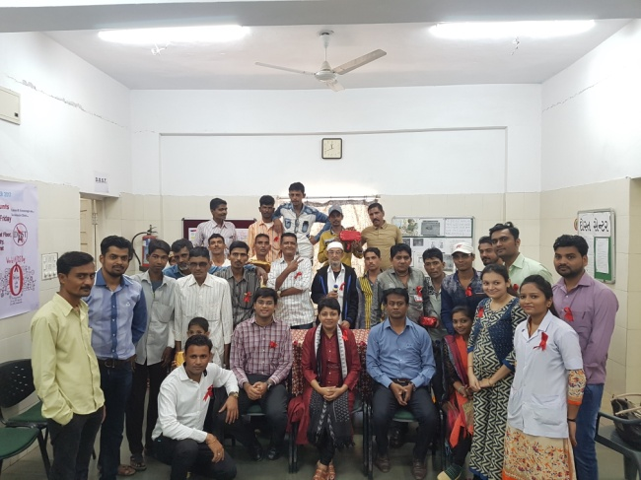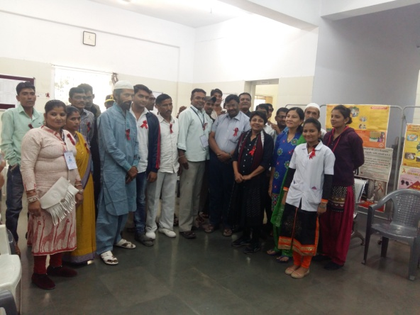
World AIDS Day 2018 at Dost Center DOST center meeting 2016
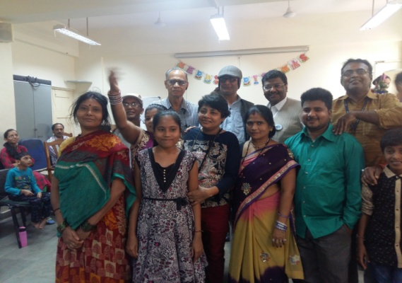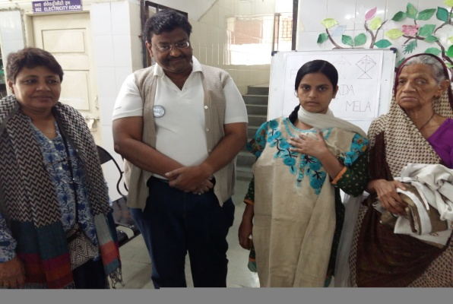
Maitri on Christmas 2016 Maitri on Uttarayan 2016

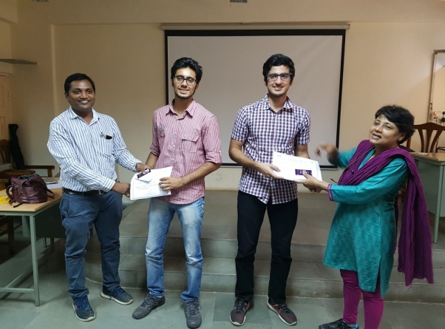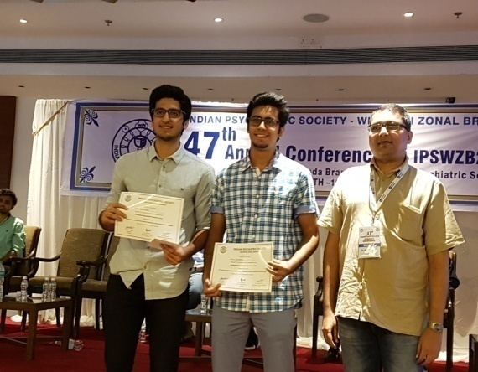
UG Quiz State Zonal level September 2016 UG Quiz West Zone level Oct 2016

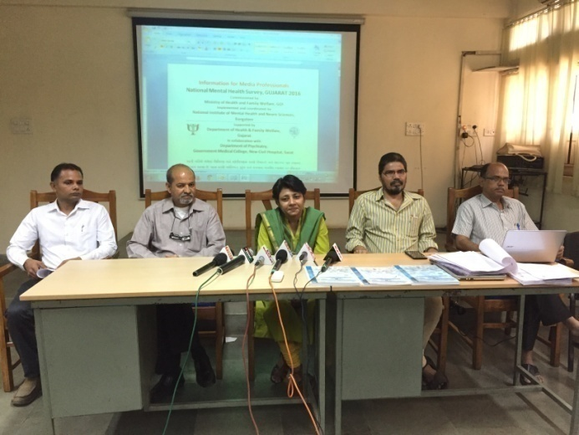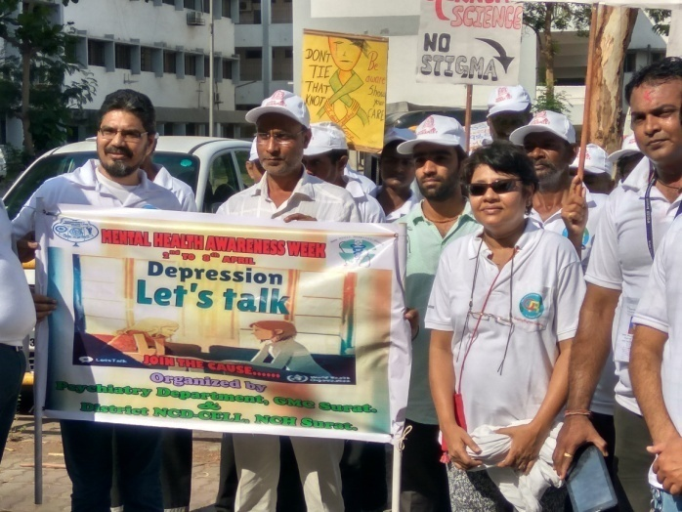
NMHS report Press Conference 2016

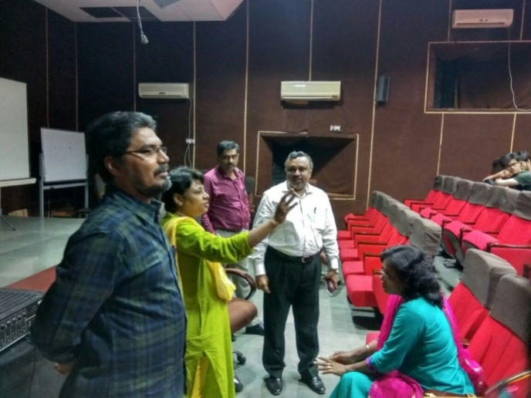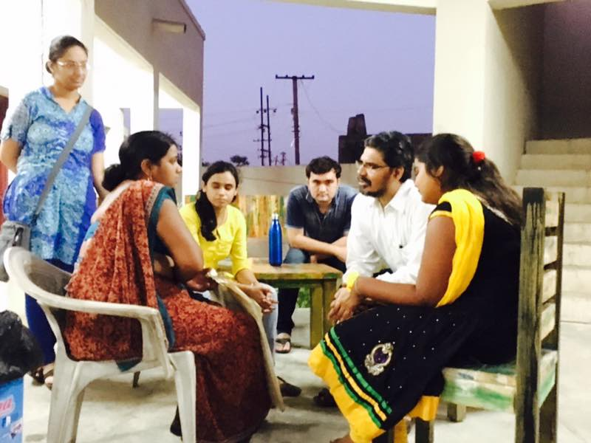
World Health Day 2017 Depression – Let’s Talk
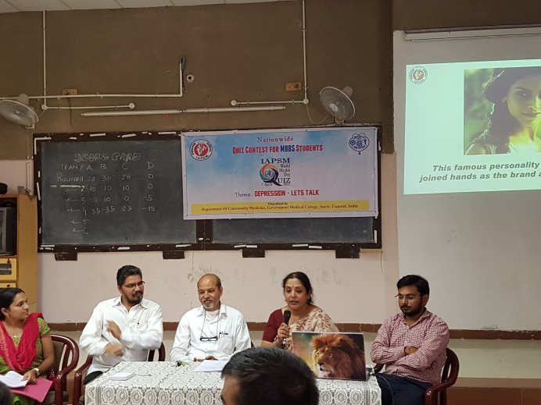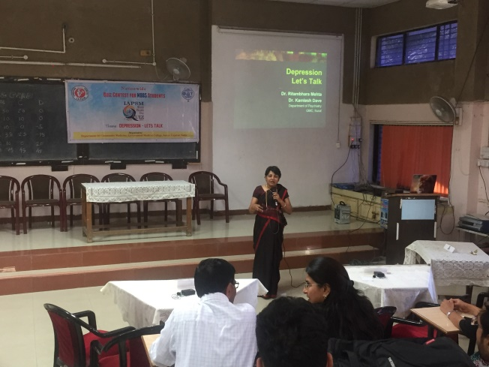
Mental health awareness week April 2017
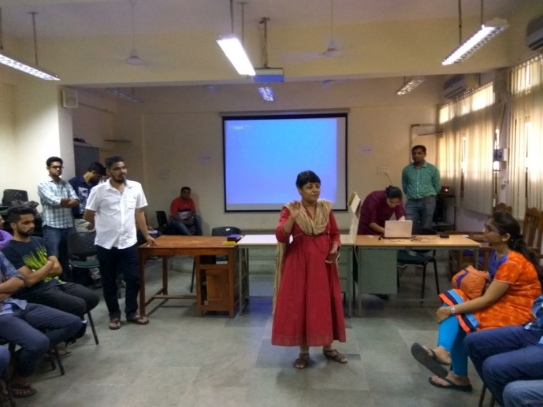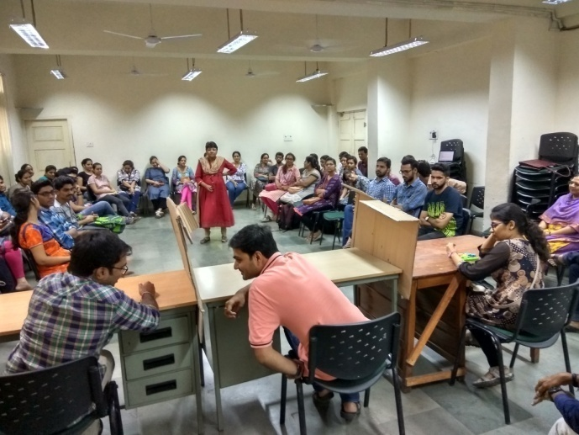

PG Induction programme May 2017

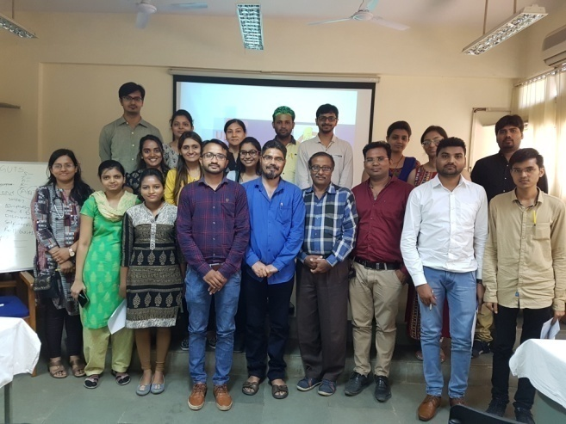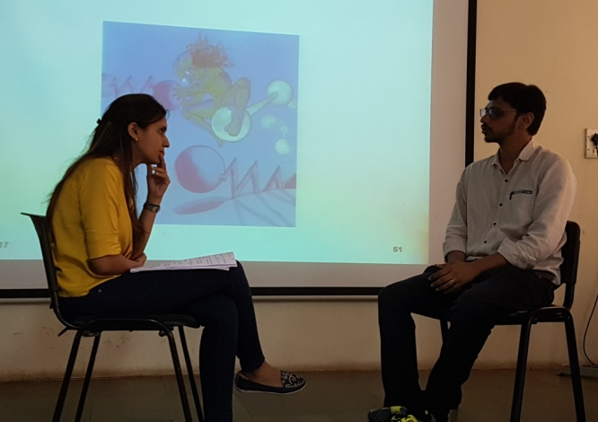
GUTS - ‘Give Up Tobacco Sensibly’ May 2017
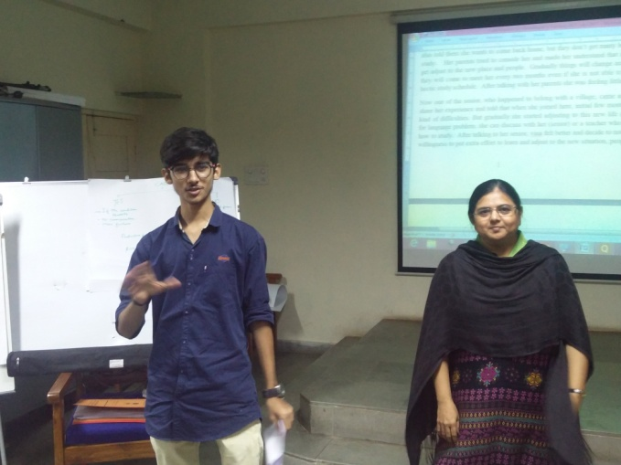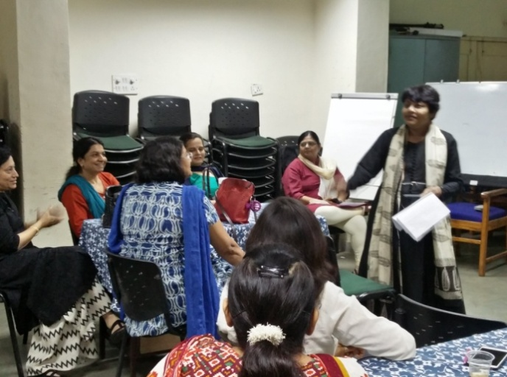
Gatekeeper training for suicide prevention July 2017

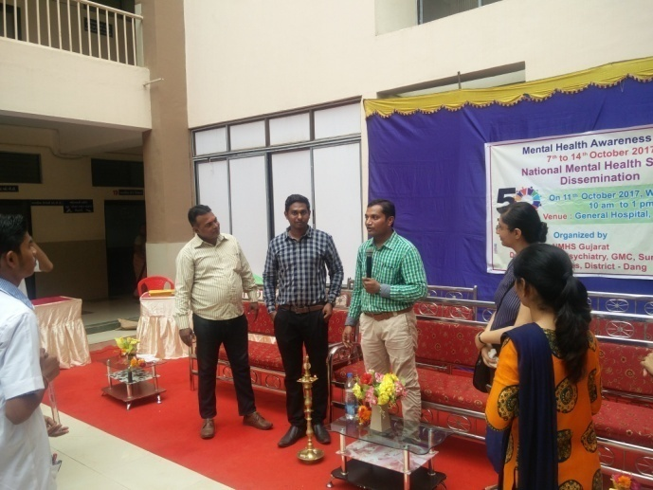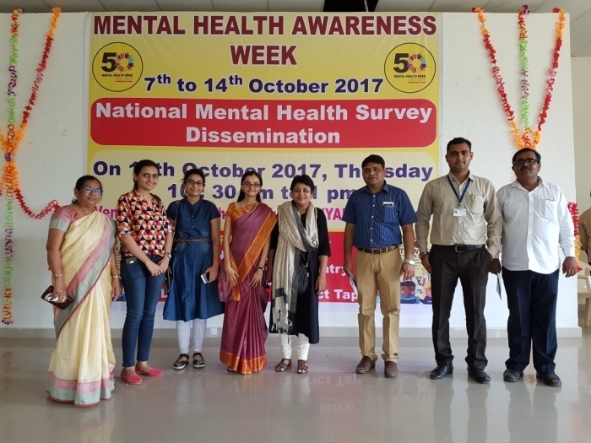.
Mental Heath Awareness Week Oct 2017

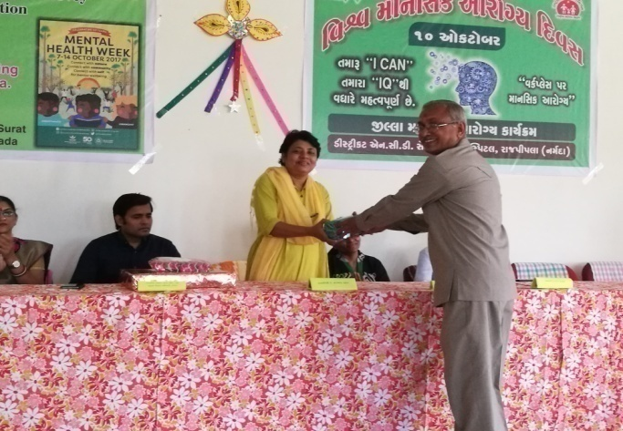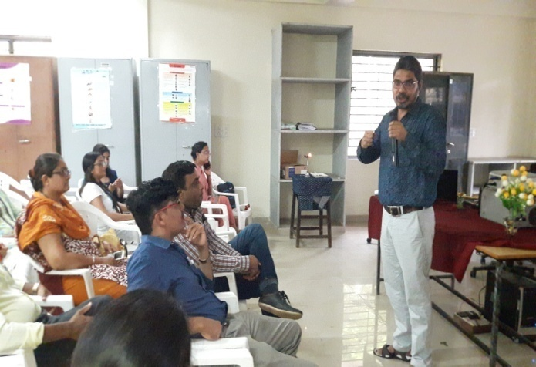
Mental Heath Awareness Week Oct 2017

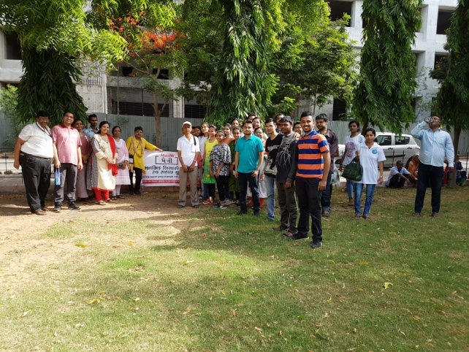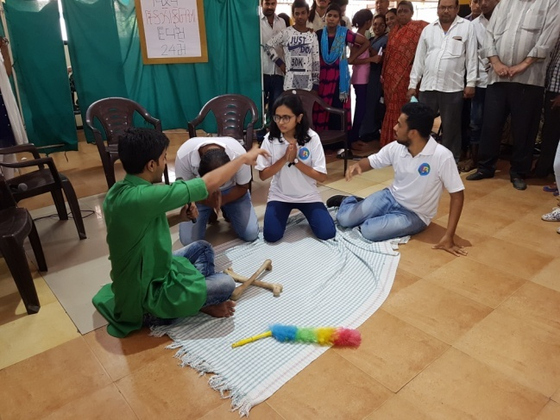
WORLD SCHIZOPHRENIA DAT 2018
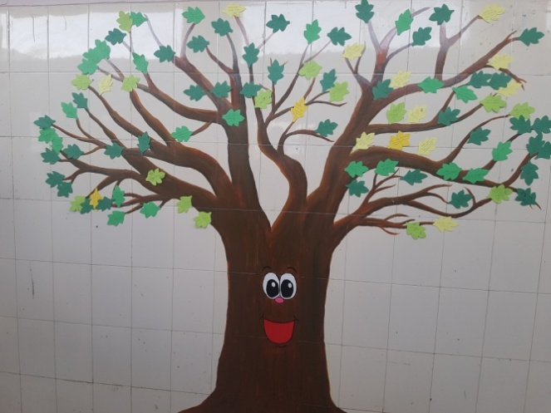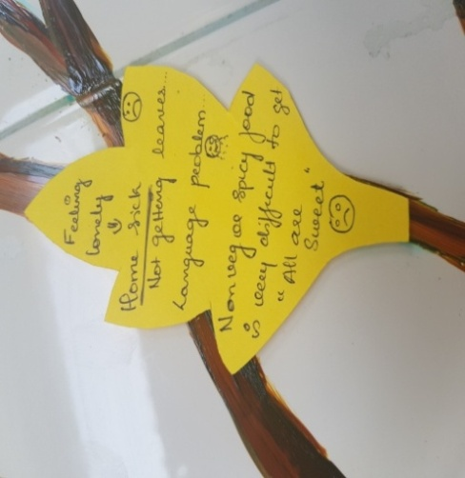
DASH PG WORKSHOP 2018
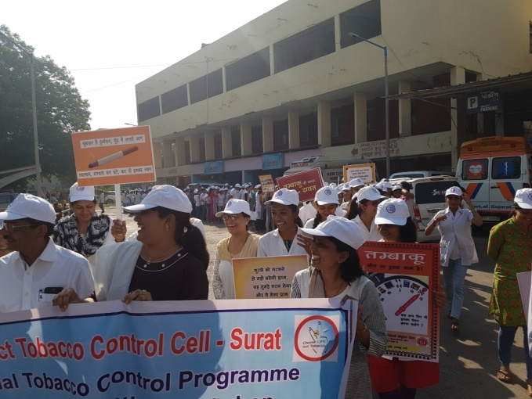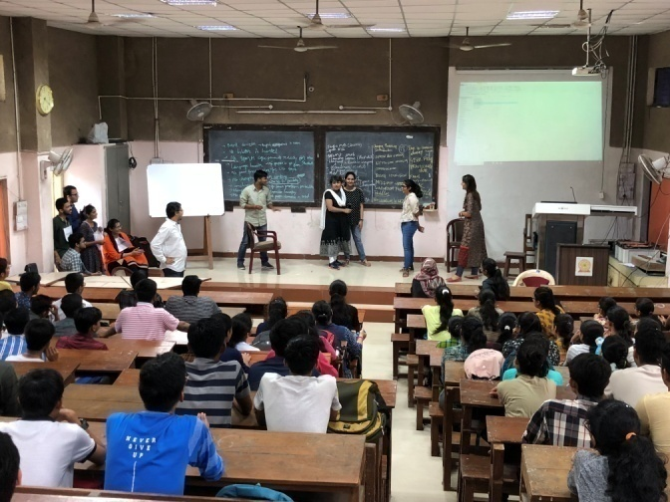
WORLD NO TOBBACCO DAY 2018 DASH UG ORIENTATION PROGRAMME
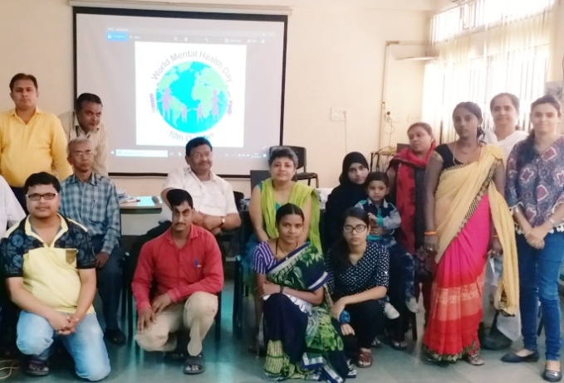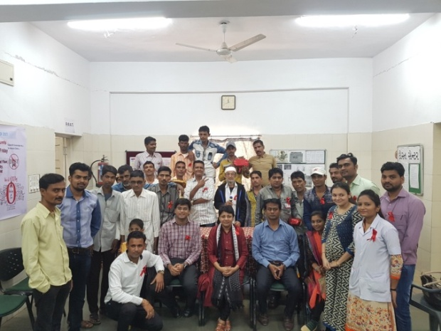
WORLD MENTAL HEALTH DAY WORLD AIDS DAY

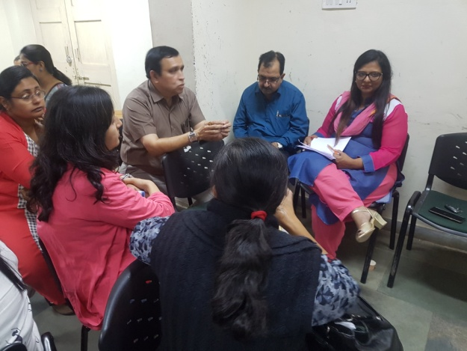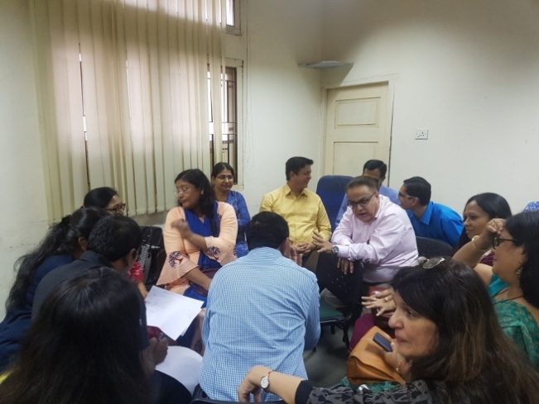
PG guides training

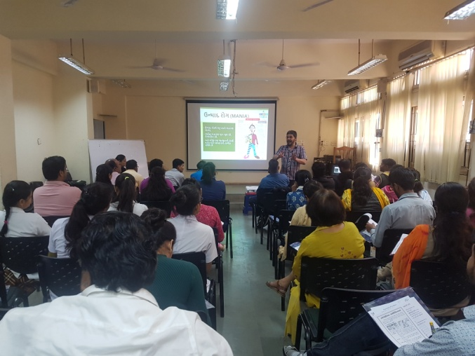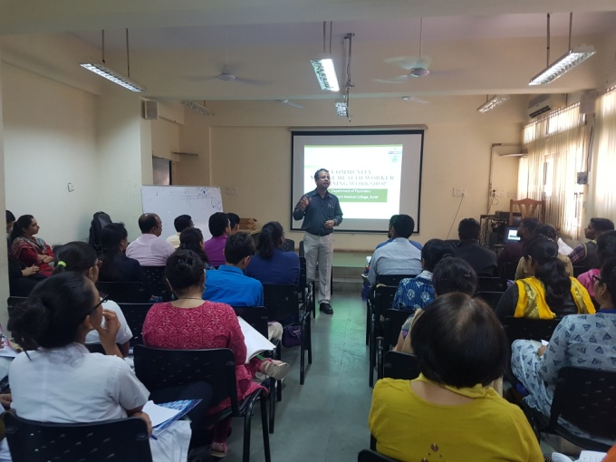
MENTAL HEALTH TRAINING FOR COMMUNITY WORKERS
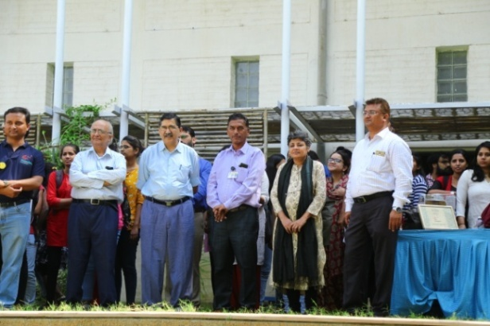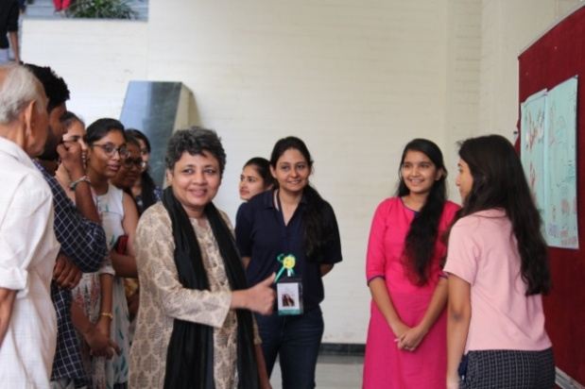
World Mental Health Day 10 October 2018 at IIPH
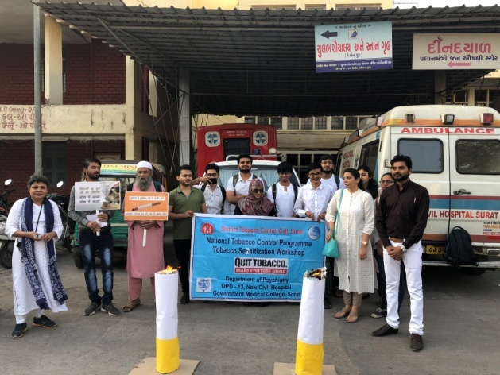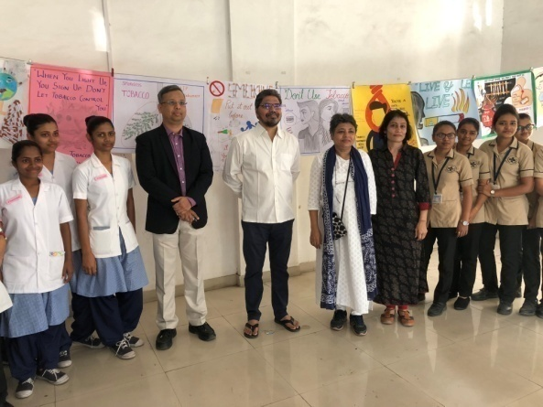
No Tobacco Day 2019 Poster making No Tobacco Day 2019

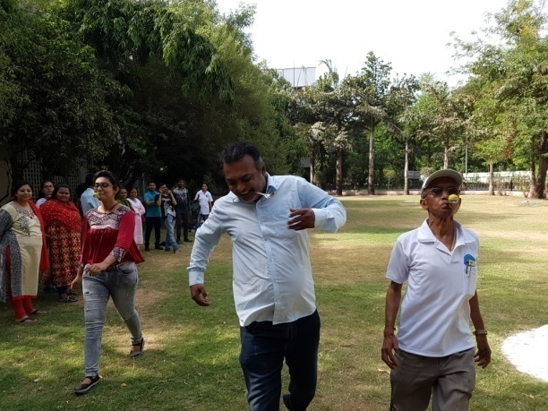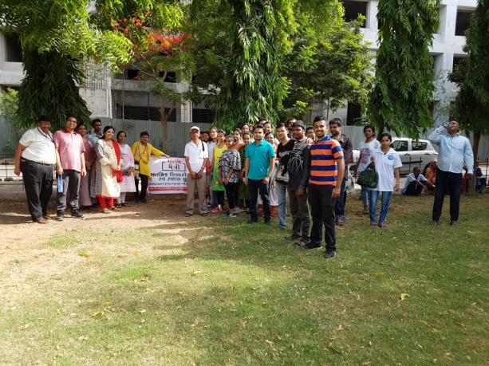
World Mental Health Day 2018 World Mental Health Day 2018

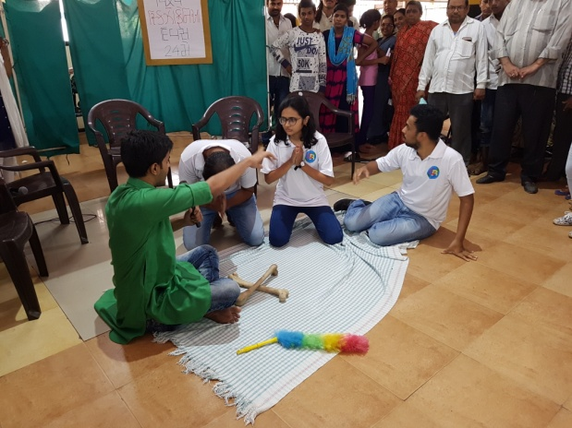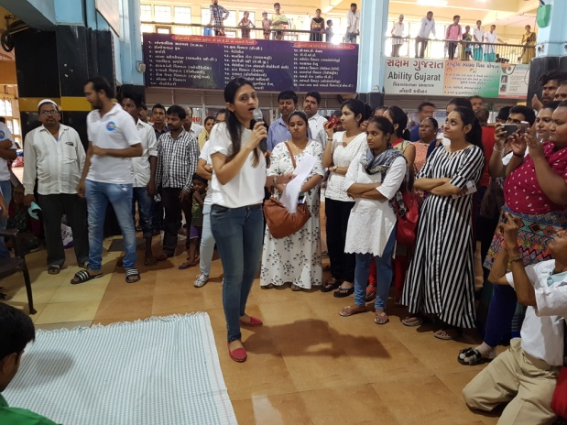
World Mental Health Day 2018 World Mental Health Day 2018

No Tobacco Day 2019 Poster making No Tobacco Day 2019

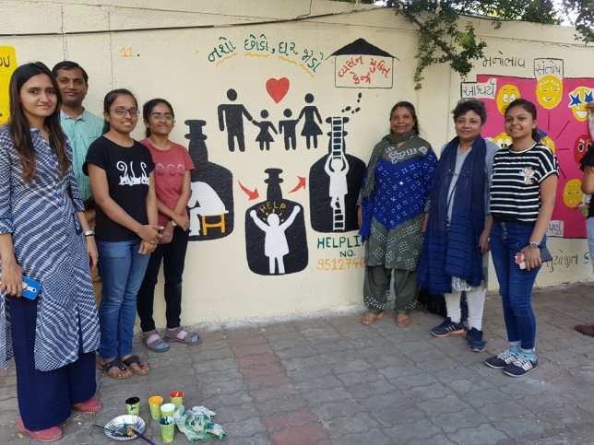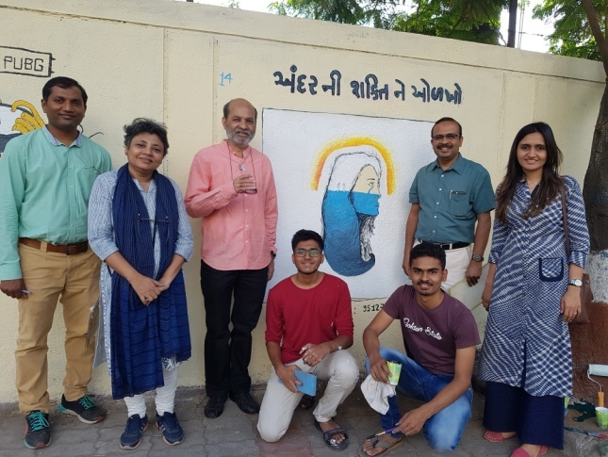

Wall Paintings on Mental Health Awareness during EUCRASIA 2019

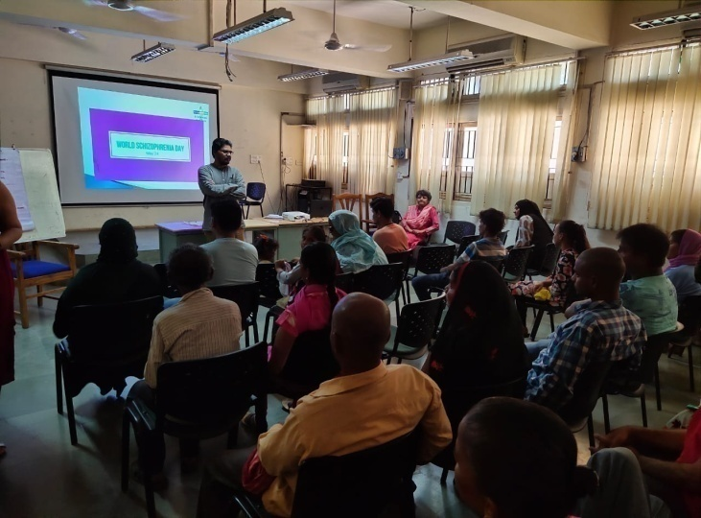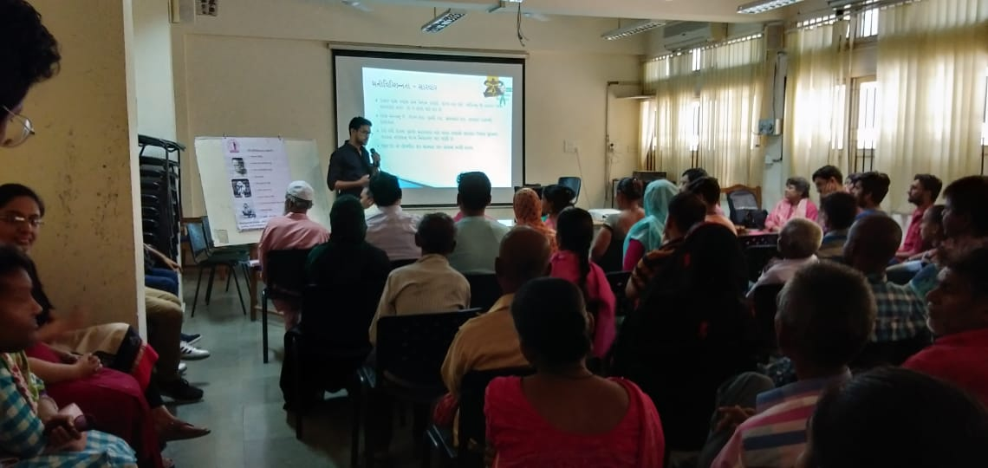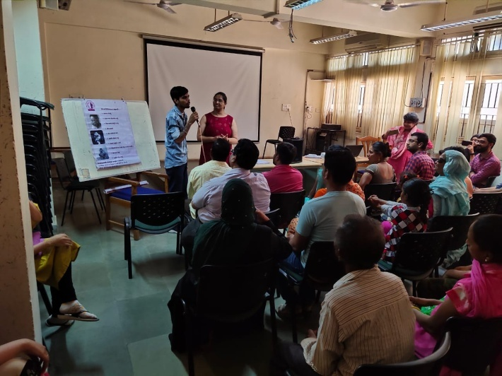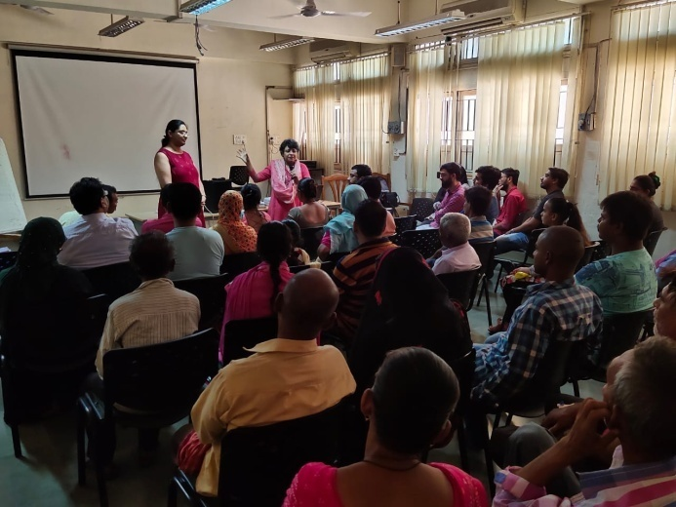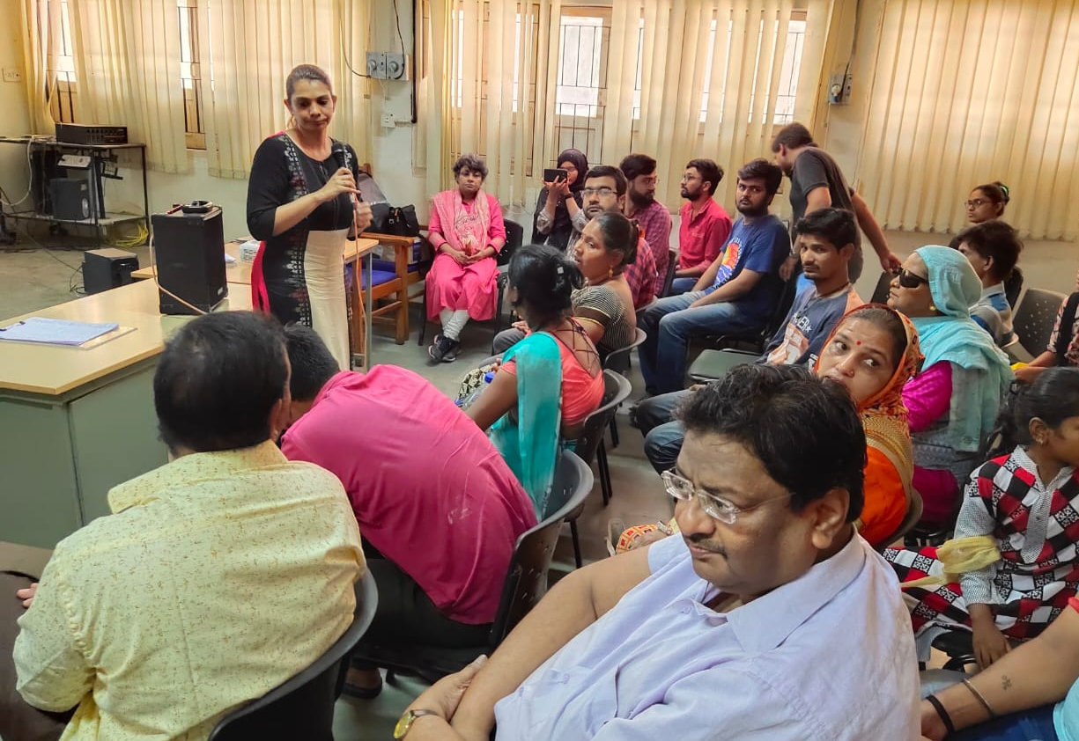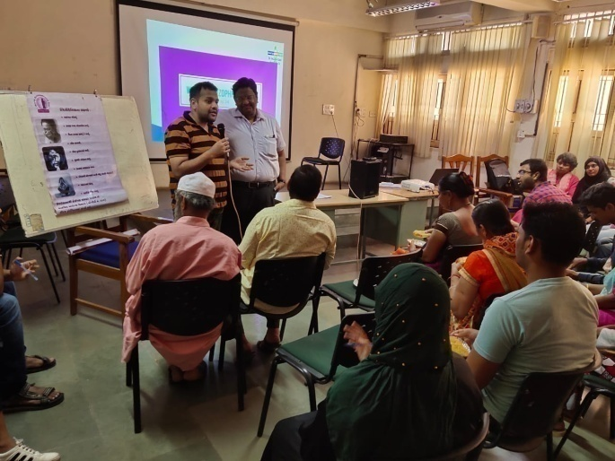

WO

W
World Schizophrenia Day 24th May 2019
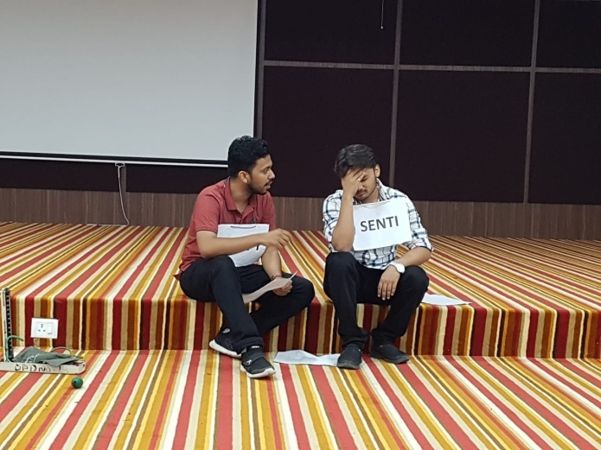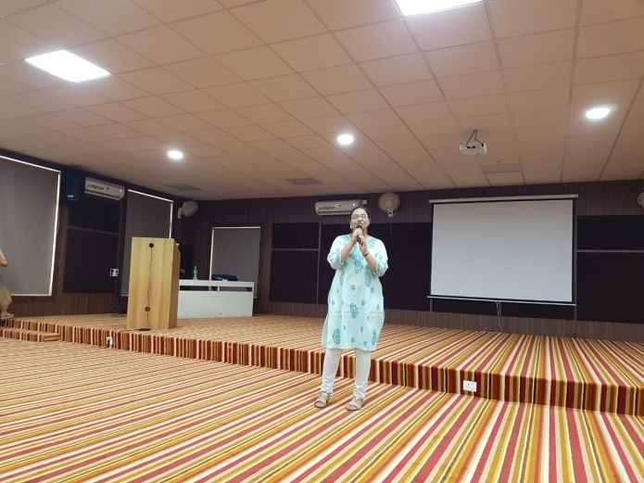

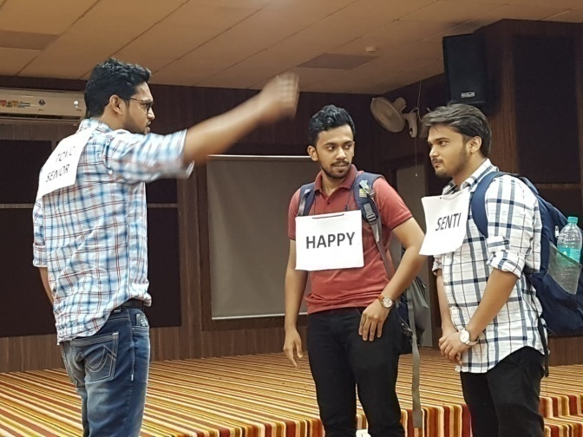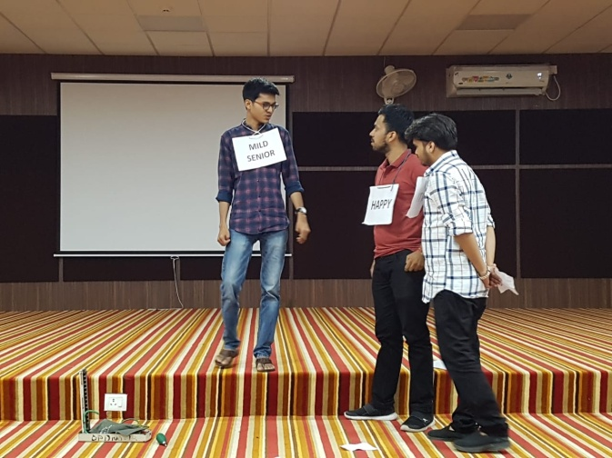

POST GRAGUDATE Orientation Programme- 25 May 2019

dkdjqoihdadowqisxdo
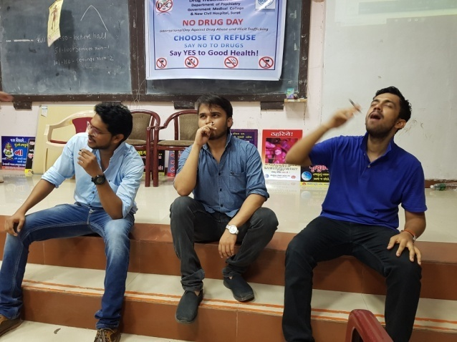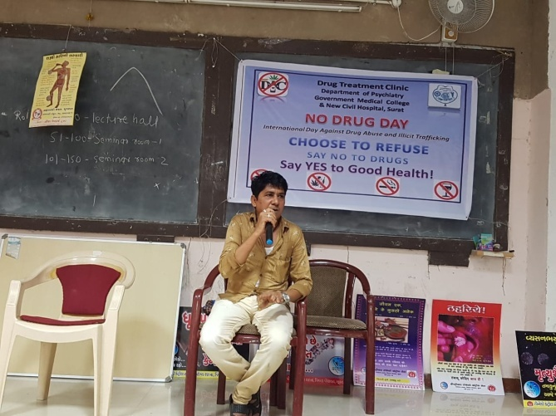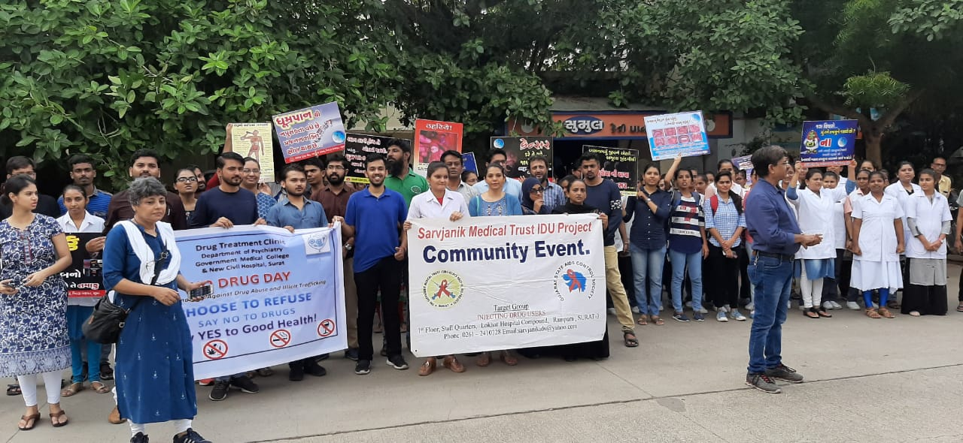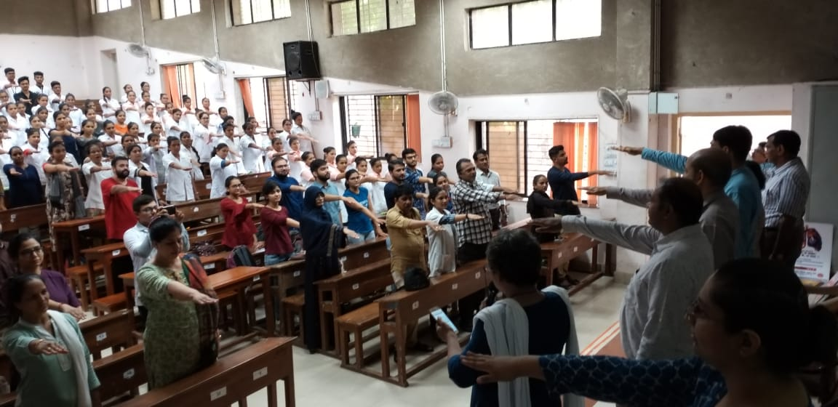
International No Drug Day- 26 June 2019

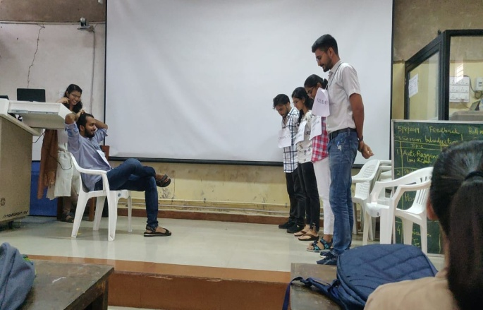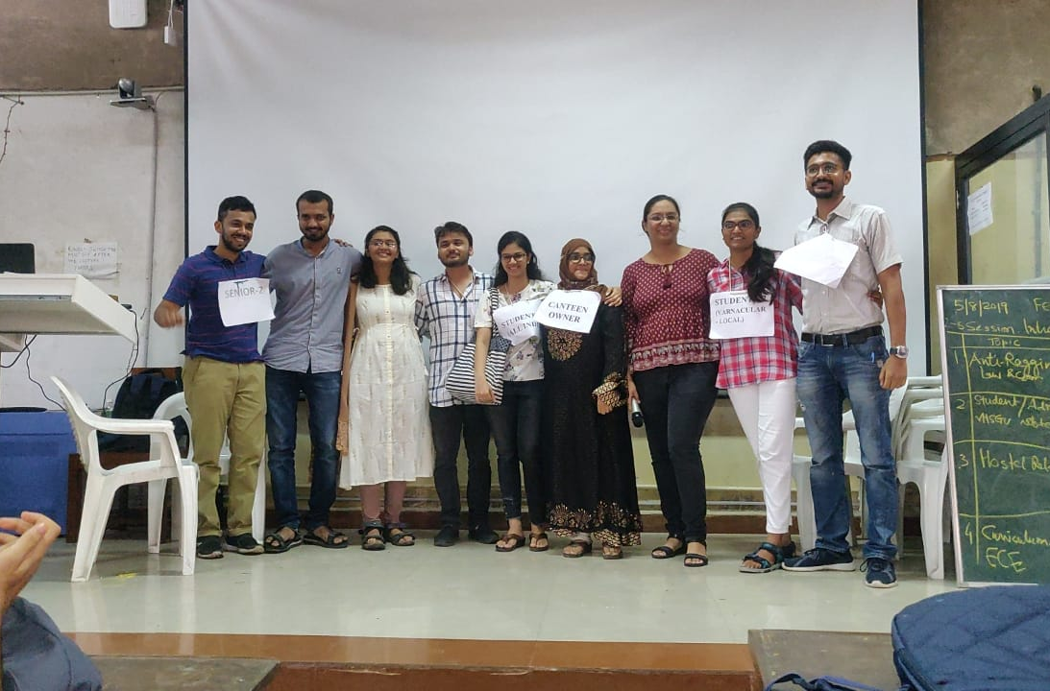

UG Orientation Program- Senior-Junior Play- 6th August 2019

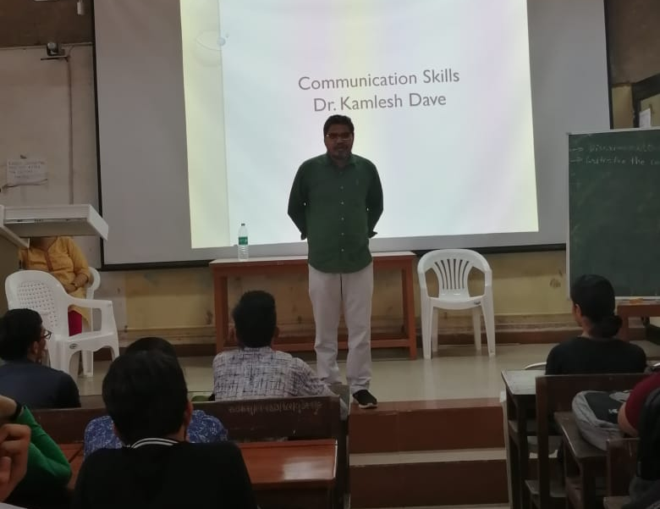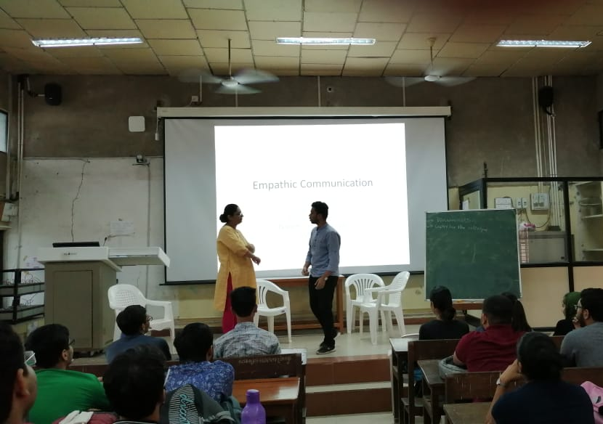
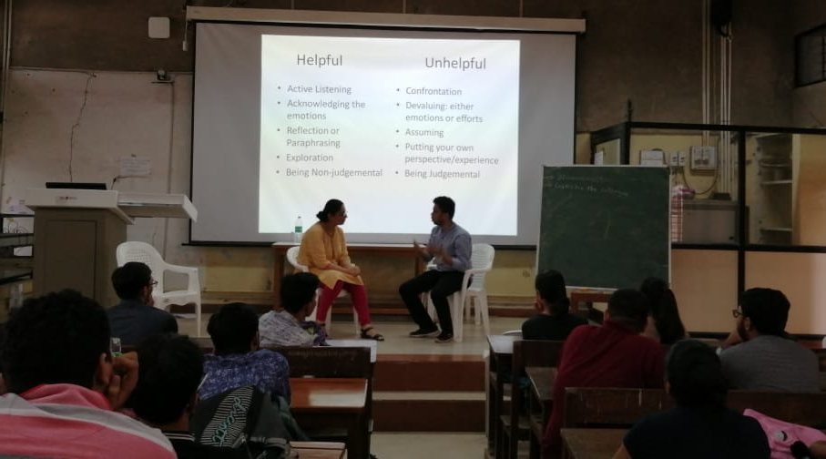

UG Orientation Program- Communication Skills- 14th August 2019

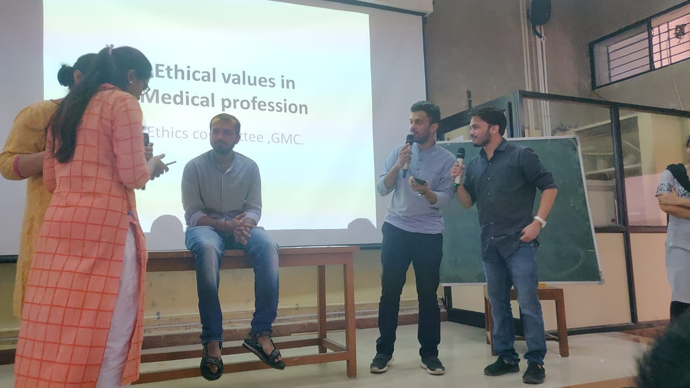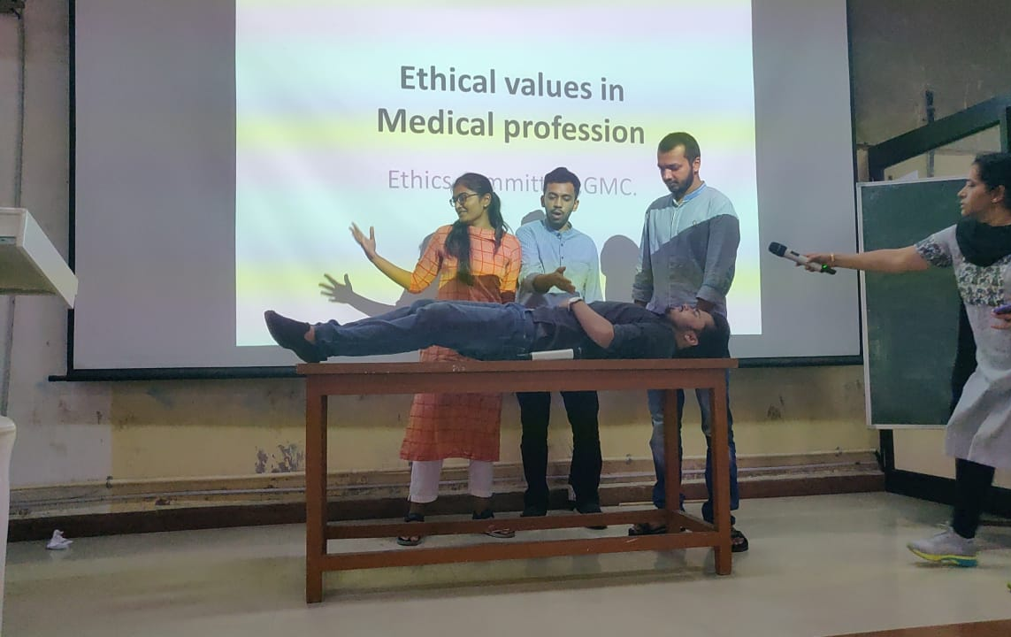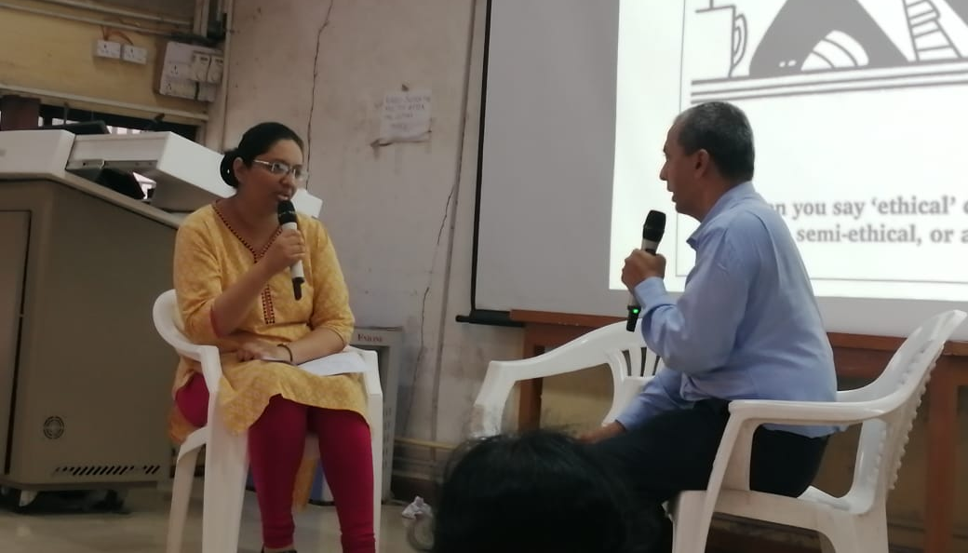

UG Orientation Program- Ethical values in Medical Profession- 14th August 2019

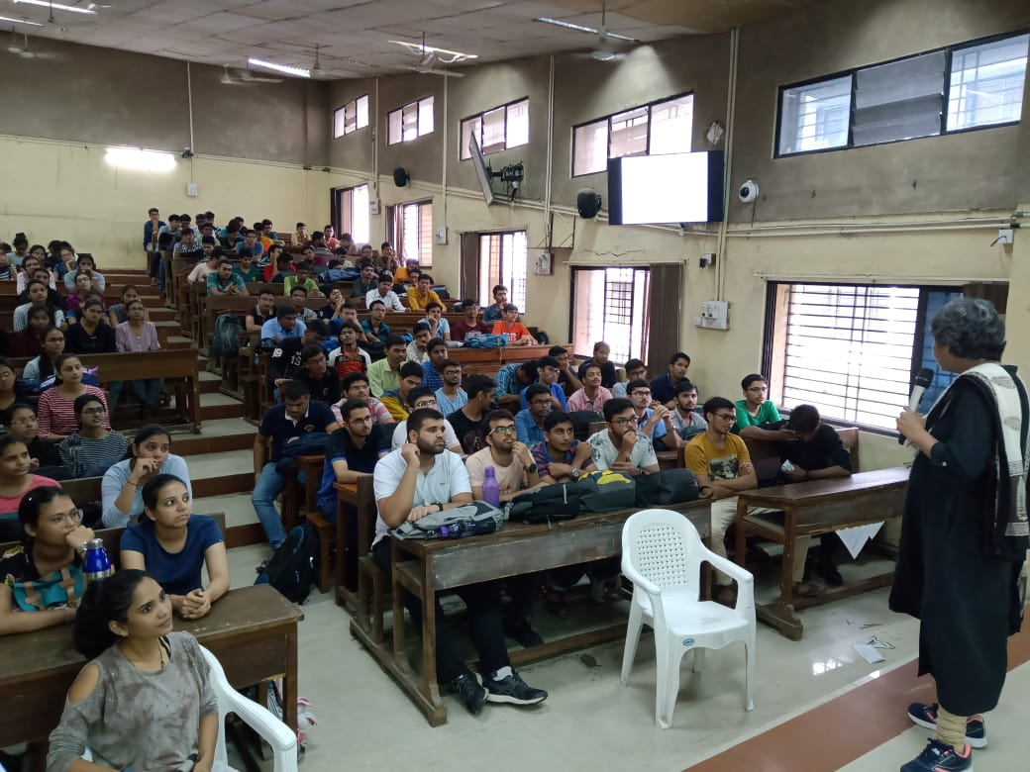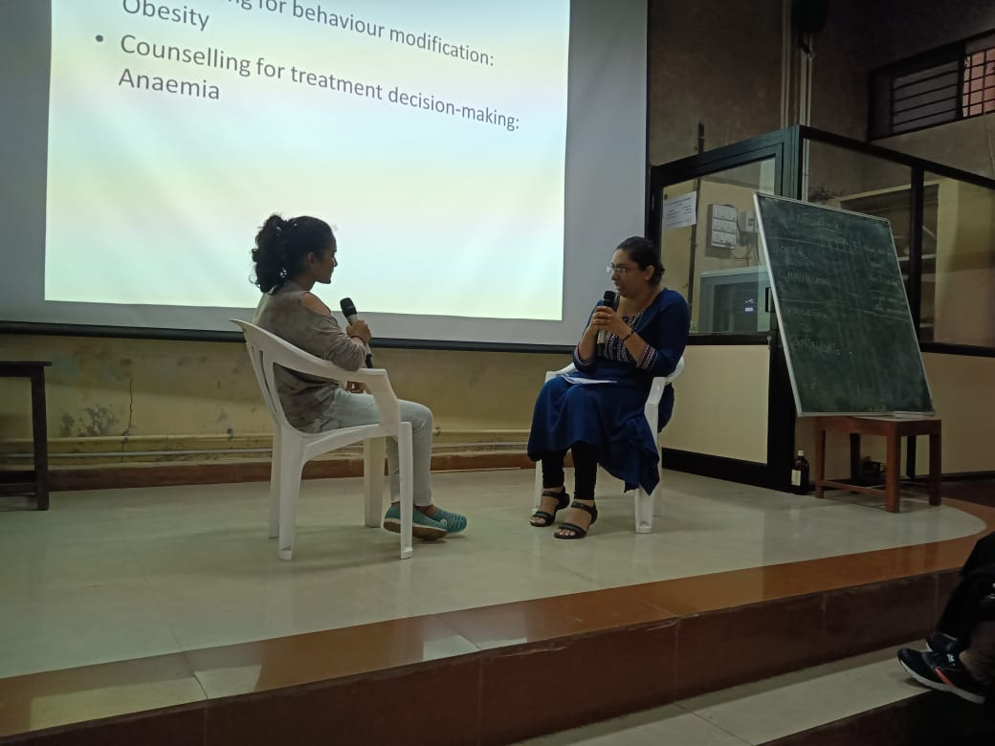

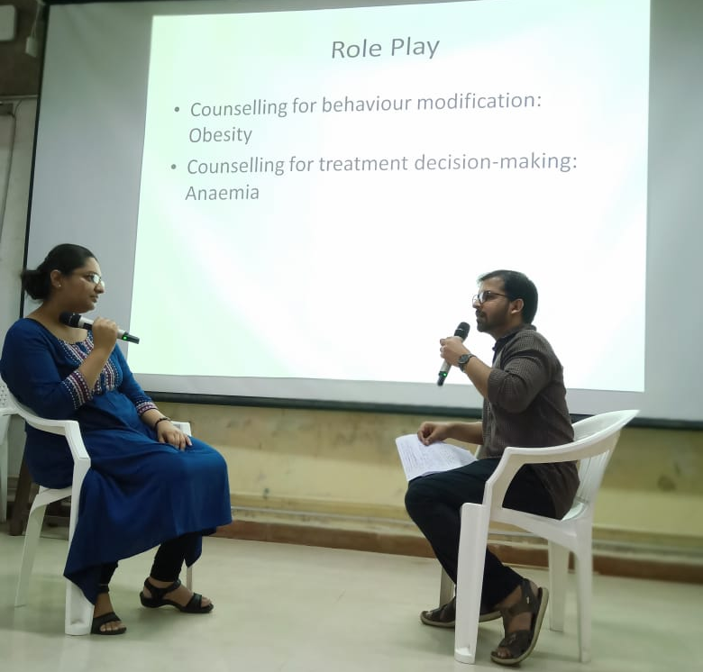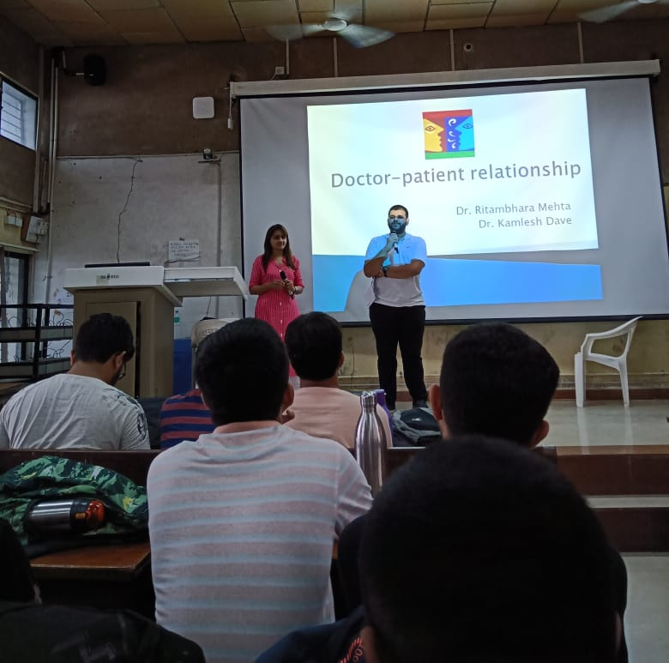

UG Orientation Program- Doctor Patient Relationship- 26th August 2019

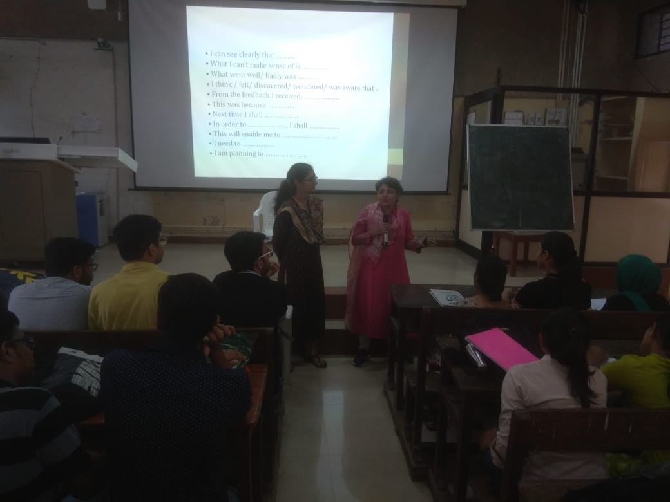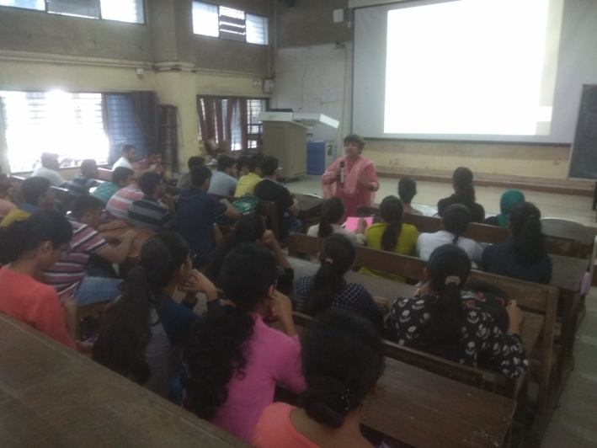

UG 1st MBBS CBME Foundation Course - Reflective Writing- 31st August 2019

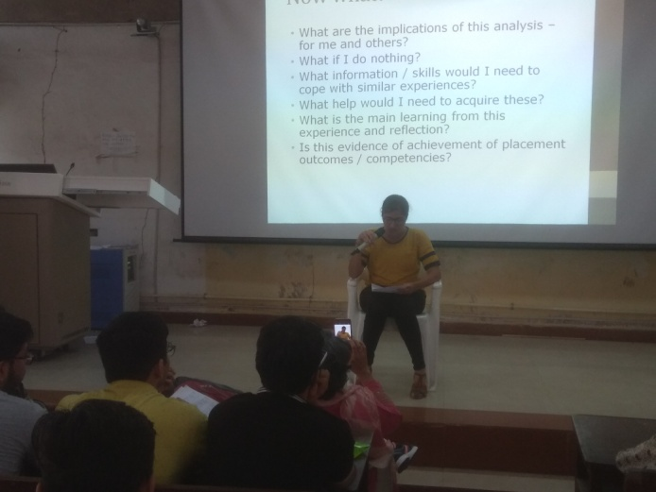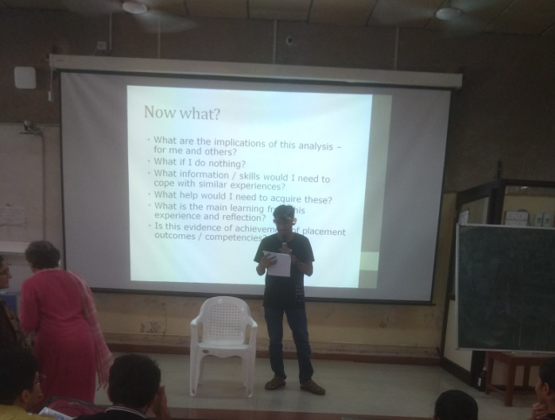

UG 1st MBBS CBME Foundation Course - Reflective Writing- 31st August 2019

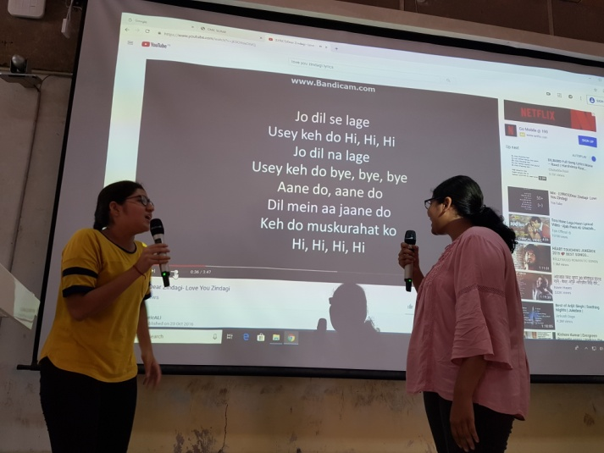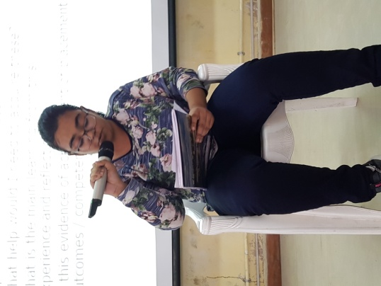

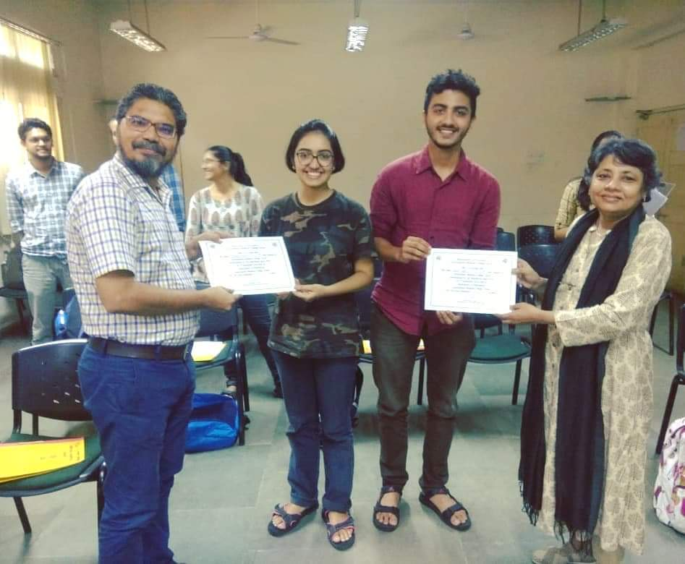

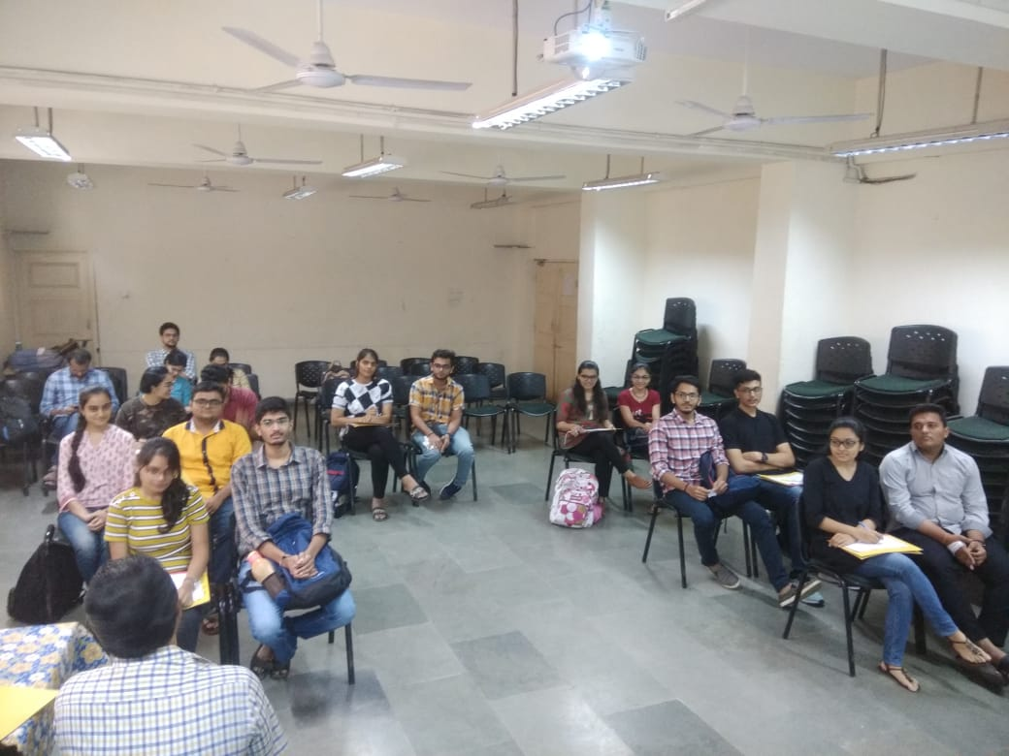

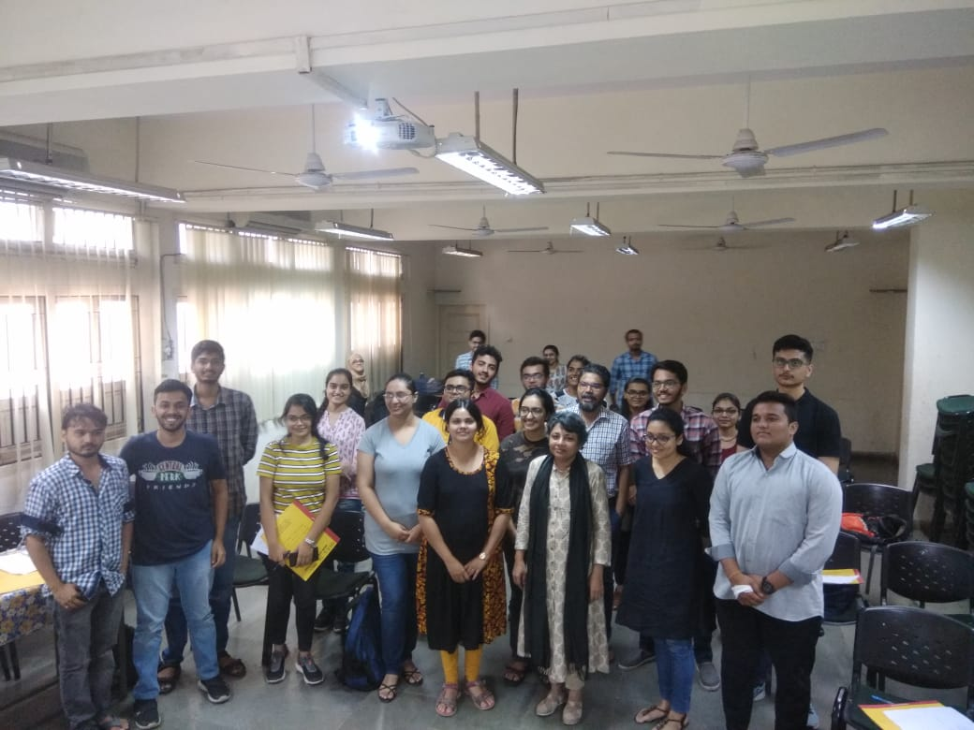

UG QUIZ Competition- 5th September 2019

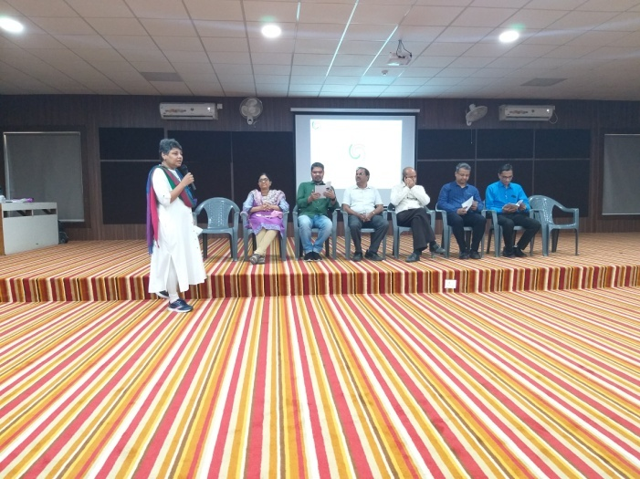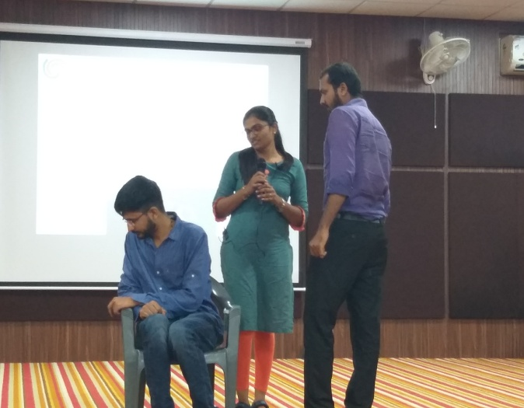

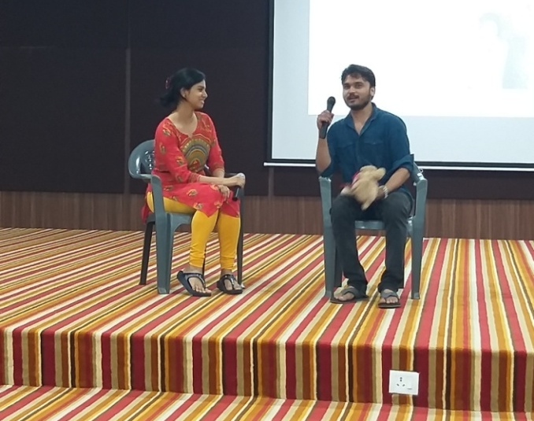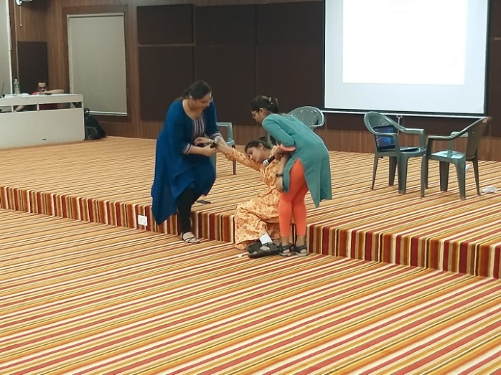

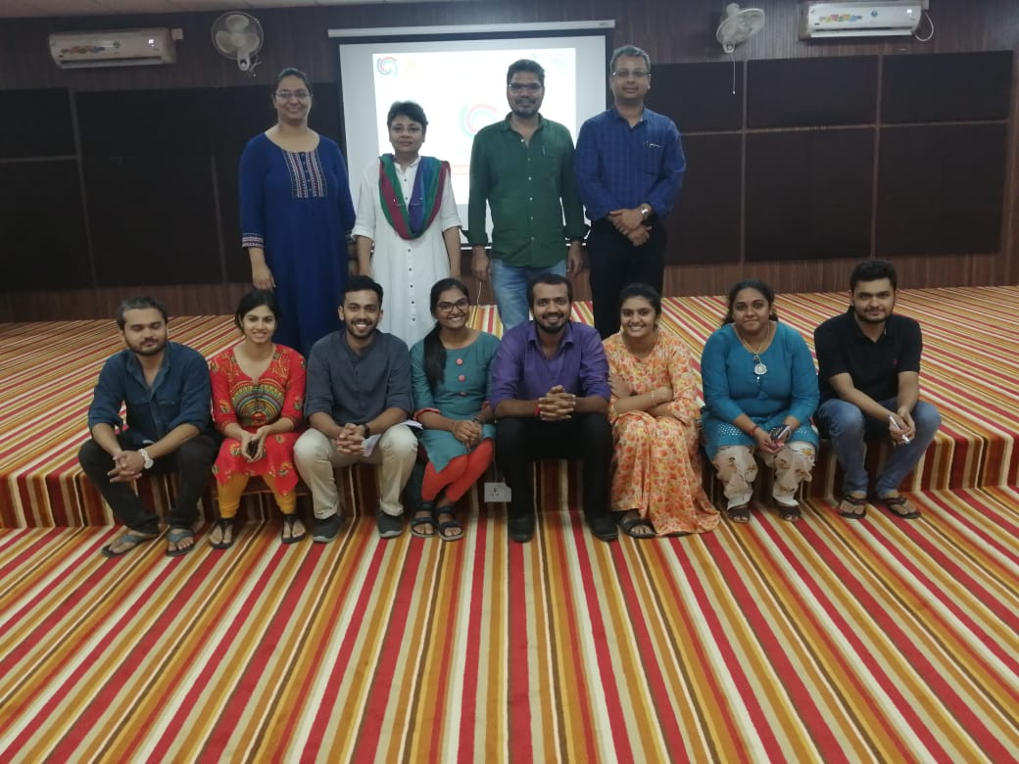

World Suicide Prevention Day- 10 September 2019

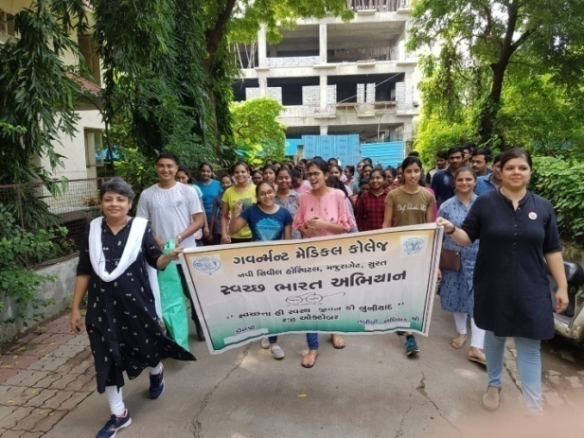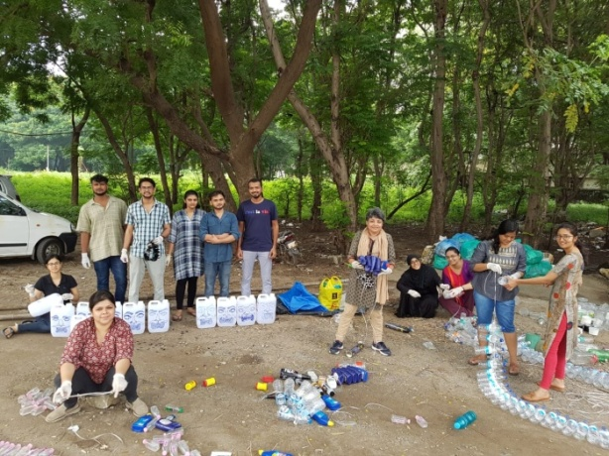

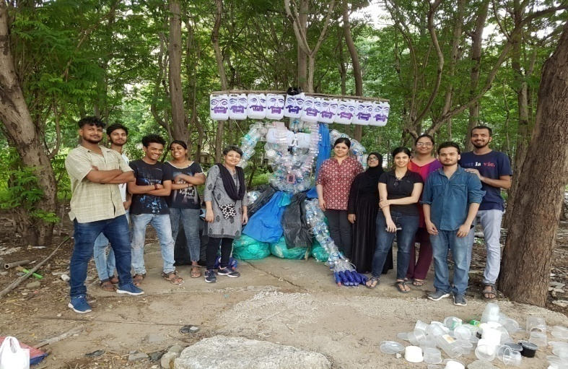
Swaccha Bharat Campaign- Making of Ravan From Plastic Waste

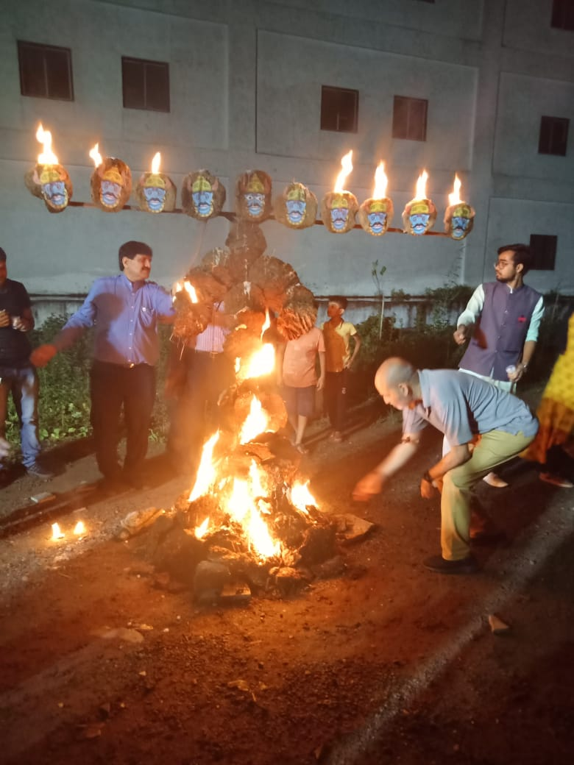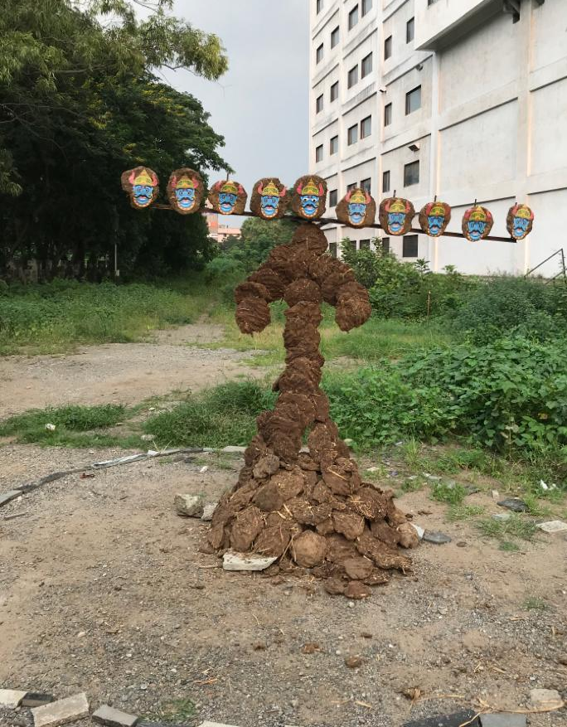
Biodegradable Ravan Burning- 9 October 2019
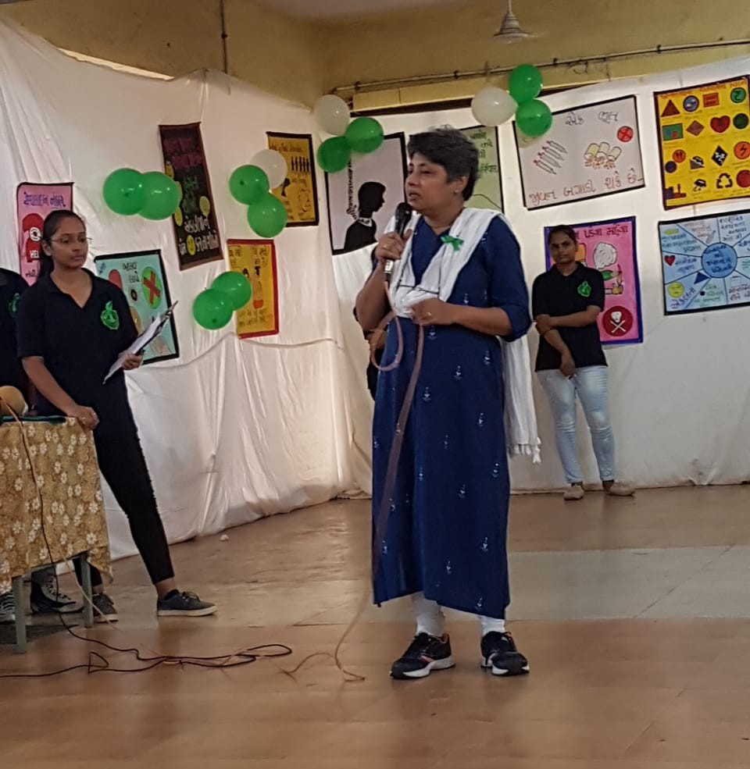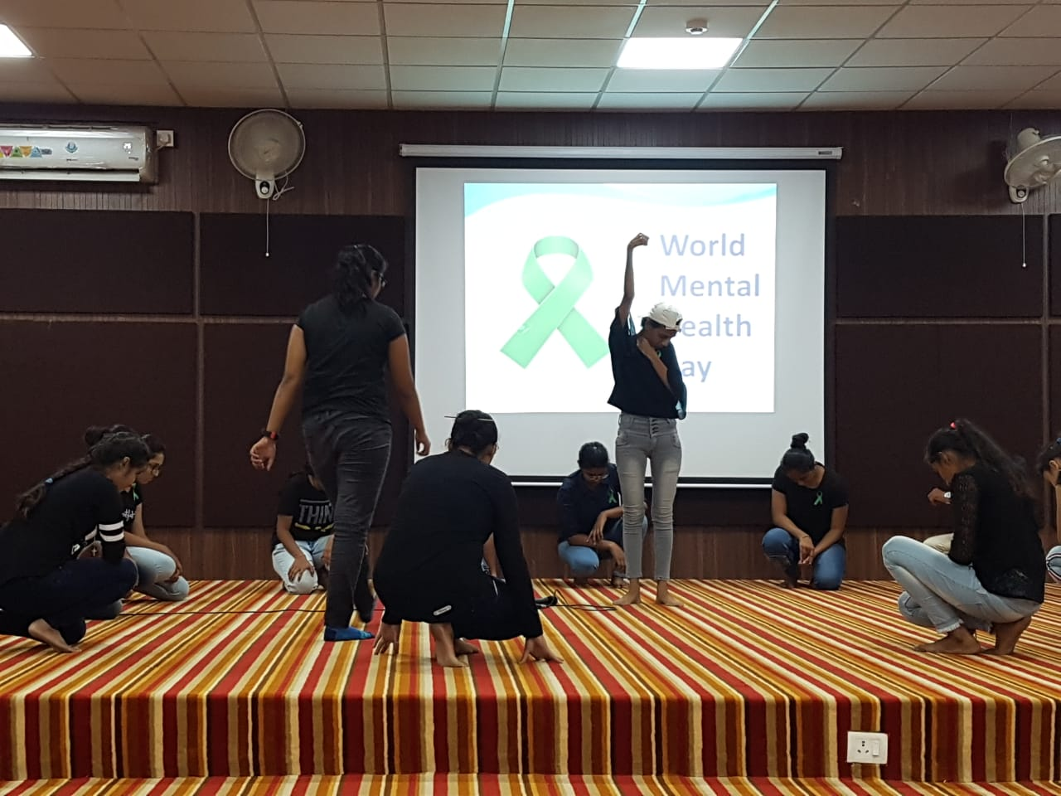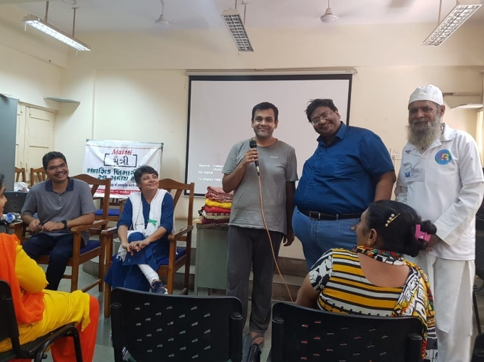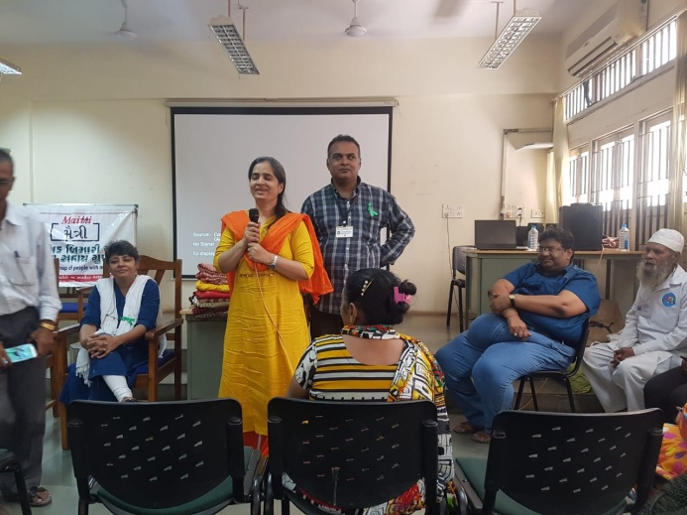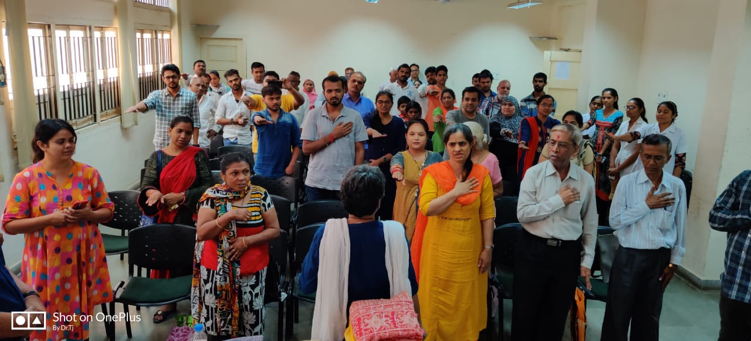

World Mental Health Day Celebrations-10 October 2019
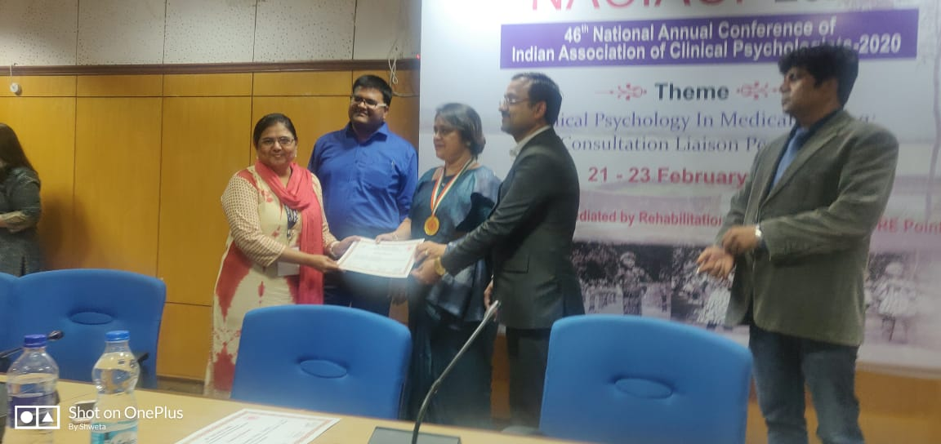
Award for Ms Ami Pathak Feb 2020

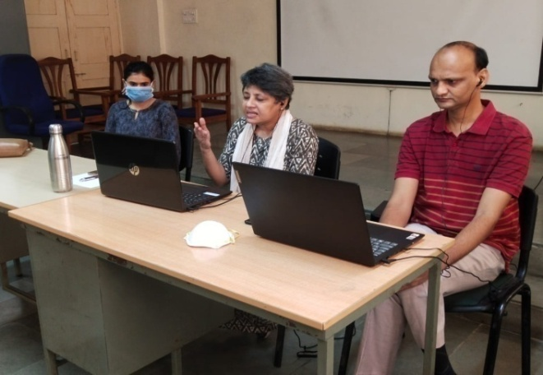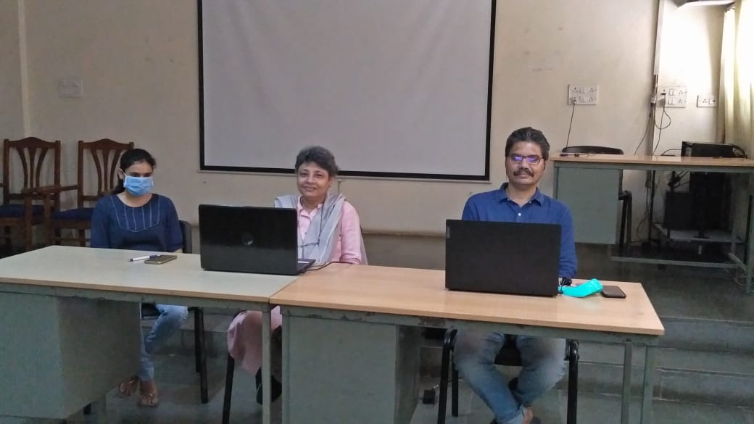

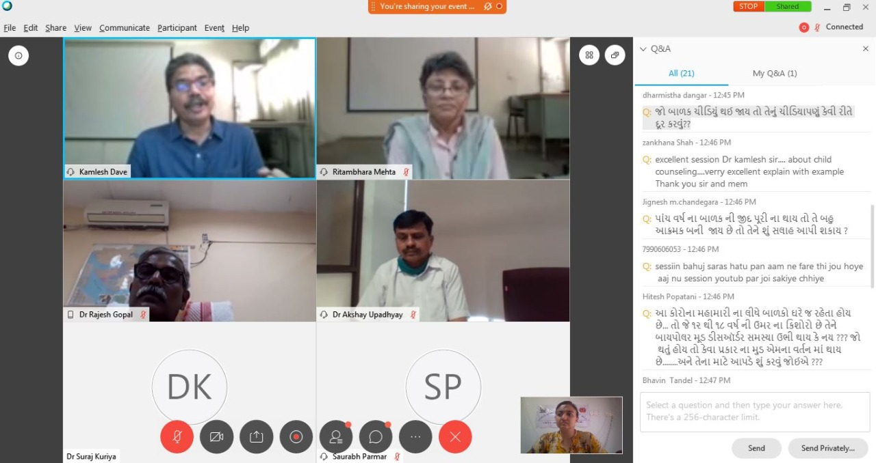

COVID19 Webinars by Psychiatry Department May 2020

